SQL Assignment – 1
SALESPEOPLE Data:

CREATE TABLE SALESPEOPLE(
-> SNUM INT(4),
-> SNAME VARCHAR(10),
-> CITY VARCHAR(10),
-> COMM FLOAT(3,2)
-> );

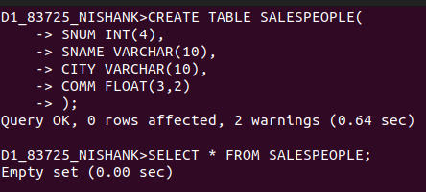

INSERT INTO SALESPEOPLE VALUES(
-> (‘1001’, ‘PEEL’, ‘LONDON’, .12),
-> (‘1002’, ‘SERRES’, ‘SAN JOSE’, .12),
-> (‘1004’, ‘MOTIKA’, ‘LONDON’, .12),
-> (‘1007’, ‘RIFKIN’, ‘BARCELONA’, .12),
-> (‘1003’, ‘AXELROD’, ‘NEW YORK’, .12),

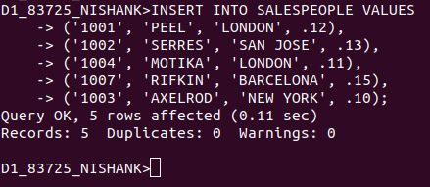

CUSTOMERS Data:

CREATE TABLE CUSTOMERS(
-> CNUM INT(4),
-> CNAME VARCHAR(10),
-> CITY VARCHAR(10),
-> RATING INT(4),
-> SNUM INT(4)
-> );

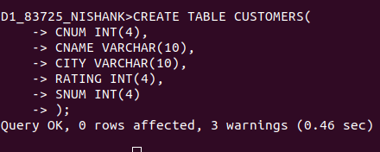

INSERT INTO CUSTOMERS VALUES
-> (2001, 'HOFFMAN', 'LONDON', 100, 1001),
-> (2002, 'GIOVANNI', 'ROME', 200, 1003),
-> (2003, 'LIU', 'SAN JOSE', 200, 1002),
-> (2004, 'GRASS', 'BERLIN', 300, 1002),
-> (2006, 'CLEMENS', 'LONDON', 100, 1001),
-> (2008, 'CISNEROS', 'SAN JOSE', 300, 1007),
-> (2007, 'PEREIRA', 'ROME', 100, 1004);

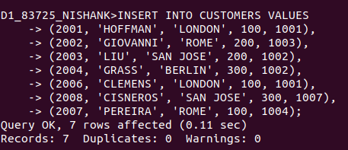

ORDERS Data;

CREATE TABLE ORDERS(
-> ONUM INT(4),
-> AMT FLOAT(7,2),
-> ODATE DATE,
-> CNUM INT(4),
-> SNUM INT(4)
-> );

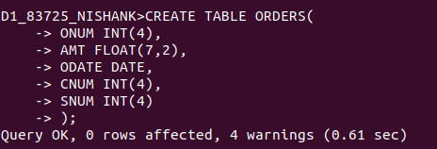

INSERT INTO ORDERS VALUES
-> (3003, 767.19,'1990-10-03', 2001, 1001),
-> (3002, 1900.10,'1990-10-03', 2007, 1004),
-> (3005, 5160.45,'1990-10-03', 2003, 1002),
-> (3006, 1098.16, '1990-10-03', 2008, 1007),
-> (3009, 1713.23, '1990-10-04', 2002, 1003),
-> (3007, 75.75, '1990-10-04', 2004, 1002),
-> (3008, 4723.00, '1990-10-05', 2006, 1001),
-> (3010, 1309.95, '1990-10-06', 2004, 1002),
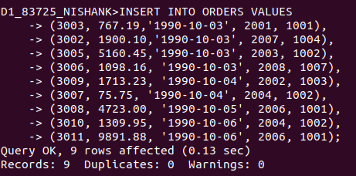
-> (3011, 9891.88, '1990-10-06', 2006, 1001);

