Assignment – 4

Q1) Write a select command that produces the order number, amount, and date for all rows in the Orders table.
Ans:

SELECT ONUM, AMT, DATE FROM ORDERS;

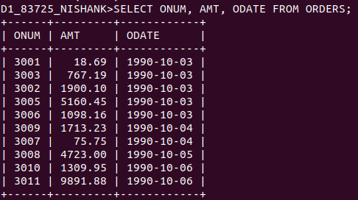

Q2) Write a query that produces all rows from the Customers table for which the salesperson’s number is 1001.
Ans:

SELECT * FROM SALESPEOPLE
WHERE SNUM = '1001';
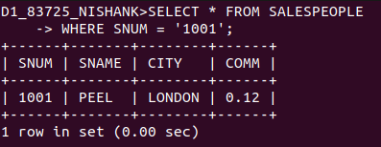

Q3) Write a query that displays the Salespeople table with the columns in the following order: city, sname, snum, comm.
Ans:

SELECT CITY, SNAME, SNUM, COMM FROM SALESPEOPLE;

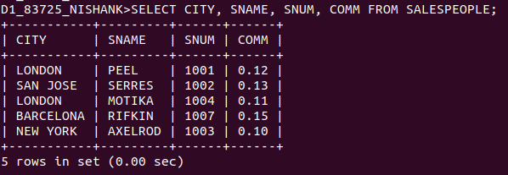

Q4) Write a select command that produces the rating followed by the name of each customer in San Jose.
Ans:
SELECT RATING, CNAME FROM CUSTOMERS
WHERE CITY = ‘SAN JOSE’;

