Assignment – 11

Subqueries

1) Write a query that uses a subquery to obtain all orders for the customer named Cisneros. Assume you do not know his customer number (cnum).
Ans:

D1_83725_NISHANK>SELECT CNAME, ONUM FROM CUSTOMERS, ORDERS
-> WHERE ORDERS.CNUM = CUSTOMERS.CNUM AND
-> CUSTOMERS.CNUM = (SELECT CUSTOMERS.CNUM FROM CUSTOMERS WHERE CNAME = 'CISNEROS');

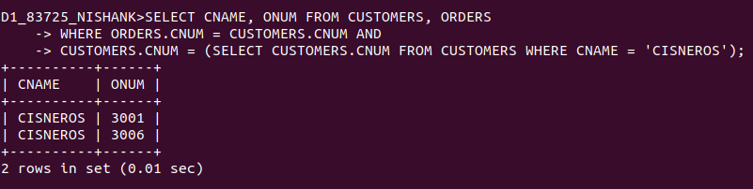

2) Write a query that produces the names and ratings of all customers who have above-average orders.
Ans:

D1_83725_NISHANK>SELECT DISTINCT ONUM, CNAME, RATING FROM CUSTOMERS, ORDERS WHERE AMT > (SELECT AVG(AMT) FROM ORDERS)
-> AND ORDERS.CNUM = CUSTOMERS.CNUM ORDER BY ONUM;

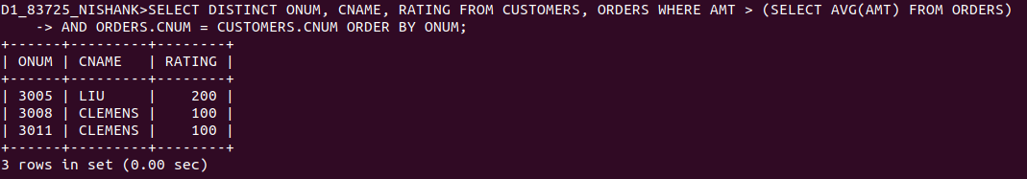

3) Write a query that selects the total amount in orders for each salesperson for whom this total is greater than the amount of the largest order in the table.
Ans:

D1_83725_NISHANK>SELECT SNUM, SUM(AMT) FROM ORDERS GROUP BY SNUM HAVING SUM(AMT) > (SELECT MAX(AMT) FROM ORDERS);

