SQL Assignment – 14

Entering, Deleting, and Changing Field Values.

1) Write a command that puts the following values, in their given order, into the salespeople table: city – San Jose, name – Blanco, comm – NULL, cnum – 1100.
Ans:

D1_83725_NISHANK>INSERT INTO SALESPEOPLE (CITY, SNAME, COMM, SNUM) VALUES ('SAN JOSE', 'BLANCO', NULL, 1100);

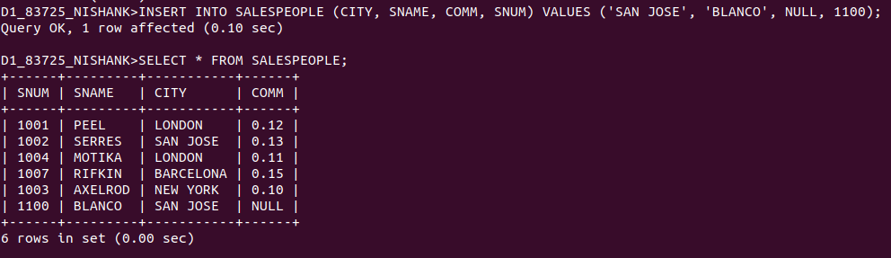

2) Write a command that removes all orders from customer Clemens from the Orders table.
Ans:

D1_83725_NISHANK>DELETE FROM ORDERS WHERE CNUM = (SELECT ABCD.CNUM FROM (SELECT CNUM FROM CUSTOMERS WHERE CNAME = 'CLEMENS') ABCD);

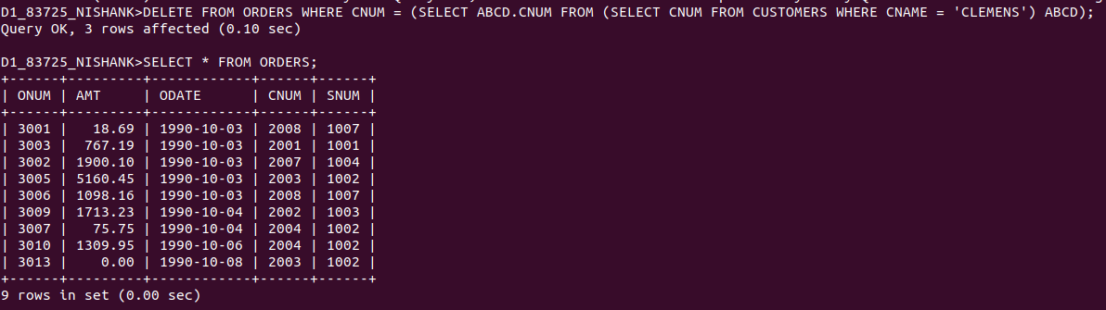

3) Write a command that increases the rating of all customers in Rome by 100.
Ans:

D1_83725_NISHANK>UPDATE CUSTOMERS SET RATING = RATING + 100WHERE CITY = 'ROME';

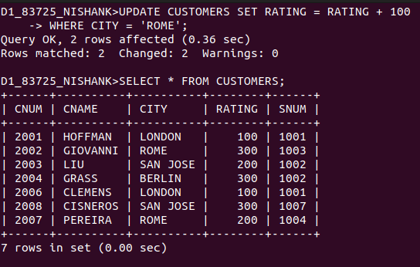

4) Salesperson Serres has left the company. Assign her customers to Motika.
Ans:

D1_83725_NISHANK>UPDATE CUSTOMERS SET SNUM = (SELECT SNUM FROM SALESPEOPLE WHERE SNAME = 'MOTIKA')
-> WHERE SNUM = ANY(SELECT ABCD.SNUM FROM (SELECT SNUM FROM SALESPEOPLE WHERE SNAME = 'SERRES')ABCD);

