SQL Assignment – 15

Using Subqueries with DML Commands.

1) Assume there is a table called Multicust, with all of the same column definitions as Salespeople. Write a command that inserts all salespeople with
more than one customer into this table.
Ans:

D1_83725_NISHANK>INSERT INTO MULTICUST SELECT * FROM SALESPEOPLE WHERE SNUM IN (SELECT SNUM FROM CUSTOMERS GROUP BY SNUM HAVING COUNT(SNUM)>1);

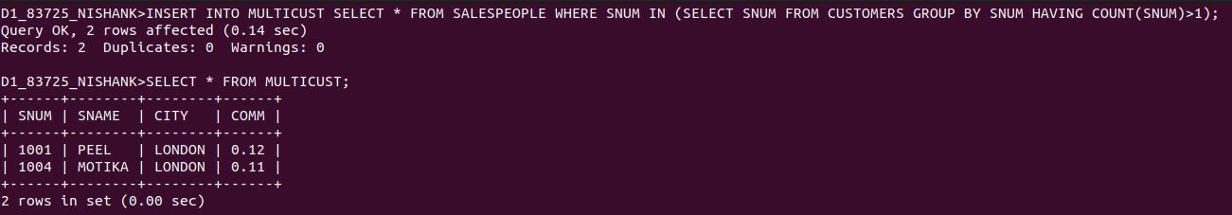

2) Write a command that deletes all customers with no current orders.
Ans:

D1_83725_NISHANK>DELETE FROM CUSTOMERS WHERE CNUM = ANY
(SELECT ABCD.CNUM FROM (SELECT CNUM FROM ORDERS GROUP BY CNUM HAVING COUNT(ONUM) = 0) ABCD);

3) Write a command that increases by twenty percent the commissions of all salespeople with total orders above Rs. 3,000.
Ans:

UPDATE SALESPEOPLE SET COMM = COMM + .2
WHERE SNUM =ANY (SELECT SNUM FROM ORDERS GROUP BY SNUM HAVING COUNT(ONUM) > 1);

