Assignment - 3

1.ls - Display hidden files

Ans:

nishank@nishank-Predator-G3-572:~/SunBeam/OSModule/OS_Assignments$ ls -l -a
total 20
drwxrwxr-x 5 nishank nishank 4096 May 31 23:06 .
drwxrwxr-x 5 nishank nishank 4096 May 31 19:26 ..
drwxrwxr-x 2 nishank nishank 4096 May 31 21:52 Assignment_1
drwxrwxr-x 2 nishank nishank 4096 May 31 23:09 Assignment_2
drwxrwxr-x 8 nishank nishank 4096 May 31 23:09 .git

2.renameRename all *.txt files to *.htm

Ans:

nishank@nishank-Predator-G3-572:~/SunBeam/OSModule/OS_Assignments/Assignment_3/FiletoRenamefromtxttoHTM$ rename 's/\.txt$/.htm/' *.txt

3.ln -sCreate symbolic link (shortcut) for a file

Ans:

nishank@nishank-Predator-G3-572:~/SunBeam/OSModule/OS_Assignments/Assignment_3/Temp$ ln -s File1

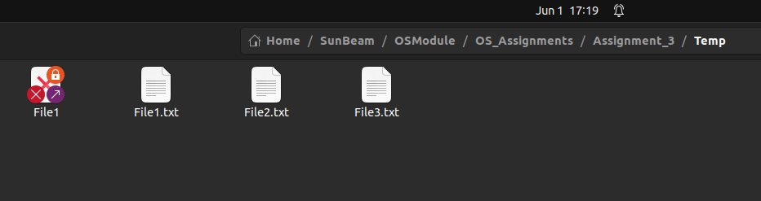

4.ln Create hard link for a file

Ans:

nishank@nishank-Predator-G3-572:~/SunBeam/OSModule/OS_Assignments/Assignment_3$ ln -P Temp/File1.txt

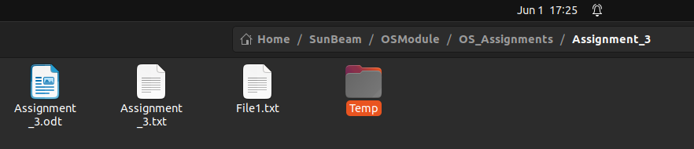

5.statDisplay time stamp of the file

Ans:

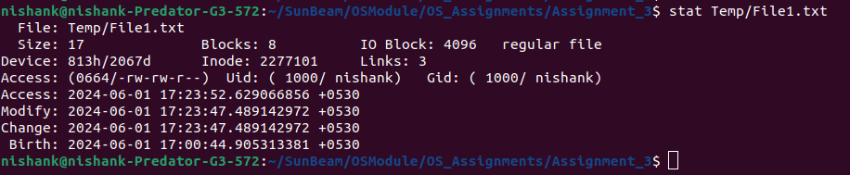

6.touchChange the time stamp of the file

Ans:

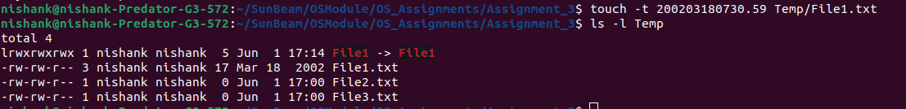

7.touchCreate empty file

Ans:

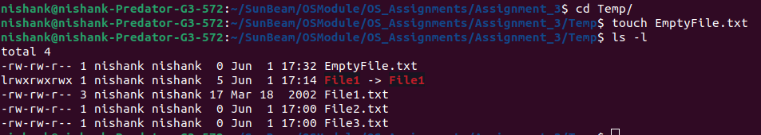
8.tailPrint all lines in a file from fifth line onwards

Ans:
Remember 5 will print the last 5 lines
Whereas,
+5 will print all the lines starting from Line 5 and Onwards

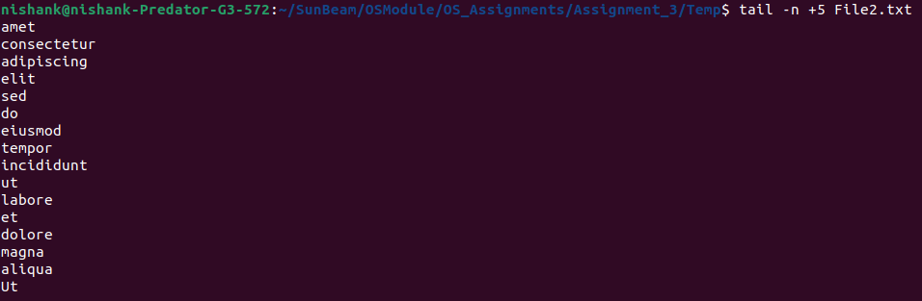

9.init 0, poweroffShutdown (Only for super-user)

Ans:
nishank@nishank-Predator-G3-572:~/SunBeam/OSModule/OS_Assignments/Assignment_3/Temp$ init(0)

10.init 6, rebootReboot (Only for super-user)

nishank@nishank-Predator-G3-572:~/SunBeam/OSModule/OS_Assignments/Assignment_3/Temp$ init(6)

12.whoamiFind current user

Ans:

13.ttyFind current terminal

Ans:

14.who am iFind current user and terminal

Ans: Done with the Command, cannot take screenshot there

15.usersFind all users logged into the system

Ans:

16.whoFind all users logged in and terminals in user

Ans:

17.grep, egrep, fgrep Find a given word/pattern from the file

Ans:

Finding a Word:

Find a pattern (i.e Correct Number)
^([a-zA-Z\d\.-]+)@([a-z]+).(com)$

Email Validation: ClassWork

18.chmodMake a file as read-only

19.chmodMake a file as write, read and execute

20.wc (using redirection)Take input from the file, count words and store output to other file

Ans:

21.who | wc (using pipe)Count words in output of “who” command

22.head, tail (using pipe)Print lines 5 to 10 from the given file

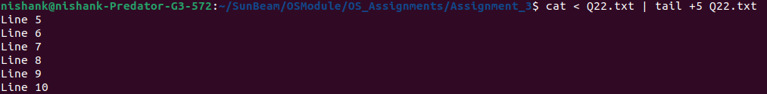

23.sort , uniq (using pipe)Print the uniq values from the unsorted file

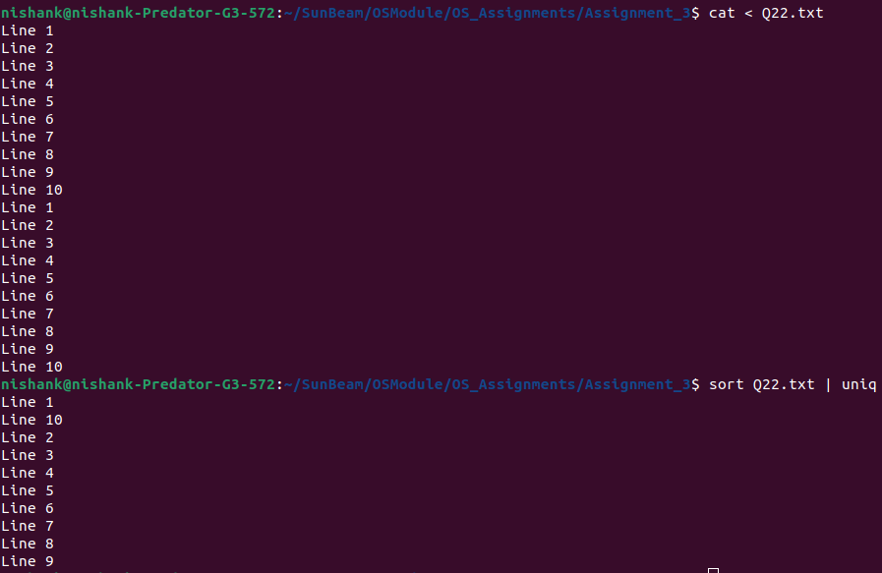

24.who, grep (using pipe)Display all users not using tty2, tty3, tty4

25.lsDisplay all files in ascending order of their file size

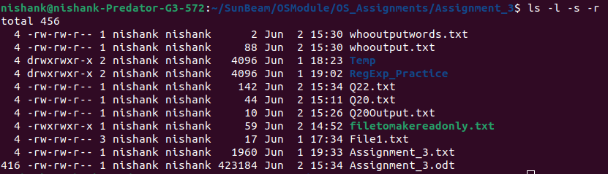

26.ls, grep (using pipe)Count number of files and directories from current directory

27.ls, grep (using pipe)Display only hidden files in a directory

28.trConvert file contents into uppercase , also learn "-s" option of this command

29.cutSplit the file contents using delimiter and print required fields

If there are multiple spaces, then we have to replace the 1 or multiple spaces with a single $

If there is only one Space between each column

