A Wearable Body Awareness Support System for Women Using Temperature Sensing and Generative AI

1. Background and Motivation
Recent advances in wearable technologies, mobile health applications, and artificial intelligence have made it increasingly easy for individuals to collect data about their own bodies. Smartwatches continuously monitor heart rate and sleep, while health applications track physical activity, menstrual cycles, and daily wellbeing. As a result, people today have unprecedented access to personal physiological information.
However, most existing health technologies are still designed around a paradigm of monitoring, analysis, and prediction. Their primary objective is often to improve prediction accuracy, optimize health management, or provide timely recommendations. Although users can obtain large amounts of physiological data, they do not necessarily develop a deeper understanding of what these data mean in relation to their lived bodily experiences. Data can reveal that a change has occurred, but it does not automatically help individuals understand why it happened or how it relates to their daily lives.
This limitation is particularly relevant in the context of women’s health. Menstrual cycles influence various aspects of women’s physiological and psychological states, including body temperature, sleep quality, fatigue, energy levels, and emotional experiences. Among these indicators, body temperature is one of the physiological signals most closely associated with menstrual rhythms. Long-term temperature fluctuations can reveal subtle changes in bodily conditions throughout different phases of the menstrual cycle. Nevertheless, these changes often remain difficult for individuals to perceive directly.
Current FemTech products have successfully utilized temperature sensing and menstrual records to support cycle tracking, ovulation prediction, and health reminders. While these systems are valuable for recording and predicting bodily events, they rarely focus on how users interpret and make sense of their own bodily experiences. In other words, current technologies help people record their bodies, but not necessarily understand them.
At the same time, recent developments in Human-Computer Interaction (HCI) have begun to reconsider the role of artificial intelligence in supporting human reflection. Rather than functioning solely as a provider of answers or recommendations, AI can also act as a conversational partner that encourages users to reflect on their experiences. Emerging research on reflective design and AI-mediated reflection suggests that meaningful questions may be more valuable than direct conclusions in supporting self-understanding.
Inspired by this perspective, this research explores how generative AI can be integrated into women’s body-awareness practices. Instead of providing health advice directly, the proposed system utilizes physiological sensing and AI-generated reflective questions to encourage users to pay attention to bodily changes and gradually develop a deeper understanding of their own physiological rhythms.
Furthermore, this work is motivated by recent explorations of AI as a medium for reflection rather than a provider of solutions, as demonstrated in projects such as Extraheric AI. Building upon these ideas, this research investigates how AI can facilitate dialogue between users and their own bodies through continuous sensing and reflective interaction.

2. Related Work

2.1 FemTech and Menstrual Health Technologies
FemTech research has attracted increasing attention in recent years due to growing interest in women’s health and personalized healthcare. Existing systems commonly employ menstrual tracking, body temperature monitoring, and symptom recording to support cycle prediction and health management. Commercial products such as menstrual tracking applications and wearable sensing devices have demonstrated the potential of physiological data collection in everyday life.
Despite these developments, most existing FemTech systems primarily focus on prediction accuracy and health monitoring. Comparatively less attention has been paid to how physiological data can support body awareness and personal meaning-making. This suggests an opportunity to explore new forms of interaction that emphasize understanding rather than prediction.

2.2 Body Awareness and Somatic Design
Research on Body Awareness emphasizes the importance of developing sensitivity to bodily sensations and internal states. Previous studies have shown that presenting physiological data alone does not necessarily increase body awareness. Understanding bodily conditions requires users to connect objective measurements with subjective experiences and everyday contexts.
Similarly, Somatic Design research argues that technology should not only measure the body but also support people’s ability to experience and interpret bodily changes. From this perspective, physiological data become meaningful when they are integrated into personal reflection and lived experience.
These findings suggest that effective body-awareness technologies should move beyond data presentation and actively support interpretation and reflection.

2.3 Reflective Design and Generative AI
Reflective Design proposes that interactive systems should not merely optimize efficiency but also encourage users to reconsider their experiences and assumptions. Previous research has explored various methods for supporting reflection, including personal informatics systems, body diaries, and retrospective visualizations.
However, many existing reflective systems rely on predefined rules and static feedback mechanisms. Their ability to adapt to individual circumstances remains limited.
Recent advances in generative AI offer new possibilities for reflective interaction. Large language models can generate context-sensitive questions and personalized conversational responses based on user data. Instead of presenting fixed interpretations, AI can encourage users to explore their own experiences through open-ended reflection.
This capability aligns with emerging perspectives that view AI as a facilitator of thinking and meaning-making. In particular, the concept of Extraheric AI demonstrates how AI can support human reflection through questioning, association, and interpretation rather than direct instruction. Inspired by this approach, the present research investigates how AI-generated reflective questions can support women’s understanding of bodily changes.

3. Research Objectives
The primary objective of this research is to develop and investigate a wearable body-awareness support system that combines temperature sensing and generative AI for women.
Specifically, this study aims to address the following research questions:
- Can AI-generated reflective questions increase users’ awareness of bodily changes?
- Can long-term temperature sensing help users recognize recurring physiological patterns associated with their menstrual cycles?
- How can generative AI facilitate the development of body awareness through reflection rather than direct recommendation?
Rather than focusing on improving prediction accuracy, this research emphasizes the process through which users interpret and understand their own bodily experiences.

4. System Design
The proposed system consists of a wearable sensing garment and a mobile application that integrates physiological sensing with AI-supported reflection.
A close-fitting wearable vest is selected as the sensing platform. Compared with conventional wearable devices such as wristbands, the vest provides a more intimate and unobtrusive form factor that can be naturally integrated into daily life. This design reduces the burden of additional device usage while supporting continuous physiological monitoring.
The wearable prototype incorporates two DS18B20 temperature sensors and a XIAO nRF52840 microcontroller. One sensor is positioned near the underarm area to capture body temperature variations associated with menstrual rhythms. Due to its proximity to the body’s core region and reduced exposure to environmental influences, the underarm area provides a more stable measurement location than distal body sites such as the wrist.
The second temperature sensor is positioned on the lateral waist area to measure environmental temperature within the clothing environment. By simultaneously recording body temperature and environmental temperature, the system can better distinguish physiological changes from environmental influences.
In addition to automatically collected temperature data, users can manually record contextual information including menstrual status, sleep quality, fatigue levels, and perceived stress. These inputs provide additional information that helps contextualize physiological changes.
Based on these data, a generative AI module analyzes recent patterns and generates reflective questions. For example, when the system detects elevated temperature levels accompanied by reduced sleep duration, it may ask:
“Your body temperature has been changing more noticeably than usual over the past few days. Have there been any changes in your daily life recently?”
Instead of directly diagnosing causes or providing recommendations, the system encourages users to revisit recent experiences and establish connections between bodily changes and life events.
The overall interaction flow consists of five stages:
Body Sensing → Pattern Identification → AI Reflection → User Reflection → Body Insight
To support this process, four primary interfaces are designed:
- Body Reflection: AI-generated reflective questions as the entry point of interaction.
- Why Did I Ask This?: Visualization of data patterns that triggered the AI question.
- Body Memory: Long-term records of physiological changes and previous reflections.
- Body Insight: Summaries of recurring bodily patterns and reflective findings.
Together, these interfaces shift the user’s attention from reading data toward constructing personal meaning from bodily experiences.
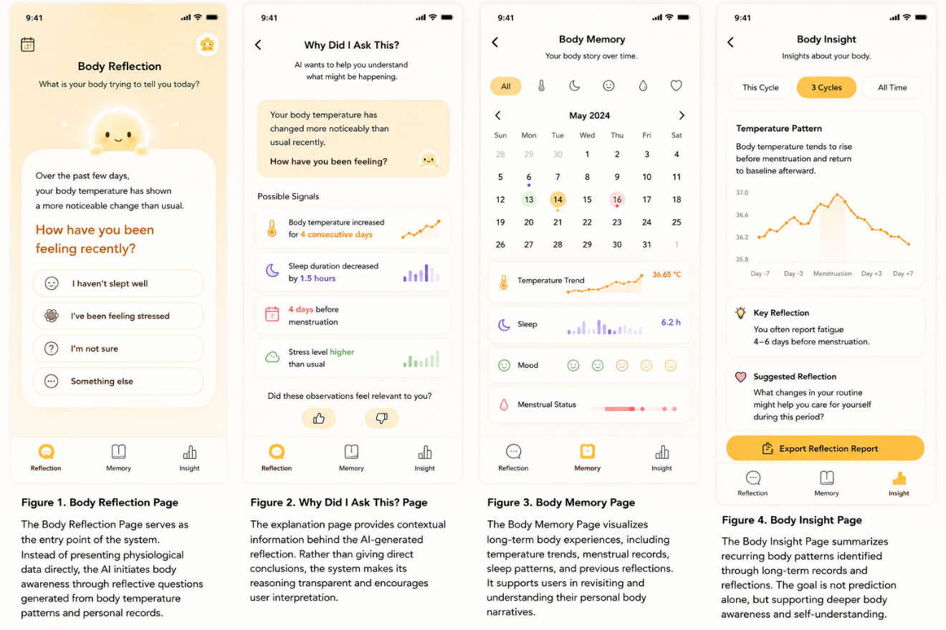
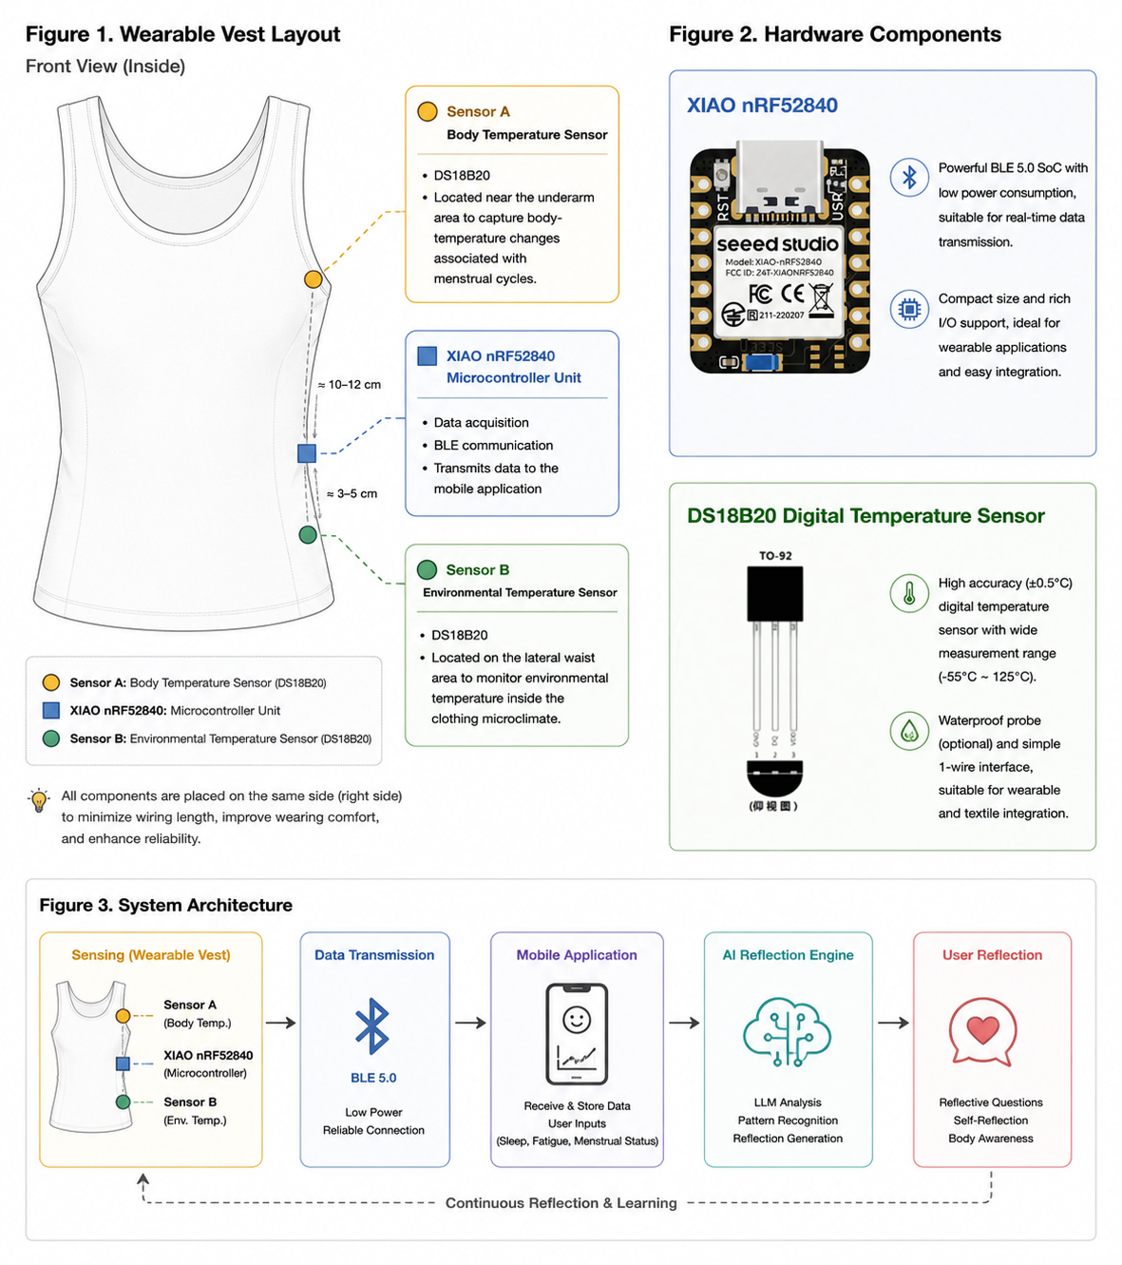

5. Prototype Development
A preliminary prototype has already been developed to verify the technical feasibility of the proposed concept.
The hardware implementation utilizes a XIAO nRF52840 microcontroller and DS18B20 digital temperature sensors. Initial experiments have successfully demonstrated real-time temperature acquisition and stable data transmission. Temperature readings have been validated through Arduino-based testing, confirming the feasibility of continuous temperature monitoring.
On the software side, a high-fidelity mobile application prototype has been created to simulate the complete interaction process, including temperature sensing, pattern identification, AI-generated reflection, user responses, and long-term insight generation.
The generative AI component will be implemented using a large language model (LLM) API. Prompt engineering techniques will be employed to transform temperature patterns, menstrual information, and user-reported experiences into personalized reflective questions.
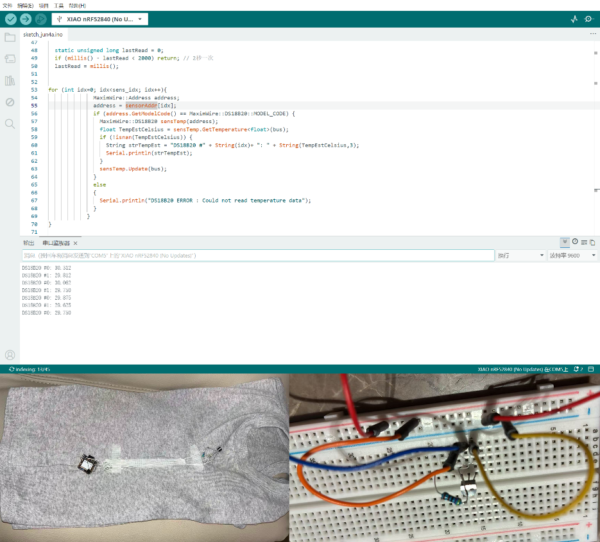
Although the current system remains at the prototype stage, both sensing functionality and interaction workflows have been validated, providing a foundation for future user studies.

6. Research Method and Expected Contributions
Future work will adopt a research-through-design approach combining prototype development and user evaluation.
First, the wearable prototype and mobile application will be further refined to support continuous sensing, data management, and AI-generated reflection. Subsequently, user studies with female participants will be conducted to evaluate the effectiveness of the system.
Qualitative interviews, questionnaires, and interaction logs will be collected to investigate user experiences and body-awareness development over time.
The evaluation will focus on three key questions:
- Whether AI-generated questions increase users’ attention to bodily changes.
- Whether long-term use helps users recognize personal physiological patterns.
- Whether generative AI can support deeper body awareness through reflective interaction.
This research is expected to contribute in three ways.
First, it proposes a FemTech interaction framework that prioritizes body awareness rather than health prediction.
Second, it explores a novel application of generative AI in the context of body awareness, demonstrating how reflective questioning may support the development of bodily understanding.
Third, it presents a wearable system that combines temperature sensing, long-term self-tracking, and reflective interaction, offering design implications for the future evolution of FemTech from health-management tools toward technologies that support bodily understanding and self-reflection.
Ultimately, this research argues that future health technologies should not only help people collect more physiological data but also support them in understanding the meanings behind those data. The value of AI may lie not only in analyzing the body, but also in fostering an ongoing dialogue between individuals and their own bodily experiences.

References
Sengers, P., Boehner, K., David, S., & Kaye, J. J. (2005). Reflective design. In Proceedings of the 4th Decennial Conference on Critical Computing: Between Sense and Sensibility (pp. 49–58). ACM. https://doi.org/10.1145/1094562.1094569
Schiphorst, T. (2011). Self-evidence: Applying somatic connoisseurship to experience design. In CHI '11 Extended Abstracts on Human Factors in Computing Systems (pp. 145–160). ACM. https://doi.org/10.1145/1979742.1979640
Höök, K. (2018). Designing with the Body: Somaesthetic Interaction Design. Cambridge, MA: MIT Press. https://doi.org/10.7551/mitpress/11481.001.0001
Epstein, D. A., Ping, A., Fogarty, J., & Munson, S. A. (2015). A lived informatics model of personal informatics. In Proceedings of the 2015 ACM International Joint Conference on Pervasive and Ubiquitous Computing (UbiComp '15) (pp. 731–742). ACM. https://doi.org/10.1145/2750858.2804250
Yatani Lab. (n.d.). Extraheric AI. Institute of Industrial Science, The University of Tokyo. Retrieved from https://iis-lab.org/research/extraherics/

