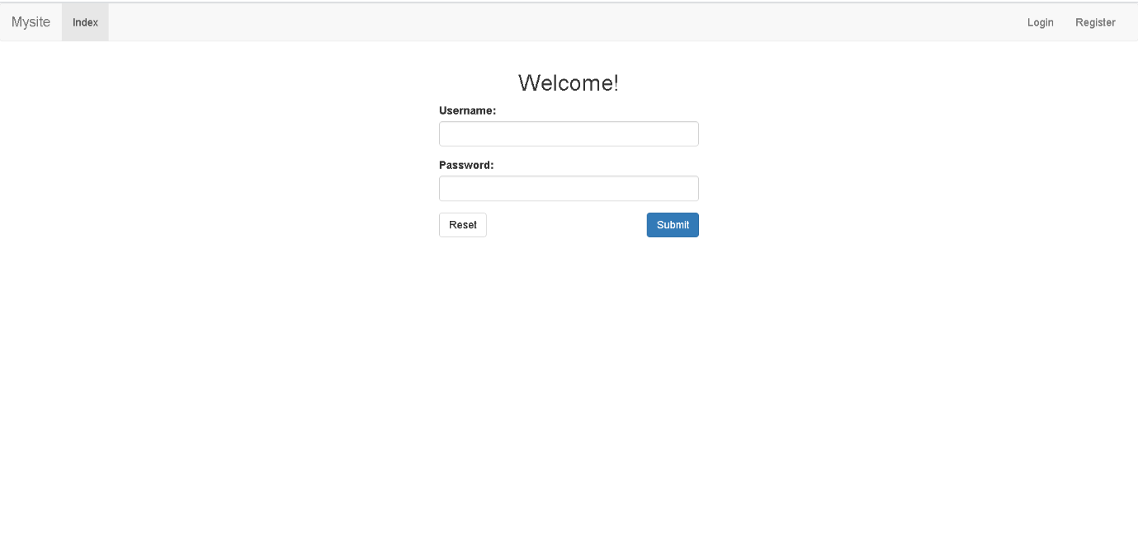

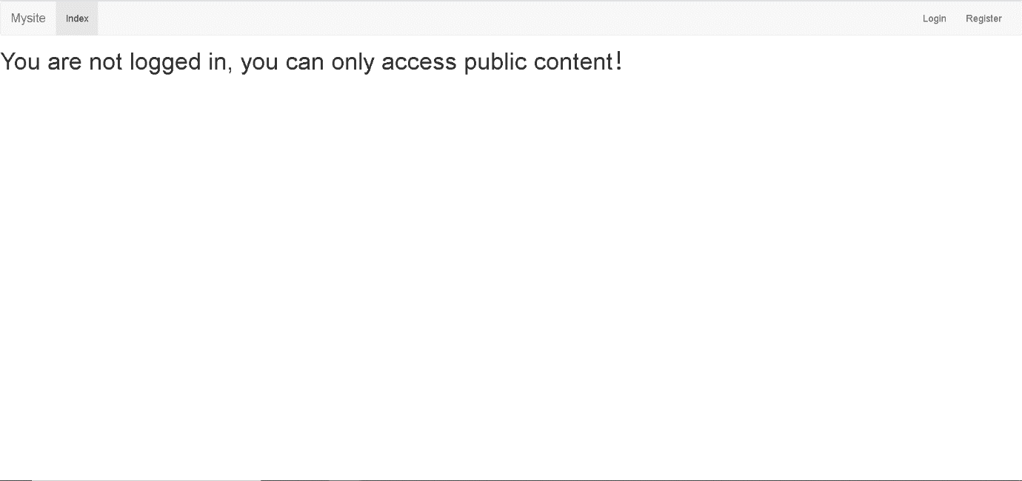
User should login first or they do not have permission to do other things

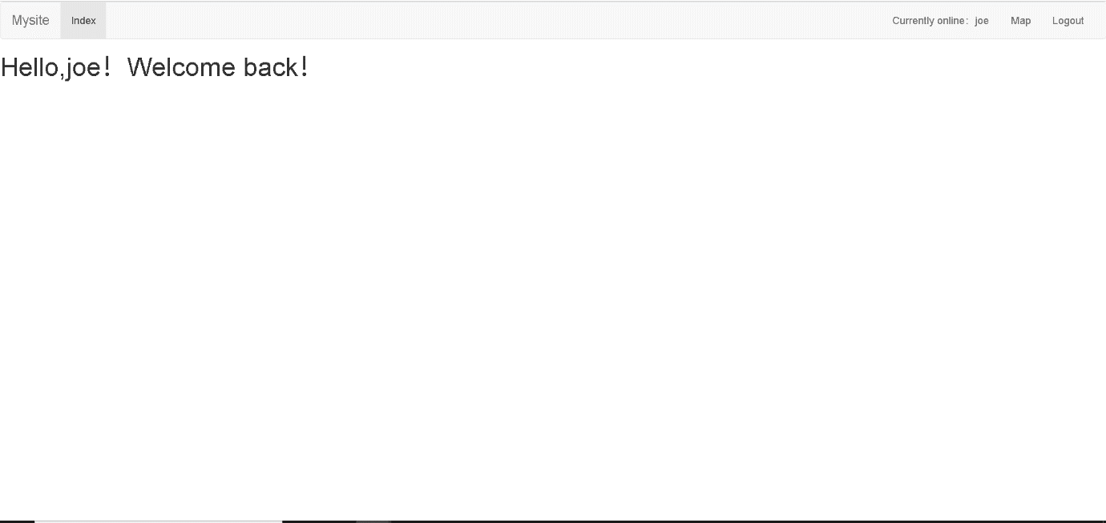

Once user login they could do something about the page.

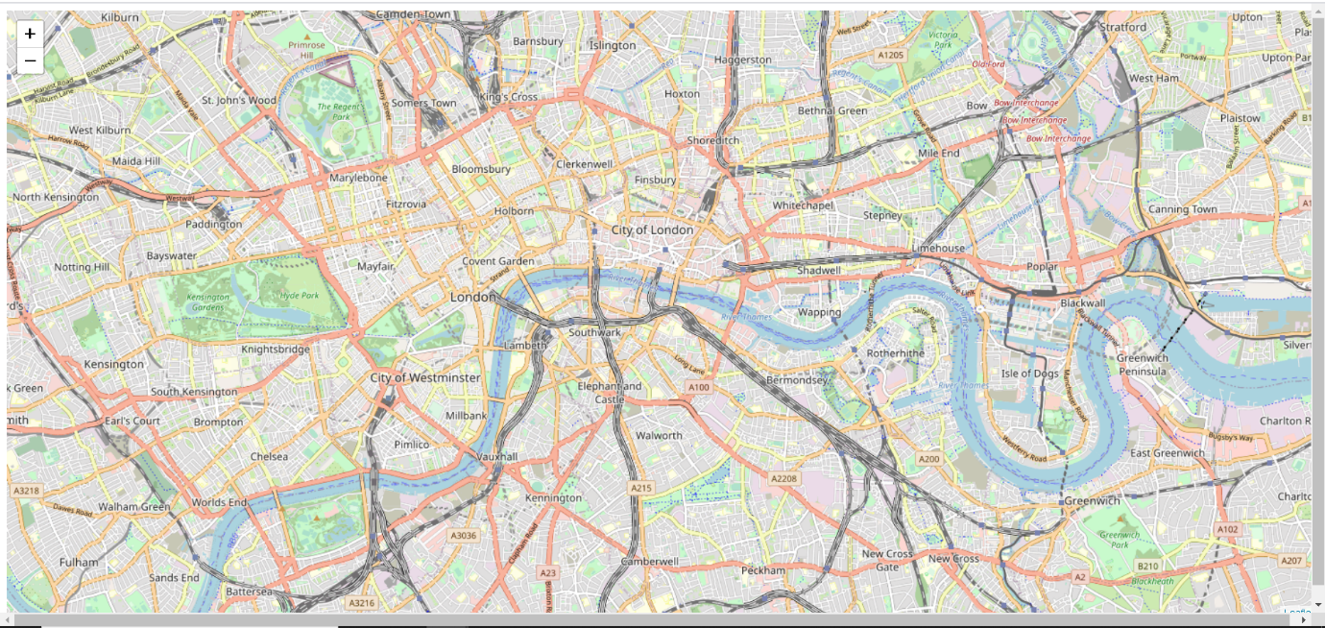

Once user click logout and then the session will be closed.

I did not upload this website to the cloud successfully. There were some errors. I tried it but failed.

