**WebX Exp 3**

**Aim :-**

To develop a basic Flask application with multiple routes and demonstrate the handling of GET and POST requests.

**Code :-**

App.py :

from flask import Flask, request, render_template

app = Flask(__name__)

@app.route('/')

def home():

return render_template('index.html')

@app.route('/submit', methods=['POST'])

def submit():

data = request.form['data']

return f"You submitted: {data}"

@app.route('/get-data', methods=['GET'])

def get_data():

return "This is a GET request response."

if __name__ == '__main__':

app.run(debug=True)

templates/index.html :

<!DOCTYPE html>

<html lang="en">

<head>

<meta charset="UTF-8">

<meta name="viewport" content="width=device-width, initial-scale=1.0">

<title>Flask App</title>

</head>

<body>

<h1>Flask Application</h1>

<form action="/submit" method="post">

<input type="text" name="data" placeholder="Enter some data" required>

<button type="submit">Submit</button>

</form>

<a href="/get-data">Get Data</a>

</body>

</html>

**Output :-**

Landing page Entered data in landing page

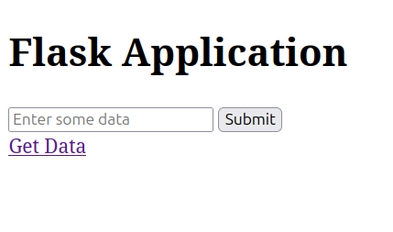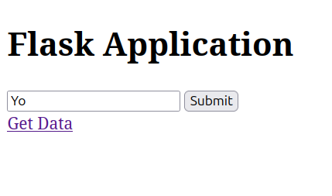

After pressing Submit After clicking Get Data

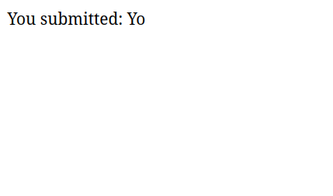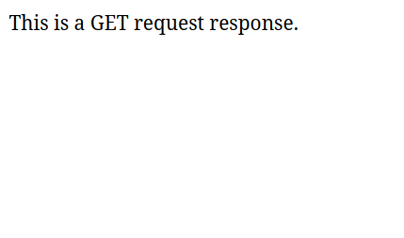

**Conclusion :-**

This basic Flask application demonstrates how GET and POST requests work and are handled, and the same was understood, and performed successfully.