***ASSIGNMENT 1, SUBMISSION 1 – CMPU4063***

***Emma Carolan D17124464 DT9420***

1. **Design (20%) – SUBMISSION 1**
   1. Outline the guidelines that you have used to design your prototype. (at least three discussed with respect to your website, with screenshots included highlighting how these concepts have been included)
      1. Mental models
      2. Metaphors
      3. Gestalt laws
      4. Miller’s chunking
      5. Automatic processing
      6. Learning theories
      7. Nielsen’s heuristics
      8. ….or any other cognitive theories/interface guidelines that you are aware of
   2. Create a *wireframe* of the website.
   3. Create a comprehensive **paper prototype** of your website (a storyboard, or screen prototypes of your website …), for three sizes e.g., iPhone, iPad and MacBook.
   4. Create a *grid* of the website. State whether you are using a grid framework to build your website. Justify your decision.**

**Word Count: 1515**

# INTRODUCTION

I have chosen to design a travel website for the province of Andalucía, Spain where I recently had the pleasure of visiting. This website will endeavour to outline several of my recommended destinations in Andalucía and offer tips in terms of where to visit and where to eat in the form of a blog. I will be including all of my own photos and experiences along with suggested itineraries and daytrips.

# DESIGN GUIDELINES (1a)

I have included the following guidelines to design the prototype for the website:

**ii. Metaphors**

The inclusion of metaphors throughout the design stage will help to attract users and bring a sense of familiarity to the webpage. When using the term ‘metaphor’ in web design this suggests real life on the web. Bringing real life to web design aims to make the user feel more comfortable and improves user experience. Buttons are an example of metaphors as they are something that happens in the outside world and the user knows what to expect when pressed or clicked. The website includes a submit button on the contact page and a back to top button on larger screens. The aim is that the user will be able to interact with the button instinctively as they would in the real world.

Icons are also another form of metaphor when it comes to web design and this website will contain social media icons for Facebook and Twitter which will be familiar to the user and which will also be clickable which the user will be accustomed to. The user will expect these icons to be at the top right of the larger screen and at the bottom of the mobile screen which will be implemented in the website in order to adhere to the familiarity and expectation of the user. This also is part of the mental model of the user in terms of visual expectation. In addition, the position of the nav bar is part of the mental model of the user and is therefore placed on the top of the larger screen and in a column format on the mobile screen. The design of the larger pages displays the written content on the left and the Google Map on the right in order to be in line with user expectation of left to right which would be common in the western world. If the website was aimed at the middle eastern market for example this might be designed from right to left.

**iii. Gestalt Laws**

Gestalt laws are very important in user interface design and the core principle is that visual perception of a user is determined by psychology. The human mind likes commonality and groups and structure and the mind can inform the eye by making sense of certain elements and seeking order. The **Figure-Ground** principle suggests that a user will differentiate between a foreground and a background and therefore subconsciously informing the user what they should be focusing on. In the design of this website the main image is a background image with a title and the user will instinctively know to focus on the content which is contained in boxes with a white background. The **Similarity** principle suggest that the user will group items together that appear similar to one another and will also see them as having the same function. This principle is invoked on the website through use of colour where the main content of the website is distinct from the header and footer of the website and therefore serves a different function. The user will also link similar elements using this principle and the use of a blue text and link is included at the end of each content where the user can click for further information. These links will be grouped by the user and identified as all having the same function. The **Proximity** principle also is used in the design of this website and states that where items are closely placed, they are more related than if they were further apart. The content posts of the website are placed in boxes which are grouped together with a map in a different column and the user will automatically relate these items to each other based on this principle.

**iv. Millers’ chunking**

Millers chunking is a method of designing a layout so as to help aid cognitive overload of the user. As such, content is presented in a manageable way and involves the grouping of data together. Chunking refers to a theory put forward by Miller which suggests that a person could only remember 5-9 chunks of information, 7 plus or minus 2. Using the chunking theory as an aid to design a website doesn’t refer to the simplification of the design but rather to facilitate the way the user processing the information or content.

This website aims to use a few features which are based on chunking in order to aid information processing for the user. This will also increase the chances of the content being read by the user.

Content on the home page will be broken up into sections with individual headings and only containing one or two main points per paragraph. Images will be captioned as it is shown that users are likely to read these and thus engage in the content. Links will be added in order to allow the user to go back to the top or the page. In addition, a ‘read more’ link will be added to the end of chunks of content or paragraphs so that the user can then choose to select these and find out more about the topic. These links will bring the user to a separate page, thus chunking and grouping the content further.

# WIREFRAME (1b)

## Wireframe for iPhone

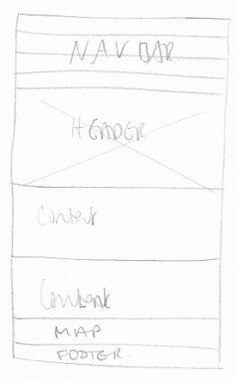

## Wireframe for iPad

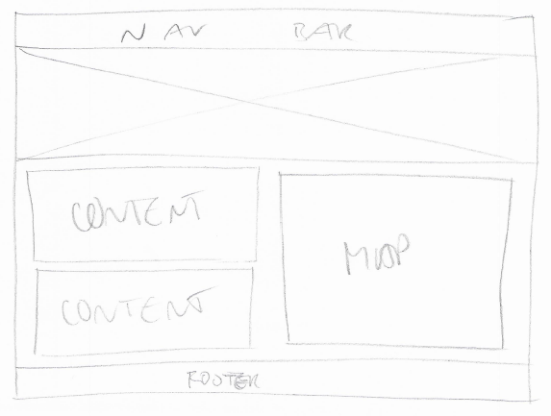

## Wireframe for Macbook

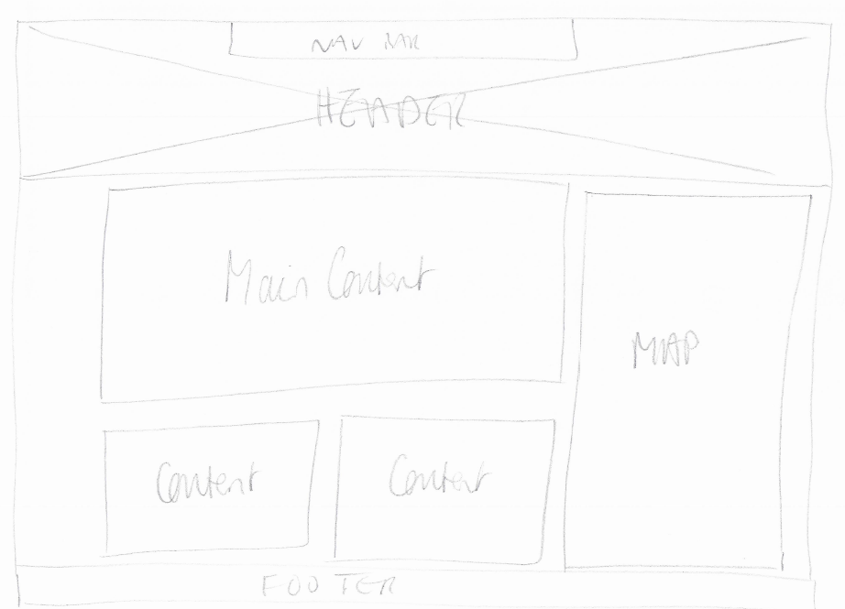

# PAPER PROTOTYPE (1c)

The following prototypes are for 3 different pages of the website – the Home Page, a Destination Page and the Contact Page. Certain items are in more suitable positions on the iPhone compared to larger screen for example the navigation bar is column based on smaller screen and Facebook and Twitter buttons have been moved.

## Prototypes for iPhone

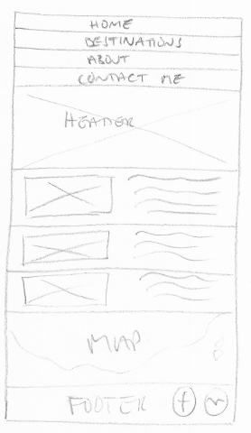 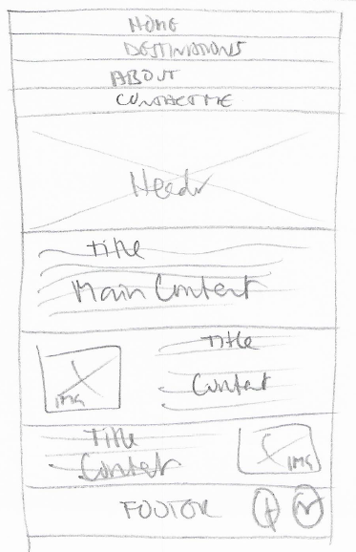

**iPhone - Home Page** **iPhone - Destination Page**

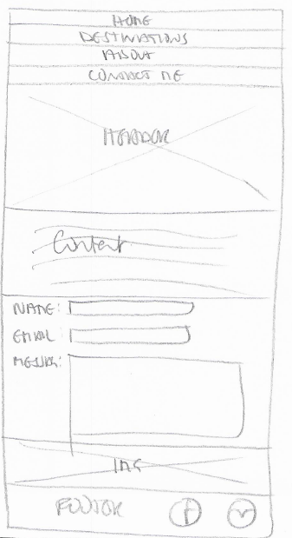

**iPhone - Contact Page**

## Prototypes for iPad

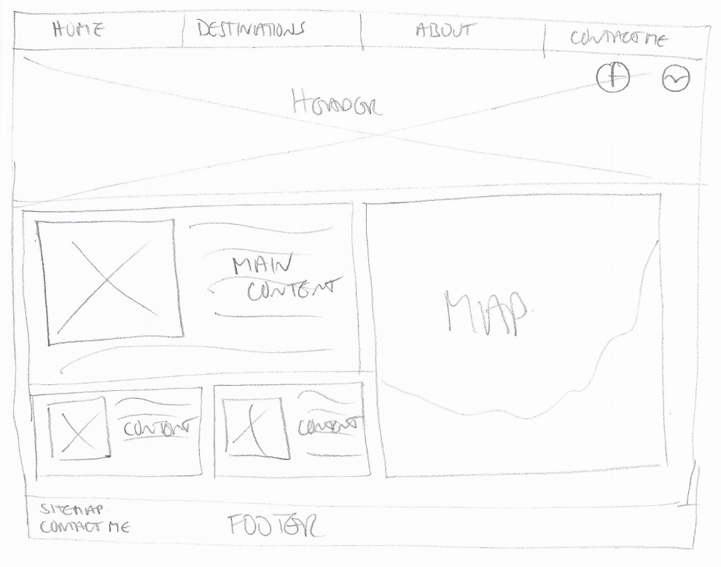

**iPad – Home Page**

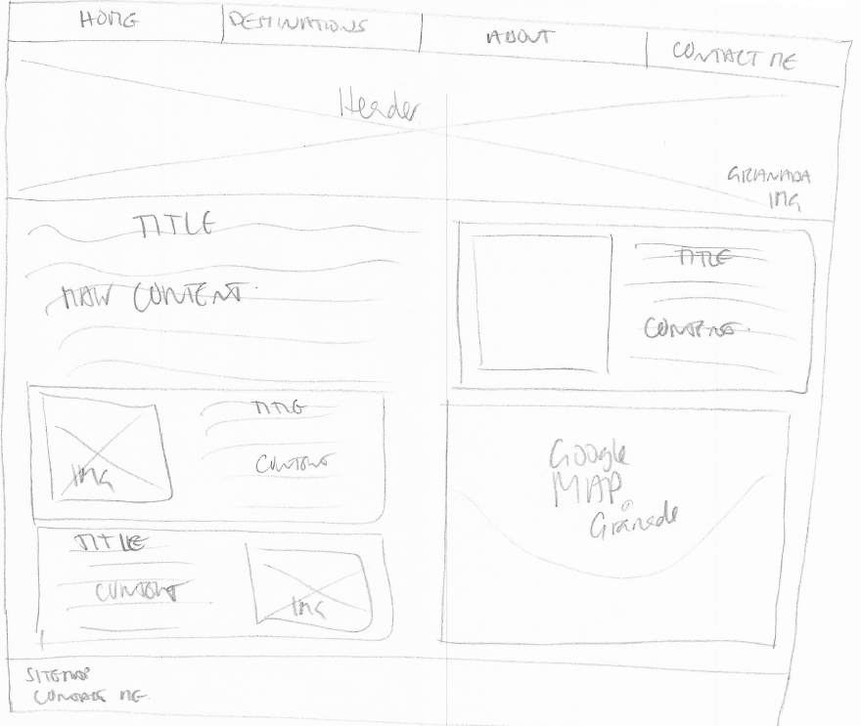

**iPad – Destination Page**

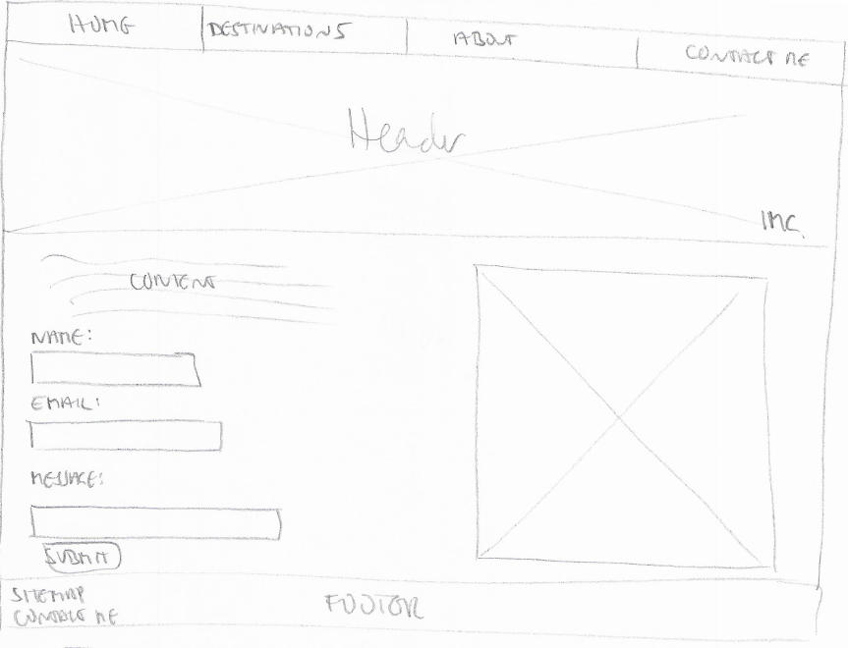

**iPad – Contact Page**

## Prototypes for Macbook

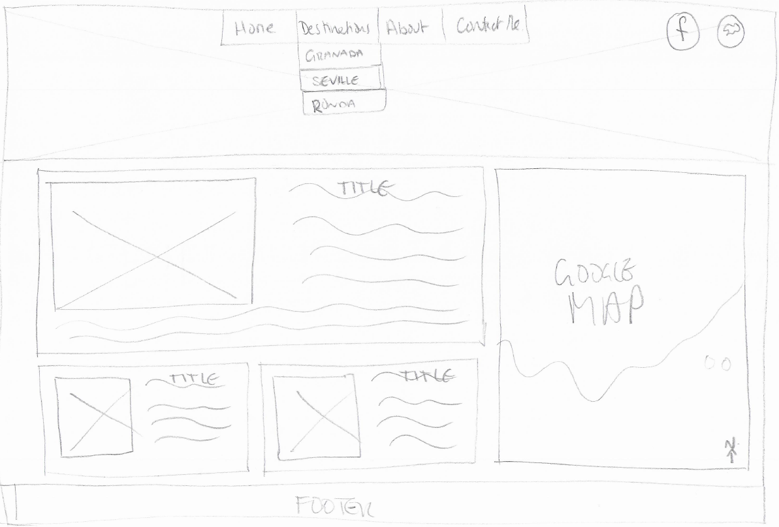

**MacBook – Home Page**

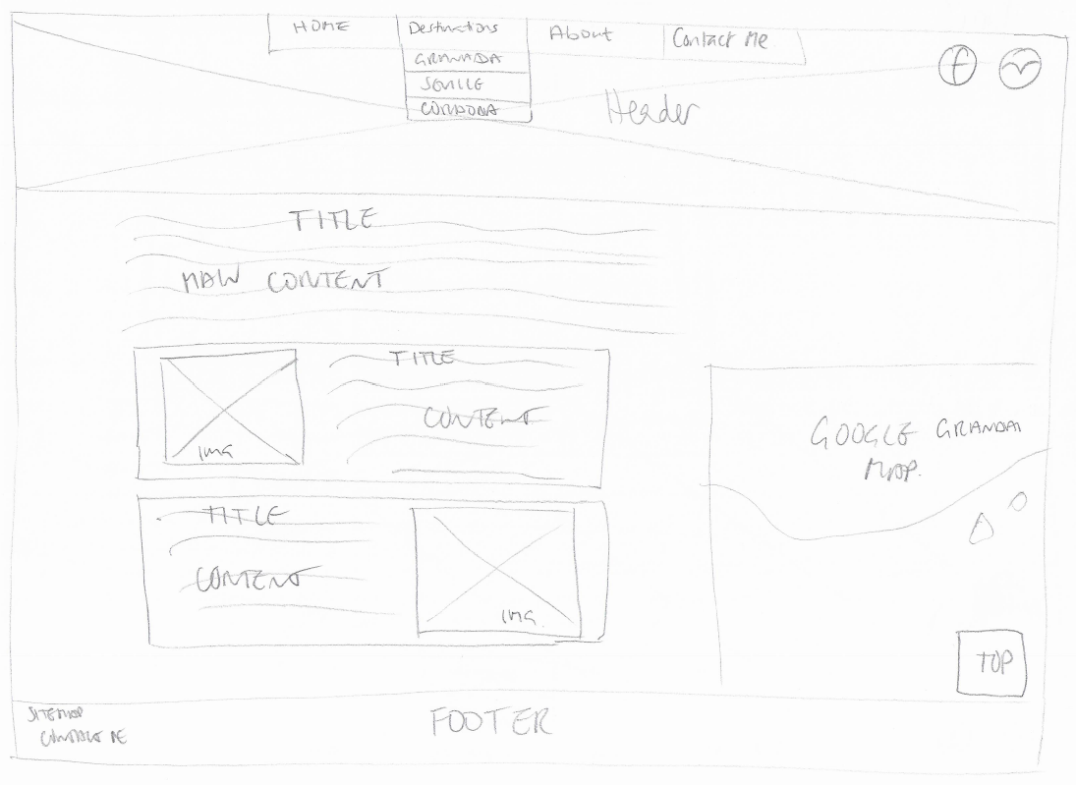

**MacBook – Destination Page**

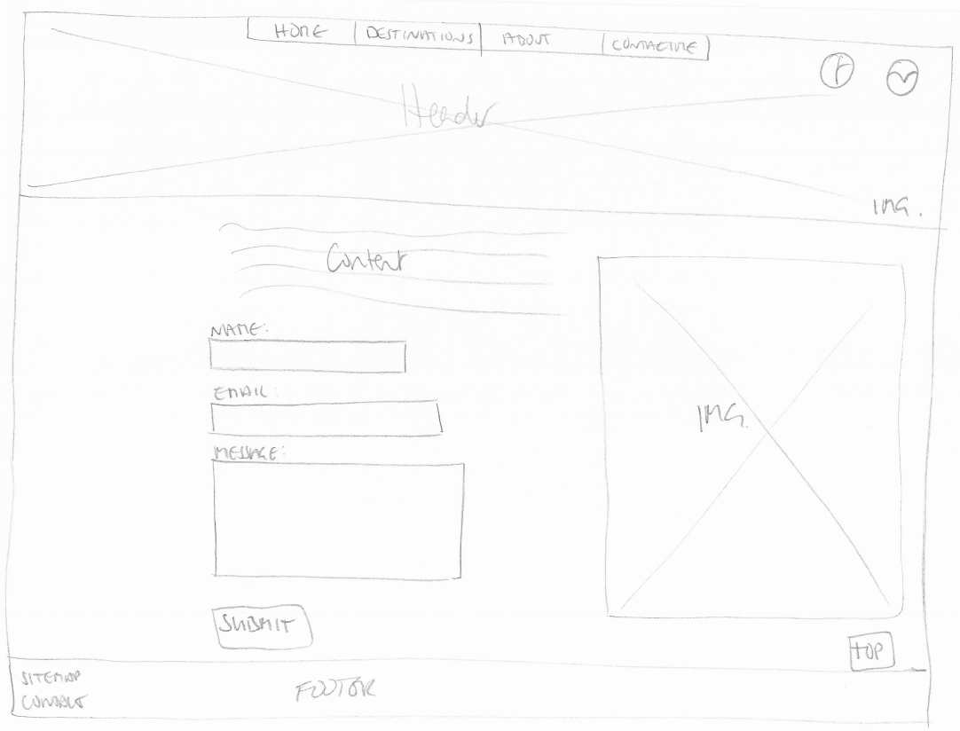

**MacBook – Contact Page**

# GRID (1d)

I have chosen to use CSS Grid in order to display the website, as opposed to a Grid Framework such as Bootstrap or Skeleton. CSS Grid is a relatively new CSS Layout is an inbuilt functionality within CSS. There are several advantages to using CSS Grid by comparison to Bootstrap, which is based on Flexbox. CSS Grid sees things in two dimensions, rows and columns, whereas Flexbox sees rows only. CSS Grid allows rows and columns to be defined in the CSS as opposed to the markup which means a lot less code in the html when using CSS Grid. Bootstrap is designed based on 12 columns which allows for many divisions, however CSS Grid does not limit or define columns and they can be designed as required. In addition, Bootstrap has to be downloaded by users and CSS Grid is provided as an inbuilt functionality. It is not necessary to amend the html markup in order to allow for responsiveness in a website with CSS Grid as this can be done via media queries in the CSS. Moving the order of divs is also very flexible with CSS Grid and can be done with very little code. However, there still is a place for Flexbox and I still plan to use flexbox when required throughout the layout which I will discuss in the final report, but the overall layout will be primarily based on CSS Grid.

In addition, I have chosen CSS Grid having researched the benefits of CSS Grid by following tutorials by Jen Simmons and Rachel Andrews who are advocates of this layout. The inbuilt layout provides everything needed to define the desired layout and requires minimal layout in the html markup. I have therefore also decided not to use other frameworks such as Responsive Grid or Skeleton as CSS Grid is powerful enough so as to be able to design a responsive grid for this website directly using this layout.

The grid for the main homepage on a MacBook currently contains 3 rows and 3 columns, as outlined below in the Grid image. This means the rows and columns are numbered from 1 to 4. I have chosen to use 3 columns and rows so as to use the “Rule of Thirds” which draws the users’ eye. As referred to previously, this also brings some similarity to the user and is a familiar layout for the user. The number of rows will most likely be increased throughout the project but this is the current grid structure. The grid for the iPad will be 2 columns thus dividing the page into 2 while the grid for the iPhone will just be one column.

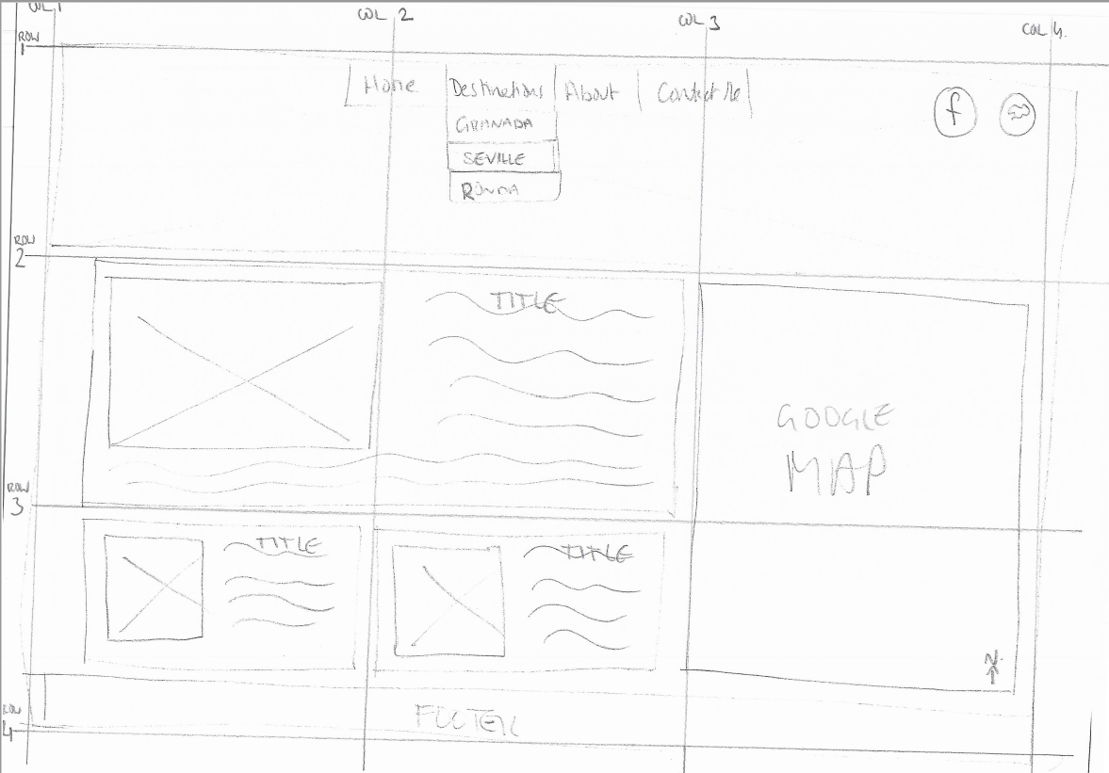

**Grid Layout using CS Grid**

# CONCLUSION

The initial CSS Grid design will be based on 1 column with media queries to amend this for larger screens, both the iPad and MacBook. The design of the prototype may be amended as the project evolves while aiming to stick the core principles of the design.