Deployment instructions

1. Download the zip file from brightspace call workspace.zip and unzip this file.

Recommended deployment process: Back-end -- Database -- Front-end

Front-end:

1. Open the command line and display it to the react-admin_client directory through the cd command.
2. Enter ‘npm install’ start to download related packages.

D1

1. After finish the install, enter ‘npm start’ to start the front-end of this project.

D2

1. When the front-end is successfully compiled, it will automatically open the browser to display the webpage, the port number is 3000.

Back-end:

1. Open the command line and display it to the react-admin_server directory through the cd command.
2. Enter ‘npm install’ start to download related packages.

D3

1. Before start the server, make sure the mongodb service has been started.
2. After finish the install, enter ‘npm start’ to start the back-end of this project.

D4

1. When the back-end is successfully compiled, it will automatically create a database in mongodb called lego_repo, this database will have three collections called categorys, sets, users, the port number is 41571.

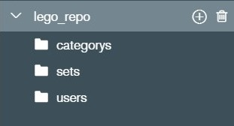

Database:

1. Use MongoDBCompass to add data by import json fail, open the MongoDBCompass and connect to the localhost:27017.
2. After start the back-end server, it will automatically create a database in mongodb called lego_repo, open this database it will have three collections.
3. The first collection called catagorys, select add data, import file.

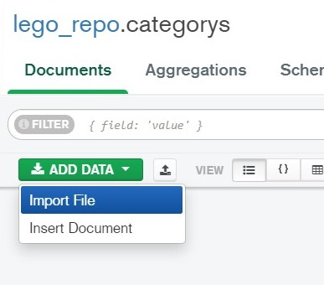

1. Select the file which I provided called catagorys.json and choose JSON type, import it and the category data will be imported.

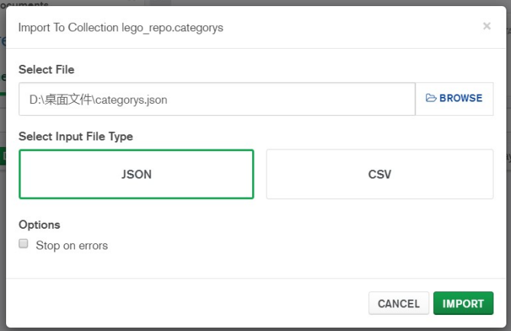

The data will looks like this.

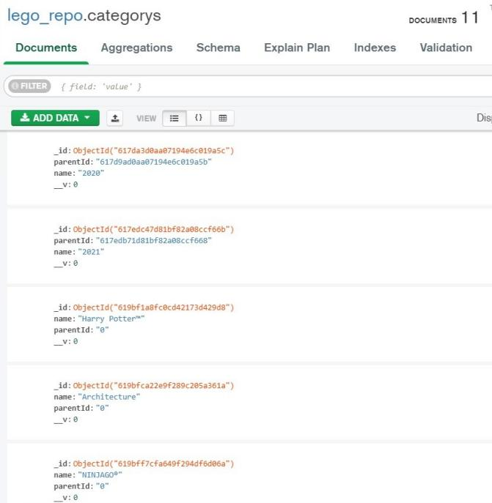

1. Import sets.json and users.json according to the same steps as above 13 -14.
2. Refresh the web page and you can see the data at this time.