GHANA COMMUNICATION TECHNOLOGY UNIVERSITY

FACULTY OF COMPUTER AND INFORMATION SYSTEMS
DEPARTMENT OF INFORMATION TECHNOLOGY

CICS 371: INTERNET TECHNOLOGY AND WEB DESIGN

PROJECT TITLE

STUDENT WEBS – EDUCATIONAL SUPPORT WEBSITE

PROJECT BY

DANIEL OSEI BOAHENE
1703189225

BSc. INFORMATION TECHNOLOGY
LEVEL 300 – GROUP B (MORNING)

DR. WILLIAM BROWN-ACQUAYE
(LECTURER)

6TH JANUARY, 2026

TABLE OF CONTENTS

Title Page ........................................................................ i
Table of Contents ............................................................... ii

CHAPTER ONE: INTRODUCTION ........................................ 1
1.1 Background of the Study ........................................ 1
1.2 Objectives of the Project ........................................ 2
1.3 Scope of the Project ................................................ 3

CHAPTER TWO: WEBSITE PLANNING AND DESIGN
2.1 Website Overview .................................................. 4
2.2 Site Map Design ...................................................... 5
2.3 Page Structure ........................................................ 6

CHAPTER THREE: DEVELOPMENT AND IMPLEMENTATION
3.1 Development Process ............................................. 7
3.2 Description of Website Pages .................................. 8
3.2.1 Home Page ............................................................ 8
3.2.2 About Page ......................................................... 9
3.2.3 Courses Page ......................................................... 10
3.2.4 Resources Page ...................................................... 11
3.2.5 Contact Page ......................................................... 12

CHAPTER FOUR: TOOLS AND TECHNOLOGIES USED
4.1 Development Tools ................................................. 13
4.2 Hosting Platform ..................................................... 14

CHAPTER FIVE: CHALLENGES AND SOLUTIONS
5.1 Challenges Encountered ......................................... 15
5.2 Solutions Implemented ........................................... 16

CHAPTER SIX: CONCLUSION
6.1 Summary and Conclusion ...................................... 17

Website URL: https://studentwebs.gt.tc

CHAPTER ONE
INTRODUCTION
1.1 Background of the Study

The rapid advancement of digital technology has transformed the way students access educational resources. Online learning platforms provide flexible and convenient access to academic materials, enabling students to study independently beyond the traditional classroom environment.

The STUDENT WEBS website was developed as an educational support platform designed to assist students in Ghana with learning materials, academic guidance, and access to reputable online educational resources. The website aims to promote independent learning and improve academic performance through easily accessible digital content.

1.2 Objectives of the Project

The main objective of this project is to design and implement an educational website for students. The specific objectives include:

Designing a user-friendly, multi-page educational website

Providing access to academic subjects and learning resources

Supporting students with study tips and educational guidance

Implementing a responsive design for all screen sizes

Demonstrating front-end web development skills using HTML, CSS, and JavaScript

1.3 Scope of the Project

The scope of this project covers the design, development, and deployment of a five-page static educational website. The website includes Home, About, Courses, Resources, and Contact pages. There is no backend system or database; all content is presented statically using HTML, CSS, and JavaScript.

CHAPTER TWO
WEBSITE PLANNING AND DESIGN
2.1 Website Overview

The STUDENT WEBS website was planned to provide a simple and structured learning platform for students. The design emphasizes clarity, ease of navigation, and accessibility. A Ghana-themed color scheme was used to reflect national identity and create a familiar learning environment for Ghanaian students.

2.2 Site Map Design

The site map illustrates the navigation structure of the website. The Home page serves as the main entry point and links to all other pages.

Navigation Structure:

Home (index.html)
│
├── About (about.html)
├── Courses (courses.html)
├── Resources (resources.html)
└── Contact (contact.html)

Figure 2.1: Site Map of the STUDENT WEBS Website
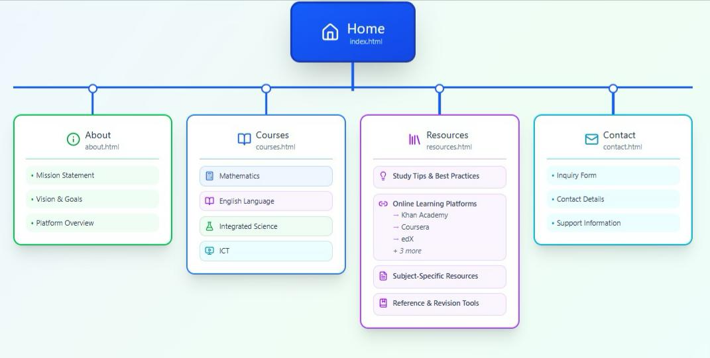
2.3 Page Structure

Each page of the website follows a consistent structure to enhance usability:

Header: Website title and navigation menu

Main Content: Page-specific educational information

Footer: Copyright information

This consistency ensures a smooth user experience across all pages.

CHAPTER THREE
DEVELOPMENT AND IMPLEMENTATION
3.1 Development Process

The website was developed using a manual coding approach. The development process involved planning page layouts, writing HTML content, styling pages with CSS, implementing basic interactivity using JavaScript, testing responsiveness, and deploying the website.

3.2 Description of Website Pages
3.2.1 Home Page

The Home page welcomes users to the STUDENT WEBS platform. It provides an overview of the website’s purpose and highlights the key educational services offered.

Figure 3.1: Home Page of the STUDENT WEBS Website
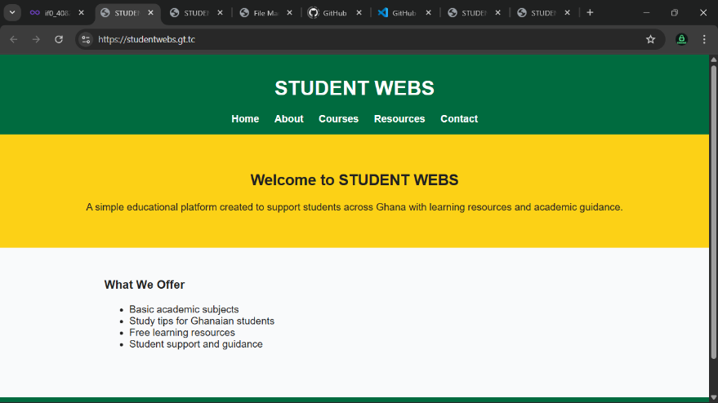
3.2.2 About Page

The About page presents information about the platform, including its mission, vision, and educational goals.

Figure 3.2: About Page of the Website
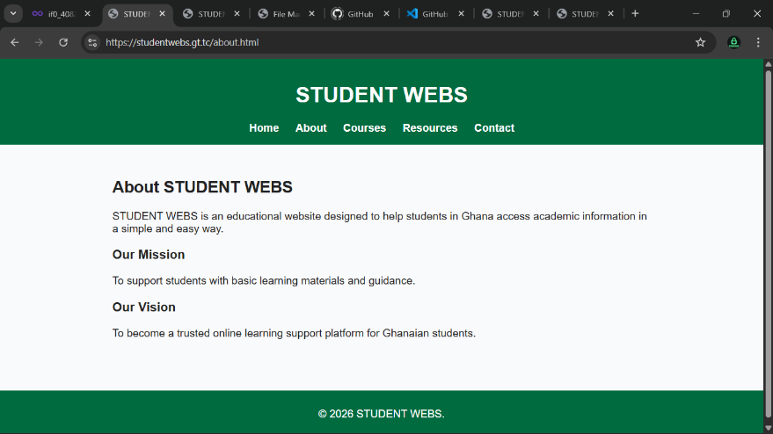
3.2.3 Courses Page

The Courses page displays academic subjects such as Mathematics, English Language, Integrated Science, and ICT. Each course includes a brief description and links to external learning resources.

Figure 3.3: Courses Page of the STUDENT WEBS Website
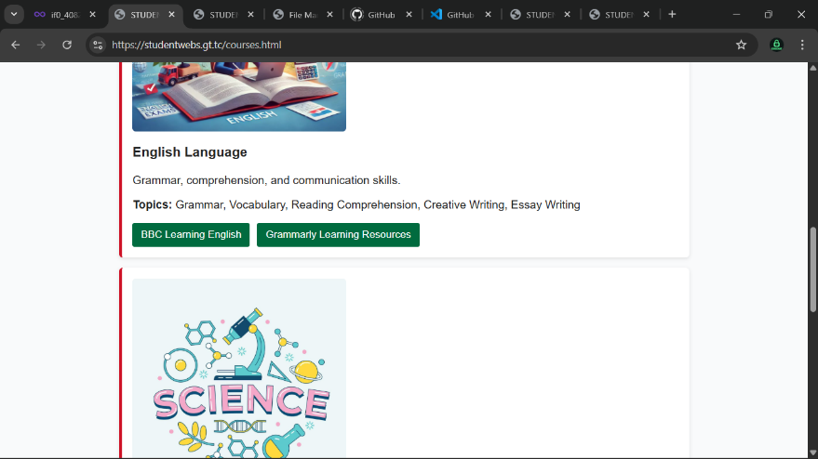
3.2.4 Resources Page

The Resources page provides a comprehensive list of study tips, online learning platforms, and reference tools to support student learning.

Figure 3.4: Resources Page of the STUDENT WEBS Website
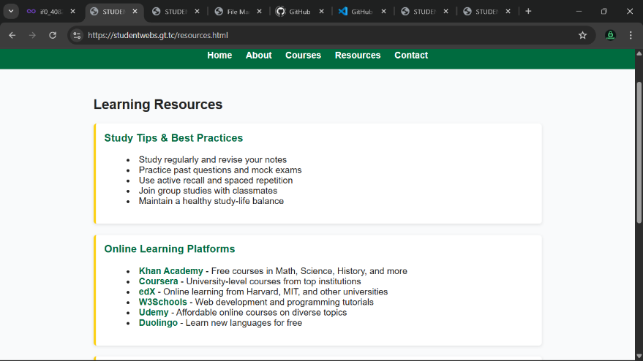
3.2.5 Contact Page

The Contact page allows users to communicate with the website owner through a contact form. The form includes validation and displays a success message upon submission.

Figure 3.5: Contact Page of the STUDENT WEBS Website
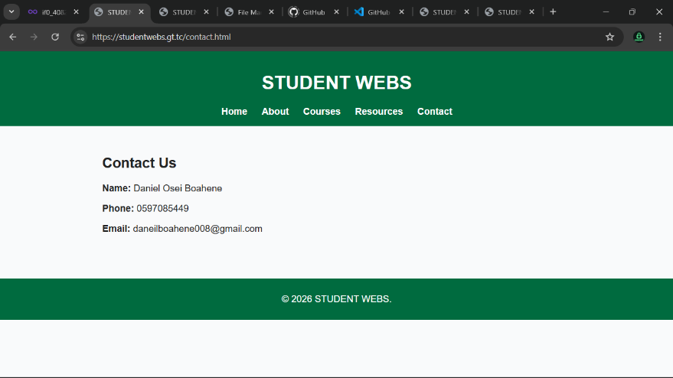
CHAPTER FOUR
TOOLS AND TECHNOLOGIES USED
4.1 Development Tools

HTML5: Used for structuring website content

CSS3: Used for styling and responsive layout

JavaScript: Used for form validation and basic interactivity

4.2 Hosting Platform

The website was hosted on InfinityFree, where all website files were uploaded and made publicly accessible.

Figure 4.1: InfinityFree Hosting Control Panel
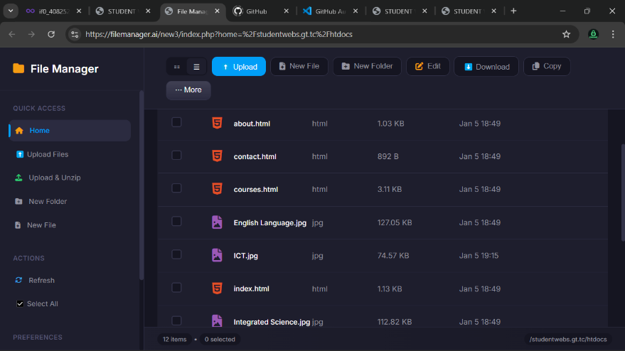
CHAPTER FIVE
CHALLENGES AND SOLUTIONS
5.1 Challenges Encountered

Organizing large amounts of educational content

Ensuring responsiveness across various devices

Linking to multiple external educational resources

5.2 Solutions Implemented

Structured content into clear sections and pages

Used responsive CSS techniques and media queries

Carefully tested and validated all external links

CHAPTER SIX
CONCLUSION
6.1 Summary and Conclusion

The STUDENT WEBS website was successfully designed and developed as an educational support platform for students in Ghana. The project achieved its objectives by providing organized academic content, learning resources, and study guidance in a user-friendly manner.

The website demonstrates effective use of HTML, CSS, and JavaScript and provides a strong foundation for future enhancements such as interactive learning features and backend integration.

