**DORRDASH ROBO DASHER PRD**

Contents

1. Background 2

2. Problem 2

3. Goals 3

4. Key features and Scope 3

5. Success Metrics 4

6. Core UX Flow 5

7. Target user 5

8. Total Addressable Market – TAM 6

9. COMPETITORS 7

10. Acquisition Channel Strategy 7

11. Marketing Strategy 8

12. Pricing Strategy 8

13. Prelaunch Checklist 9

14. Risk and Risk Management 9

15. Training Guide 10

16. User Guide 10

17. Post-Launch Iteration 10

18. A/B Testing 11

# Background

Over the years , there use of robots to aid manufacturing started, the assembly line and further automation advancement has led to the development of service robots to cater for various needs ranging from Domestic – Industrial, Simple task to Complex/specialized ones , Home – Medical surgeries.

Service robots powered with AI, OpenCV, and computer vision aided by advancement in deep learning. Service robots have been able to perform logistics, transportation, delivery and haulage, perform human-level intelligent decisions.

This has created an opportunity to improve automation in their process.

# Problem

Small deliveries has always been an economic and operational tussle for Food delivery.

Customers would rather go get the items themselves when they consider the delivery fee they would be charged for the item.

Human Dashers would rather not take the dash order because there is a chance they would not get a fair enough tip for their effort.

Some restaurants would rather decline this small orders when they consider the commission value.

These problems exist for our competitors in the same market and with rapid advancement in autonomous movement and robotics, an opportunity lies where we could solve this issue using Robots as dashers for small deliveries (Robo-Dasher).

This would in-turn translate in lower operating cost in delivering small order, higher amount of small orders would be places, further market share capitalization.

# Goals

* Develop mechanical build of Robots capable of delivery with Partner Company.
* Develop app to:

Allow robot deliver autonomously using sidewalks as travel path

Allow human control of robot in certain case

Allow robot interface with Customers

Allow Humans make Robo-dasher a choice delivery method

* Increase the number of small orders

# Key features and Scope

|  |  |  |
| --- | --- | --- |
| Priority | Feature | Description |
| P0 | Sign-in with employee ID | The users are in the operations team of Door dash. The expectation is that they hold a valid company email ID or employee ID, which they can use to login to this app |
| P0 | List of all tasks in the main menu | There must be a main menu that shows the list of all tasks that the operations team can do using this app.  Organized list would help them go directly to the required pages. |
| P0 | Check status of delivery | Operator must be able to enter just the customer’s registered email ID or phone number to retrieve the status of the active order of a customer. |
| P0 | Track status of the dasher delivering the active order | The operator must be able to track the exact position of the robot dasher who is delivering a particular order. He should also read the estimated time of arrival at the destination. |
| P1 | Track live status of the robot (that is delivering an order) on a map | The operator must be able to view the current position of the robot dasher in a map and could see the live update as and when the robot is moving. |
| P2 | Direct link to ‘IT Support’ in login page | There must be a direct link from login page to connect to ‘IT Service’ department, in case of any issues with logging in.  This feature is not very critical to be in the software and the user can directly call the IT support. However, this can be considered as a P2 priority feature that can be implemented later. |
| P1 | Control Route guidance of the robot delivering an order | From the tracking status of a robot dasher, the operator would be able to control the robot  To change its route guidance |
| P2 | Add a new job in the queue of the robot delivering an order | From the tracking status of a robot dasher, the operator would be able to control the robot   * To add a new job into its queue |
| P2 | Read logs from robot delivering an order | From the tracking status of a robot dasher, the operator would be able to control the robot   * To read its error logs |
| P3 | Enter user feedback for a particular order | * From the tracking status of a robot dasher, the operator would be able to enter user’s / customer’s feedback for that particular order |
| P1 | Track status of any dasher | From main menu, operator should be able to track the status (job status/location) of any robot dasher by inputting the unique ID of the dasher |
| P2 | Assign job to robots | From main menu, operator should be able to assign a job to any robot dasher. He can input Restaurant ID and can search for all robots nearby. On clicking any robot, he can assign a job to that robot. He can sort the list of robots using its ‘distance to Restaurant / job status / battery status’ |
| P1 | Control robots (Route guidance) | From main menu, operator should be able to control any robot dasher. He can input the robot ID and can  change its current route, if it’s active on a job |
| P2 | Direct link to ‘IT Support’ in login page | There must be a direct link from login page to connect to ‘IT Service’ department, in case of any issues with logging in.  This feature is not very critical to be in the software and the user can directly call the IT support. However, this can be considered as a P2 priority feature that can be implemented later. |
| P1 | Control robots (Manual guidance) | From main menu, operator should be able to control any robot dasher. He can input the robot ID and can   * Guide manually by pulling it over on the side street |
| P1 | Control robots (control power) | From main menu, operator should be able to control any robot dasher. He can input the robot ID and can   * Control power of the robot |

# Success Metrics

* Increase the amount of small orders.
* Improve ease to order and quicker delivery time
* Improve app rating to greater than 4

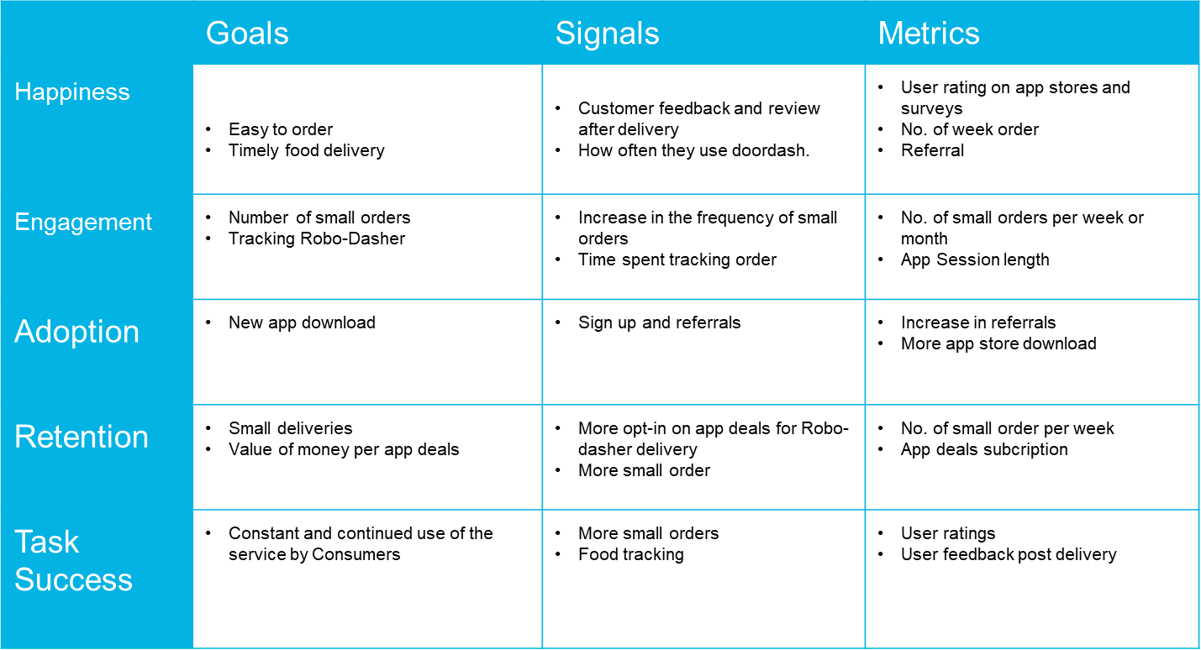

# Core UX Flow

Mocks

Storyboard

[Prototype version 1](https://www.figma.com/proto/aPczb1pO39frce23PLXj9r/ROBO-DASHER?node-id=13%3A631&scaling=scale-down&page-id=0%3A1&starting-point-node-id=2%3A286)

[Prototype version 2](https://www.figma.com/proto/474Zqi9gBJu94ix00xPIFX/ROBO-DASHER---V2?node-id=13%3A631&scaling=scale-down&page-id=0%3A1&starting-point-node-id=2%3A286)

# Target user

The direct users of this product is our DoorDash operators who would be able to assist our actual customers track, route the Robo-Dasher and also manually control the Robo-dasher. However the target users in the long run , are DoorDash customers who have order and are in need of a this product

# Total Addressable Market – TAM

With a planned roll out in San Francisco CA, we have estimated the ‘TAM” for the rollout phase as:

**Top-Down TAM:**

SF Population: 883,255

Estimated Homeless Population: 8838

Homeless population in 2019: 8,035

With the average rate of increase over the past 4 years @10%

Average amount spent on food delivery per buyer per year: 579.76$

**TAM calculation (Top down): (883,305-8597) x 579.76 = $507M**

**DoorDash Market Share estimated at 56% market share = $284M**

[*San Francisco, California Population 2021 (Demographics, Maps, Graphs) (worldpopulationreview.com)*](https://worldpopulationreview.com/us-cities/san-francisco-ca-population)

[*Homeless Population | City Performance Scorecards (sfgov.org)*](https://sfgov.org/scorecards/safety-net/homeless-population)

**Bottom-Up TAM:**

SF Population: 883,255

No of Households in SF: 362,354

Average Food order value = 47.75 for simple meals

Minimum Estimated amount of Order per year = 24 (estimated as 2 orders per month)

**TAM calculation (Bottom-Top) = 362354 x $47.75 x 24 = $415M**

**DoorDash Market Share estimated at 56% market share = $232M**

[*San Francisco, California Population 2021 (Demographics, Maps, Graphs) (worldpopulationreview.com)*](https://worldpopulationreview.com/us-cities/san-francisco-ca-population)

[*Homeless Population | City Performance Scorecards (sfgov.org)*](https://sfgov.org/scorecards/safety-net/homeless-population)

[*Cost of Living in San Francisco, California. Jan 2022. Prices in San Francisco (numbeo.com)*](https://www.numbeo.com/cost-of-living/in/San-Francisco)

**Assumptions**:

* DoorDash offers delivery services to all customers across United States and Canada. But for this project, since we roll out the robot dashers initially in San Francisco, CA, I’d like to estimate the TAM within San Francisco first. This would give me an idea what to expect as returns on initial launch.
* For bottom-up approach, it is assumed that there will be two food orders per month which is by far a lean estimate for the TAM.

# COMPETITORS

* **Postmates:**

Revenue: $1 Billion as at 2018

Number of deliveries made: 35 Millions

Number of cities operated: 2940 US Cities as at 2019.

Number of US households using Postmates: 30 Million.

<https://en.wikipedia.org/wiki/Postmates>

<https://postmates.com/EconomicImpactReport.pdf>

<https://expandedramblings.com/index.php/postmates-statistics-facts/>

* **Uber Eats**

Estimated Annual revenue: $4.8 Billion as at 2020

Number of cities operated: >6000 cities in 45 Countries

Market Share: Stands at 29%

Number of users: 66 million monthly active users of the platform

Autonomous Delivery: Drone technology under development

<https://en.wikipedia.org/wiki/Uber_Eats>

<https://finance.yahoo.com/news/uber-major-advantage-food-delivery-analyst-170720185>.

https://www.appsrhino.com/ubereats-revenue-and-usage-statistics-2022/

# Acquisition Channel Strategy

**Channel 1:** Advertisements through Facebook, Twitter, YouTube, TikTok and Snapchat

* Why this channel would work for the product:

Social networking enables reach to wide range of customers. Over the years DoorDash has reached many customers through this social networking sites. Having an established social media presence would ensure that this product can be advertised on the available channels

**Channel 2:** Promotion emails to all existing clients – merchant restaurants, customers and dashers

* Why this channel would work for the product

Existing customers are the foundation for the future growth. Having acquired a significant amount of “clients” over the years, it would be easier and quicker to roll out testing on new functionality on a sample of our client, we can easily receive feedback that would gear us towards large scale deployment. This would further boost “clients” confidence in our plans and ability to serve them.

**Channel 3**: Advertising on Website, App. and Blogs – DoorDashs’, Influencers

* Why this channel would work for the product

Details on the product can be provided on the DoorDash app and blog – How to, User guides, FAQs etc.

All these channels above would bring to the attention of all existing and new potential customers that DoorDash would be introducing the Robo-Dasher to the market.

# [Marketing Strategy](Marketing%20Guide.docx)

[](Marketing%20Guide.docx)

[Link to Marketing Strategy](Marketing%20Guide.docx)

# Pricing Strategy

This application is an in-house tool and would not be sold to any third party. Hence NO pricing strategy.

There would be no direct revenue from the application, but revenue would be generated form the Robo-Dasher deployment via advertising on the robots, and the delivery charge for delivery jobs done by the Robo-Dasher.

# Prelaunch Checklist

|  |  |
| --- | --- |
| **Teams to interface with** | **Discussion item** |
| Technical Writer | To get help on writing ‘Learning /Help center information and articles’, ‘Guidance article for the Customer Support team’, ‘User Guide’, ‘Release notes’ |
| Engineering | To get support on the launch day for any technical issue |
| Representative from Operations and Customer Support / Product Specialists | To get feedback on the features planned and developed before rolling out to the entire operations team within the organization.  To interact with the customer support post-launch to get feedback on their level of support and the customer satisfaction index |
| Marketing | To interact with Marketing team to know the impact of the tool on the overall food ordering behavior of the customers |
| Leadership / Management | To keep them in the information loop |

# Risk and Risk Management

|  |  |  |
| --- | --- | --- |
| **S/N** | **Risks** | **Mitigation** |
| 1 | Network issue between the application used by the operator and the Robo-dasher in the field | * High bandwidth, dedicated connectivity established for communication with robots * Redundant communication channel planned * Possibility to trigger the field support team to check on the status of the robot manually |
| 2 | Irrevocable damage or technical issue in the Robo-dasher on job (that couldn’t be controlled from the application) | * Possibility to pass the order to another Robo-dasher / human dasher in the vicinity * Information sent to the field support team to address the issue in the Robo-dasher immediately |
| 3 | Technical issues when we roll this application out to the global operations team | * Discuss with the Engineering team to confirm that our system can handle the extra pressure of the market expansion, is the solution / system stable enough and scalable |

# [Training Guide](Training%20Guide%20for%20Sales%20and%20Customer%20Support%20Template.docx)

[](Training%20Guide%20for%20Sales%20and%20Customer%20Support%20Template.docx)

[Link to Training Guide](Training%20Guide%20for%20Sales%20and%20Customer%20Support%20Template.docx)

# [User Guide](User%20Guide%20Template.docx)

[](User%20Guide%20Template.docx)

[Link to User Guide](User%20Guide%20Template.docx)

# Post-Launch Iteration

* **Problem identified:**

There are customer reported delay issues in 20% of the food deliveries executed by the robots.

* **Assumption made:**

They issues were caused by Robo-Dasher malfunctions.

* **Root cause:**

The problem was observed to have occurred however the operation team were not informed as timely as possible hence leading to a delay as the operations team would lag in taking manual control of the robot.

# A/B Testing

* **Proposal**

A tool to track the status of a Robo-dasher for quality and logging purpose.

If customers calls to complain about the Robo-Dasher, the operator can then use the status functionality to see the state of the Robo-Dasher.

The Track status would also have the functionality to automatically update the Operation team in any event the Robo-Dasher is offline or in an error state.

* **Success metrics**

Reduction in the customer complaint calls because of technical issues with robots to less than 5%

* **For the users in the control group (50%):**

They still work with the App without notification mechanism

* **For the users in the variant group (50%):**

We add the notification feature that notifies the operation team immediately on any issue with the robots on job

* **Hypothesis**

There should be > 50% reduction in the customer complaint calls because of technical issues with robots

# [Launch Email](Launch%20Email.docx)

[](Launch%20Email.docx)

[Link to launch Email](Launch%20Email.docx)