ISCC2024 WriteUp 提交模板
Py74on+习翼+1962389612@qq.com

Reverse+ai

解题思路
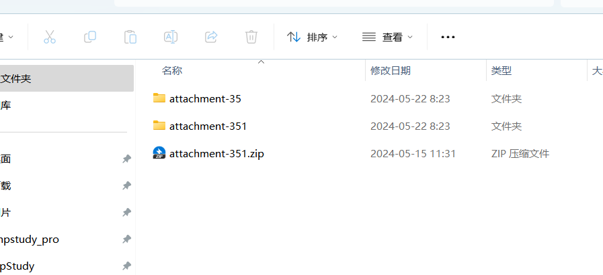
解压之后
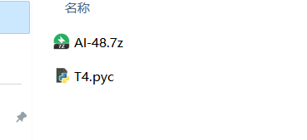
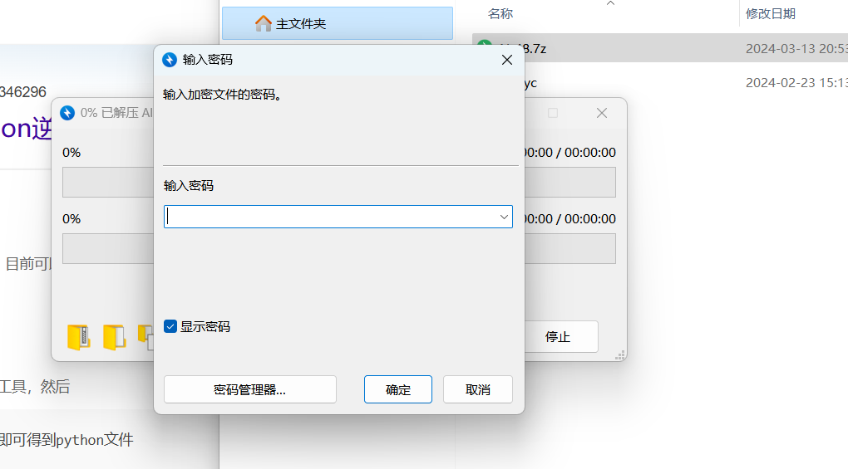压缩包要密码，先反编译一下
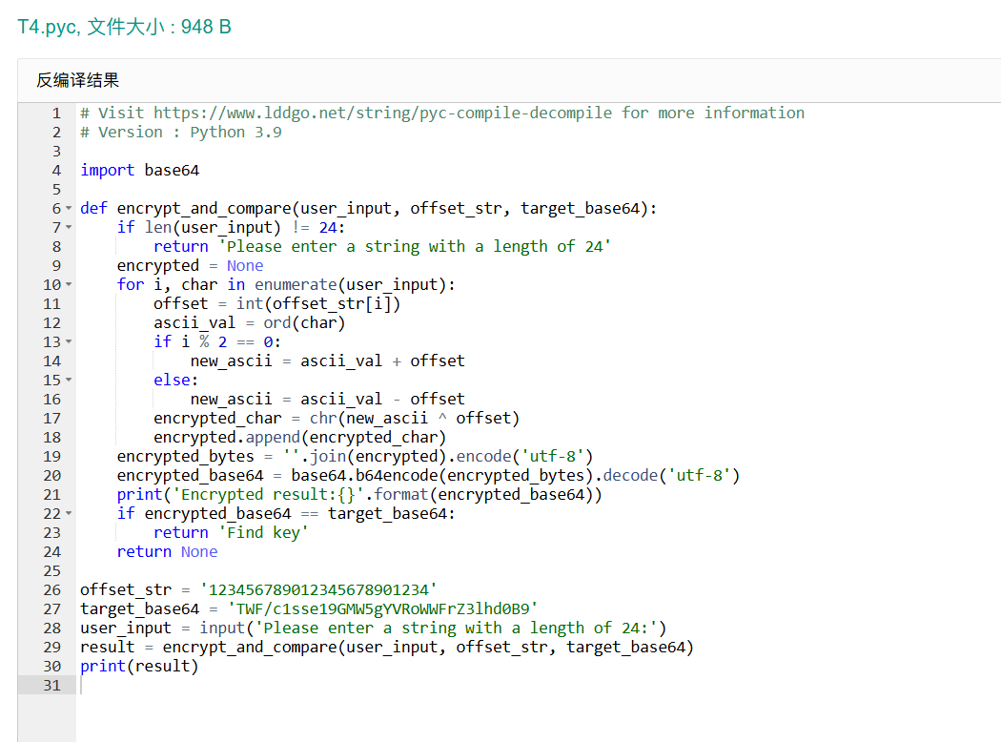
这个代码的作用是将用户输入的一个长度为24的字符串进行加密，并将加密结果与一个预先给定的base64编码字符串进行比较。如果加密结果匹配，则返回“Find key”。思路就是，先解密一个加密的base64字符串，获取解压密码。使用该密码解压一个带密码的7z文件。
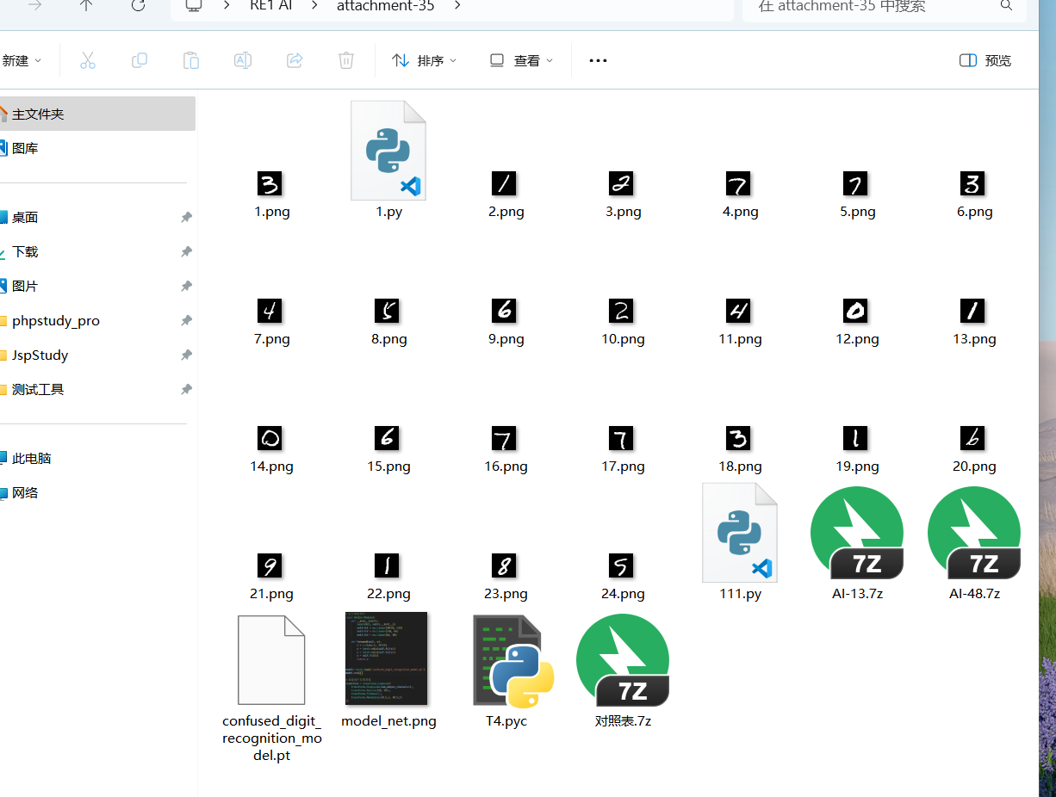
解密之后估计的用到PyTorch模型进行识别了：让gpt写个脚本，加载一个预训练的PyTorch模型，并使用该模型对一系列图像进行数字识别。将识别结果转换为特定格式的字符串，并打印输出。

Exp
import base64
import py7zr
import torch
import torch.nn as nn
import torch.nn.functional as F
import torchvision.transforms as transforms
from PIL import Image

# 文件名和加密信息
archive_name = 'AI-48.7z'
offset_values = '123456789012345678901234'
encoded_target = 'TWF/c1sse19GMW5gYVRoWWFrZ3lhd0B9'

# 解密函数
def decode_base64(encoded_string, offsets):
decoded_bytes = base64.b64decode(encoded_string.encode('utf-8'))
decoded_str = decoded_bytes.decode('utf-8')
result = []
for index, character in enumerate(decoded_str):
offset = int(offsets[index])
ascii_val = ord(character) ^ offset
if index % 2 == 0:
original_ascii = ascii_val - offset
else:
original_ascii = ascii_val + offset
result.append(chr(original_ascii))
return ''.join(result)

# 获取解压密码
password = decode_base64(encoded_target, offset_values)

# 使用密码解压文件
with py7zr.SevenZipFile(archive_name, mode='r', password=password) as archive:
archive.extractall()

# 定义神经网络模型
class SimpleNet(nn.Module):
def __init__(self):
super(SimpleNet, self).__init__()
self.fc1 = nn.Linear(28 * 28, 128)
self.fc2 = nn.Linear(128, 64)
self.fc3 = nn.Linear(64, 10)

def forward(self, x):
x = x.view(-1, 28 * 28)
x = F.relu(self.fc1(x))
x = F.relu(self.fc2(x))
x = self.fc3(x)
return x

# 加载预训练模型
model = torch.load("confused_digit_recognition_model.pt")
model.eval()

# 图像预处理
preprocess = transforms.Compose([
transforms.Grayscale(num_output_channels=1),
transforms.Resize((28, 28)),
transforms.ToTensor(),
transforms.Normalize((0.5,), (0.5,)),
])

# 字符转换字典
char_map = {
"0": "@nd",
"1": "a!",
"2": "_",
"3": "F",
"4": "SSS",
"5": "W@",
"6": "K",
"7": "1",
"8": "C",
"9": "d",
}

# 读取和处理图像
decoded_flag = []
for i in range(24):
img = Image.open(f"{i + 1}.png")
img_tensor = preprocess(img).unsqueeze(0) # type:ignore
output = model(img_tensor)
predicted_label = torch.argmax(output, dim=1).item()
decoded_flag.append(predicted_label)

# 转换和输出结果
flag_string = ''.join(map(str, decoded_flag))
for key, value in char_map.items():
flag_string = flag_string.replace(key, value)

print(flag_string)

