ISCC2024 WriteUp 提交模板
Py74on+习翼+1962389612@qq.com

题目类型+题目名称

解题思路
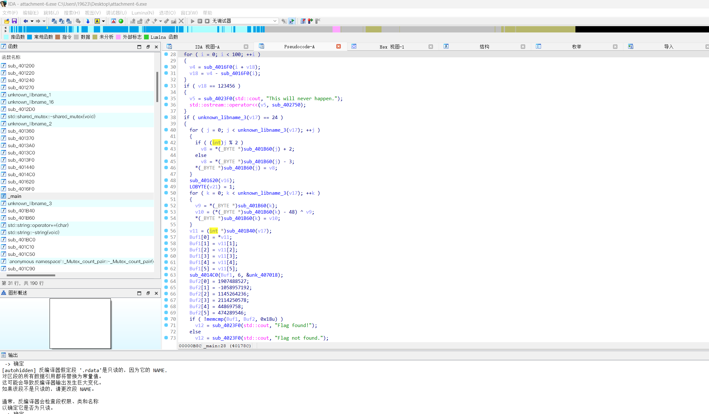
先找到main函数看看，对输入的字符串进行了三次加密最后再与预期的flag密文进行做对比
初次修改:
for ( j = 0; j < unknown_libname_3(v17); ++j )
{
if ( (int)j % 2 )
v8 = *(_BYTE *)sub_401B60(j) + 2;
else
v8 = *(_BYTE *)sub_401B60(j) - 3;
*(_BYTE *)sub_401B60(j) = v8;
}
这里根据字符在字符串中的位置奇偶性，对字符进行加减操作。
第二次修改:
for ( k = 0; k < unknown_libname_3(v17); ++k )
{
v9 = *(_BYTE *)sub_401B60(k);
v10 = (*(_BYTE *)sub_401B60(k) - 48) ^ v9;
*(_BYTE *)sub_401B60(k) = v10;
}
这段代码对每个字符进行了异或操作，这通常用于加密或混淆数据。
第三次“加密”或校验:
v11 = (int *)sub_401B40(v17);
Buf1[0] = *v11;
Buf1[1] = v11[1];
Buf1[2] = v11[2];
Buf1[3] = v11[3];
Buf1[4] = v11[4];
Buf1[5] = v11[5];
sub_4014C0(Buf1, 6, &unk_407018);
在这里，似乎是从sub_401B40(v17)取出一些数据，并将它存入Buf1数组中，然后调用sub_4014C0对这些数据进行处理。这可能是数据的第三次加密或处理。
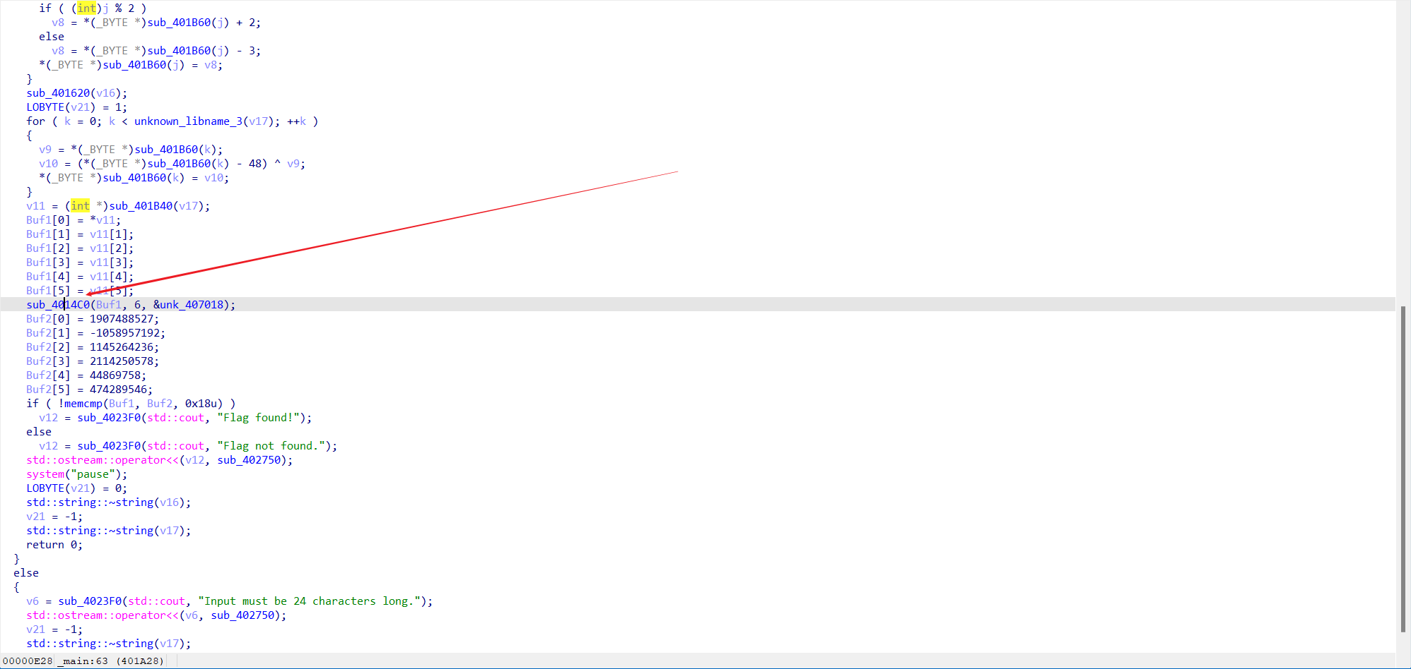
点击函数进去一看 发现是标准的 TEA 加密，密钥是 &unk_407018 直接拿脚本写一个TEA加密算法开干就好
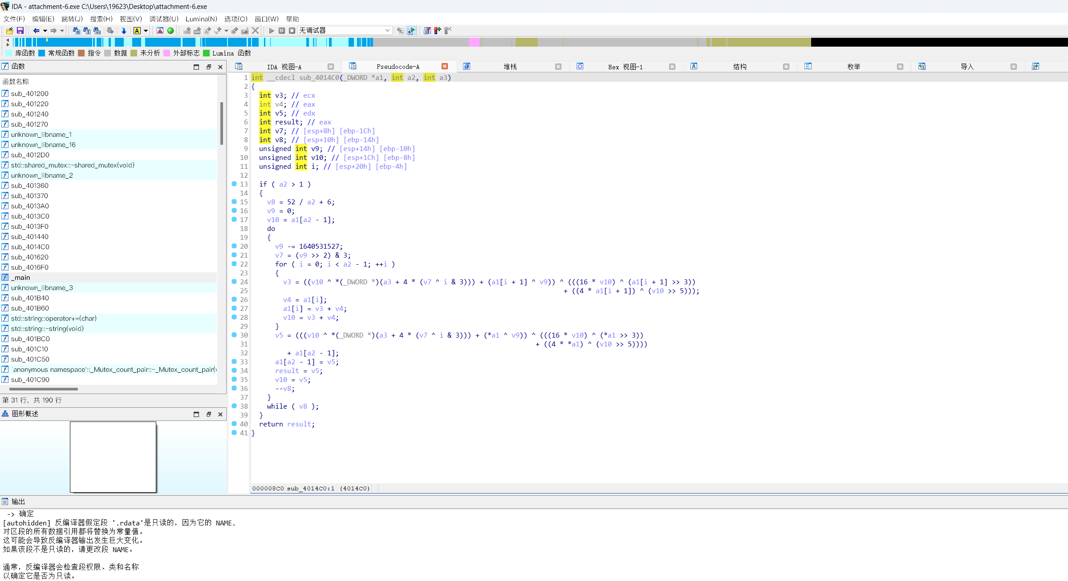
直接把取出来密文和密钥进行解密即可
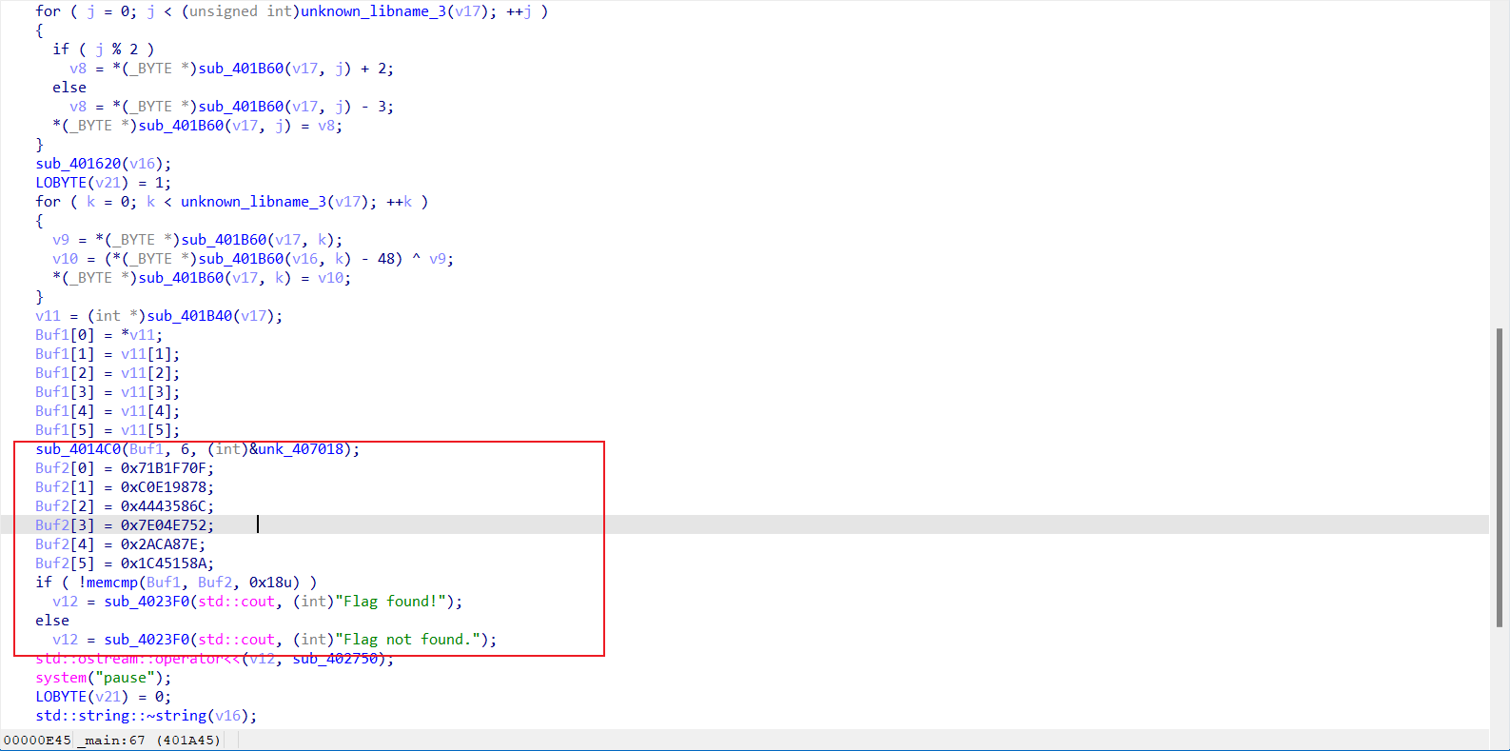
把Buf2[0]-Buf2[5]的十六进制值放在脚本运行即可
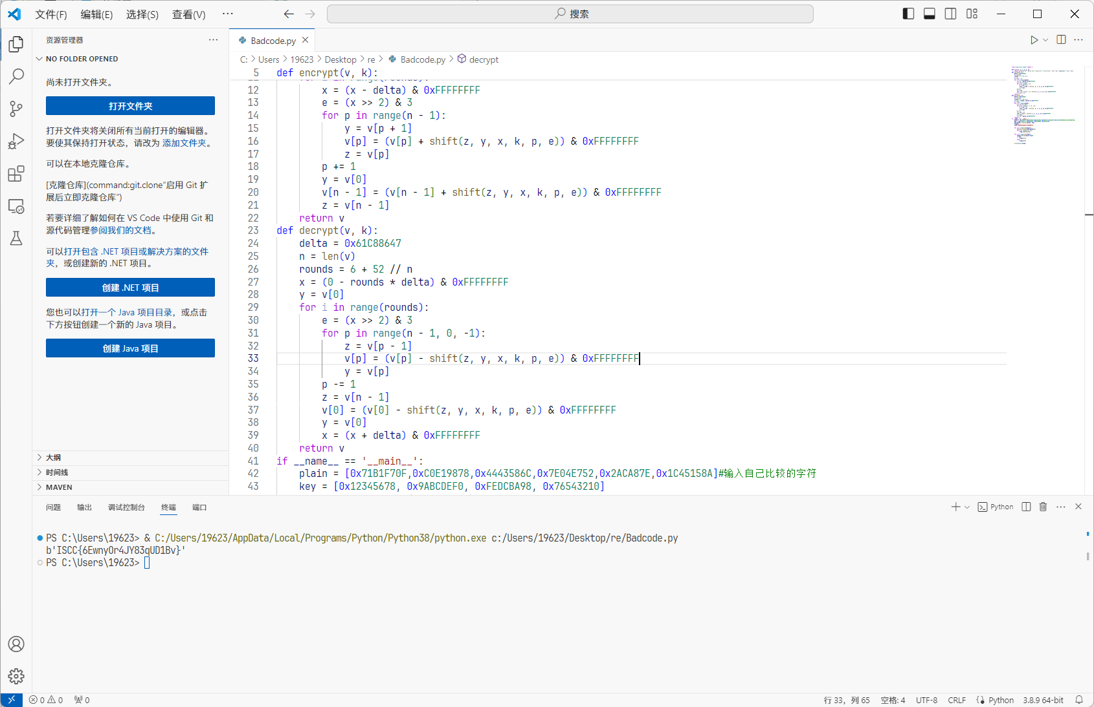

Exp
from Crypto.Util.number import long_to_bytes

def shift(z, y, x, k, p, e):
return ((((z >> 5) ^ (y << 2)) + ((y >> 3) ^ (z << 4))) ^ ((x ^ y) + (k[(p & 3) ^ e] ^ z)))

def encrypt(v, k):
delta = 0x61C88647
n = len(v)
rounds = 6 + 52 // n
x = 0
z = v[n - 1]
encrypted = v[:]
for _ in range(rounds):
x = (x - delta) & 0xFFFFFFFF
e = (x >> 2) & 3
for p in range(n - 1):
y = encrypted[p + 1]
encrypted[p] = (encrypted[p] + shift(z, y, x, k, p, e)) & 0xFFFFFFFF
z = encrypted[p]
p += 1
y = encrypted[0]
encrypted[n - 1] = (encrypted[n - 1] + shift(z, y, x, k, p, e)) & 0xFFFFFFFF
z = encrypted[n - 1]
return encrypted

def decrypt(v, k):
delta = 0x61C88647
n = len(v)
rounds = 6 + 52 // n
x = (0 - rounds * delta) & 0xFFFFFFFF
y = v[0]
decrypted = v[:]
for _ in range(rounds):
e = (x >> 2) & 3
for p in range(n - 1, 0, -1):
z = decrypted[p - 1]
decrypted[p] = (decrypted[p] - shift(z, y, x, k, p, e)) & 0xFFFFFFFF
y = decrypted[p]
p -= 1
z = decrypted[n - 1]
decrypted[0] = (decrypted[0] - shift(z, y, x, k, p, e)) & 0xFFFFFFFF
y = decrypted[0]
x = (x + delta) & 0xFFFFFFFF
return decrypted

if __name__ == '__main__':
plain = [0x71B1F70F, 0xC0E19878, 0x4443586C, 0x7E04E752, 0x2ACA87E, 0x1C45158A]
key = [0x12345678, 0x9ABCDEF0, 0xFEDCBA98, 0x76543210]
decrypted = decrypt(plain, key)
flag = []
v16 = '674094872038771148666737'

for i in range(len(plain)):
x = long_to_bytes(decrypted[i])
for j in range(3, -1, -1):
flag.append(x[j])

for i in range(len(flag)):
flag[i] ^= ord(v16[i]) - 0x30
if i % 2:
flag[i] -= 2
else:
flag[i] += 3

print(bytes(flag))

