ISCC2024 WriteUp 提交模板
Py74on+习翼+1962389612@qq.com

题目类型+题目名称

解题思路
先丢入ExeinfoPe里面查壳
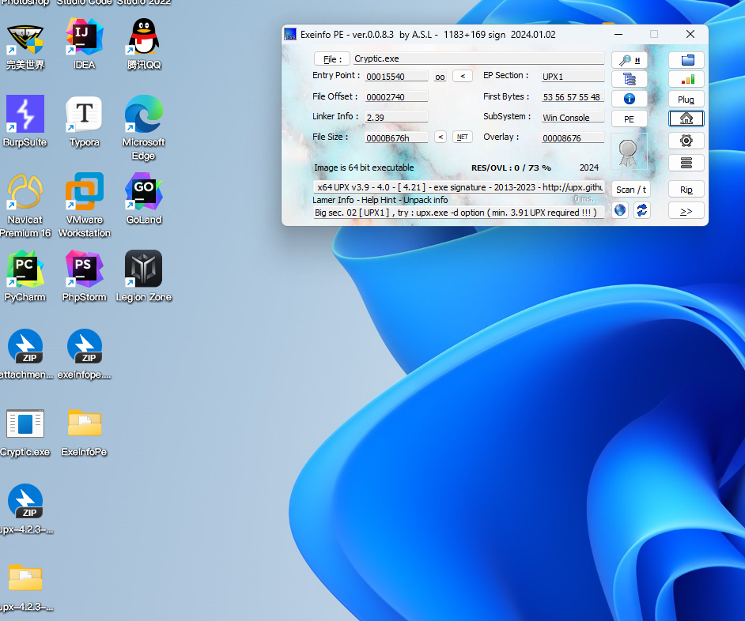
然后用UPX脱壳
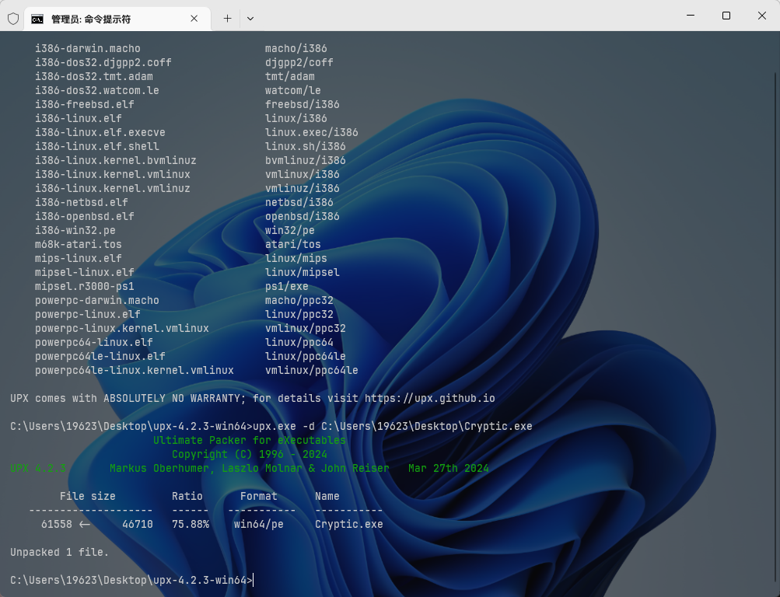
这会直接丢进IDA
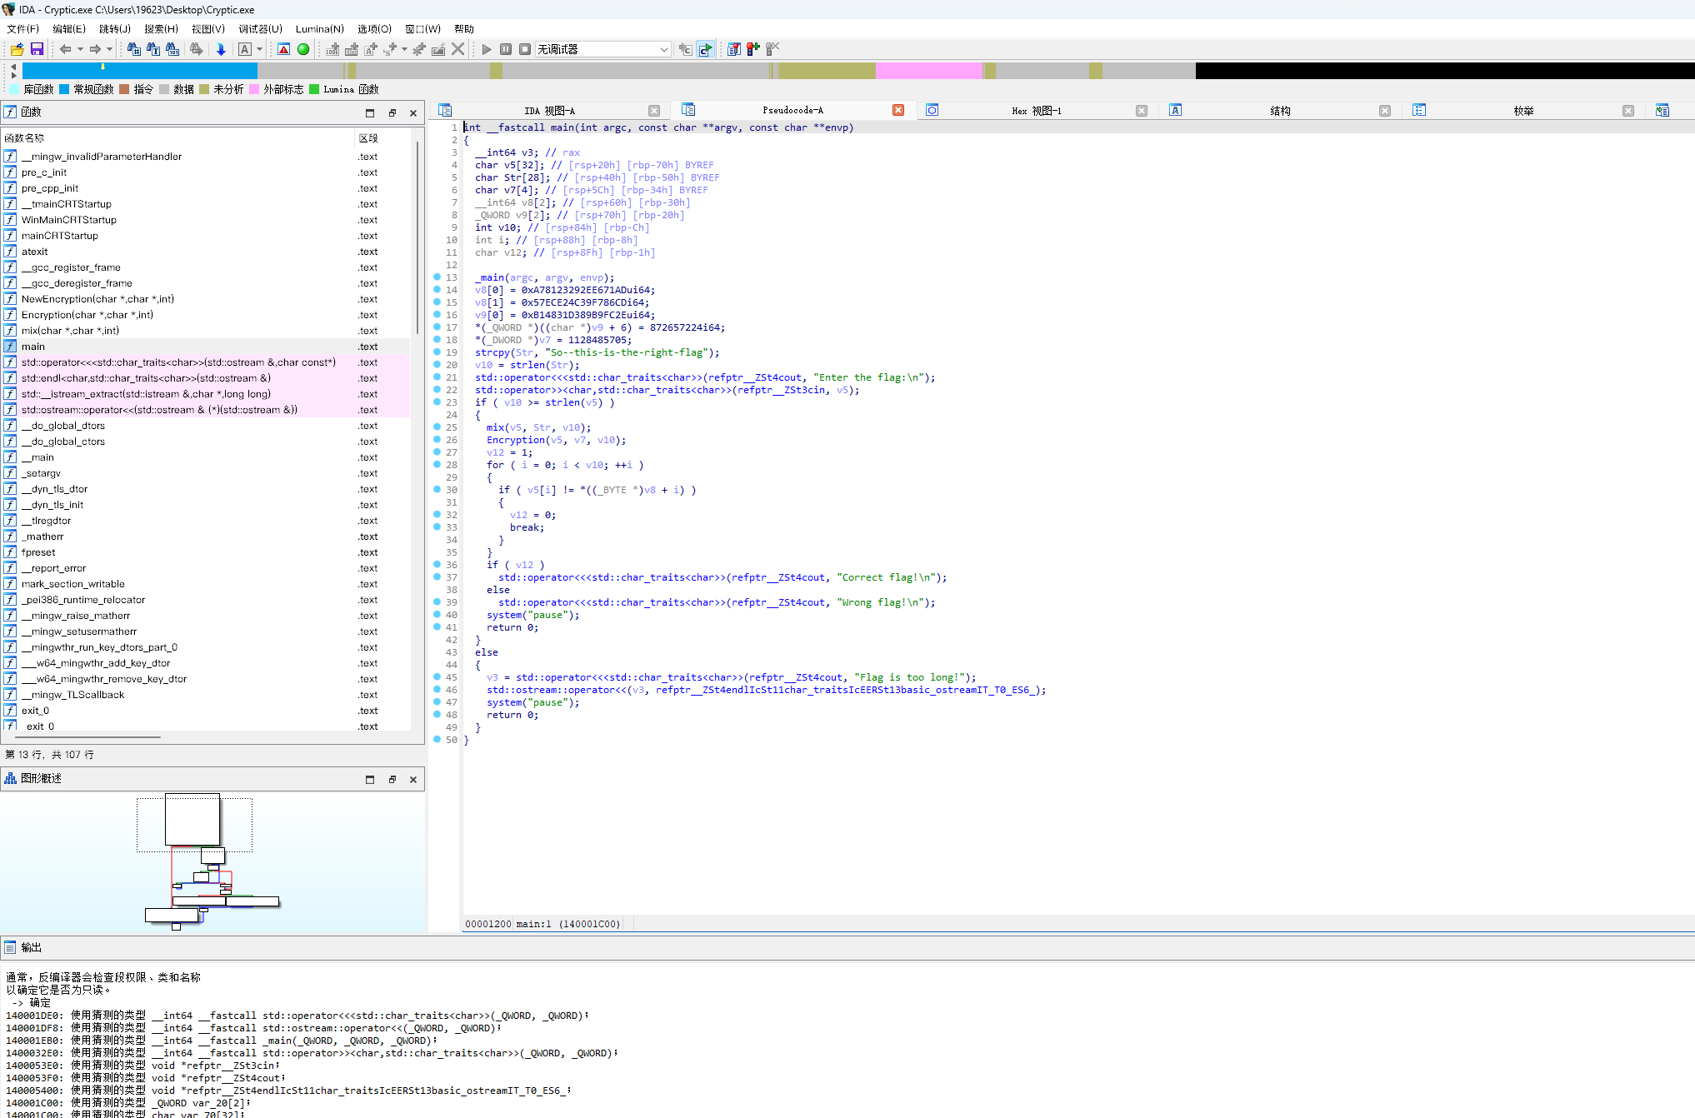
for i in range(3):
for j in range(8):
print(get_wide_byte(0x140001C10+i*0xe+j+2),end=",")
print(get_wide_byte(0x140001C3A+6),get_wide_byte(0x140001C3A+7))
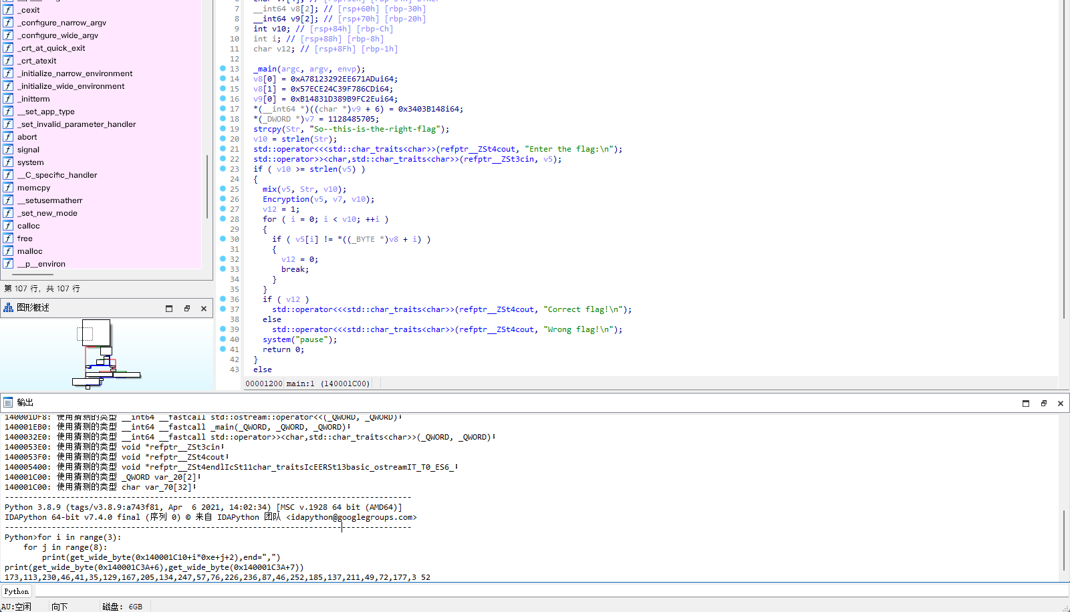
得到数组：73,113,230,46,41,35,129,167,205,134,247,57,76,226,236,87,46,252,185,137,211,49,72,177,3 52
from Crypto.Util.number import *
key1 = 'So--this-is-the-right-flag'
key1_ = []
key2 = 'ISCC'
cmp = [173,113,230,46,41,35,129,167,205,134,247,57,76,226,236,87,46,252,185,137,211,49,72,177,3,52]
for i in range(len(cmp)):
cmp[i] -= 10
cmp[i] &= 0xff
for i in range(len(cmp) - 1):
cmp[i] += cmp[i + 1]
cmp[i] &= 0xff
for i in range(len(cmp) - 1):
cmp[i] ^= ord(key2[2])
for i in range(0, len(cmp), 2):
cmp[i] ^= ord(key2[i % 4])
for i in range(len(cmp) // 2):
cmp[i], cmp[26 - i - 1] = cmp[26 - i - 1], cmp[i]
for i in range(len(cmp) // 2):
cmp[i], cmp[26 - i - 1] = cmp[26 - i - 1], cmp[i]
for i in range(len(cmp)):
cmp[i] += ord(key2[i % 4])
cmp[i] &= 0xff
for i in cmp:
print(chr(i), end="")
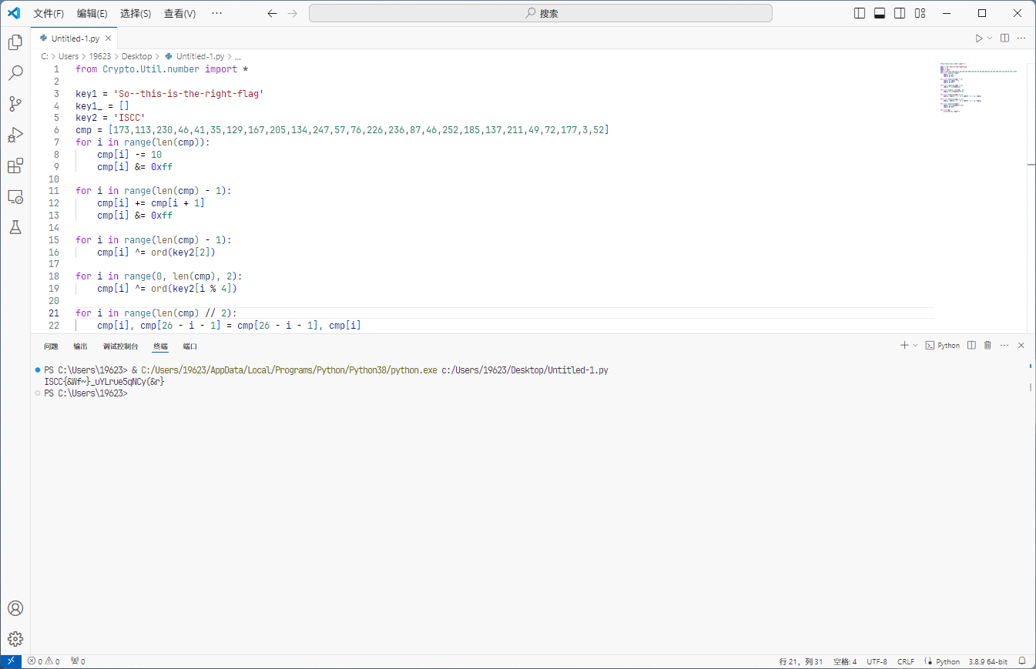
直接拿到flag

Exp
from Crypto.Util.number import *

key1 = 'So--this-is-the-right-flag'
key1_ = []
key2 = 'ISCC'
cmp = [173,113,230,46,41,35,129,167,205,134,247,57,76,226,236,87,46,252,185,137,211,49,72,177,3,52]
for i in range(len(cmp)):
cmp[i] -= 10
cmp[i] &= 0xff

for i in range(len(cmp) - 1):
cmp[i] += cmp[i + 1]
cmp[i] &= 0xff

for i in range(len(cmp) - 1):
cmp[i] ^= ord(key2[2])

for i in range(0, len(cmp), 2):
cmp[i] ^= ord(key2[i % 4])

for i in range(len(cmp) // 2):
cmp[i], cmp[26 - i - 1] = cmp[26 - i - 1], cmp[i]

for i in range(len(cmp) // 2):
cmp[i], cmp[26 - i - 1] = cmp[26 - i - 1], cmp[i]

for i in range(len(cmp)):
cmp[i] += ord(key2[i % 4])
cmp[i] &= 0xff

for i in cmp:
print(chr(i), end="")

