ISCC2024 WriteUp 提交模板
Py74on+习翼+1962389612@qq.com

Mobile+EzArd

解题思路
一只蜗牛钻进了乌龟壳，并且把自己伪装在一个角落，你能把它揪出来吗？
拿到文件后放入jadx进行反编译，将时间流转换成字符流
动调可以得到字符串：3SRNH1pdcta4283rFzAHxvZOLjIizbJ64UFx
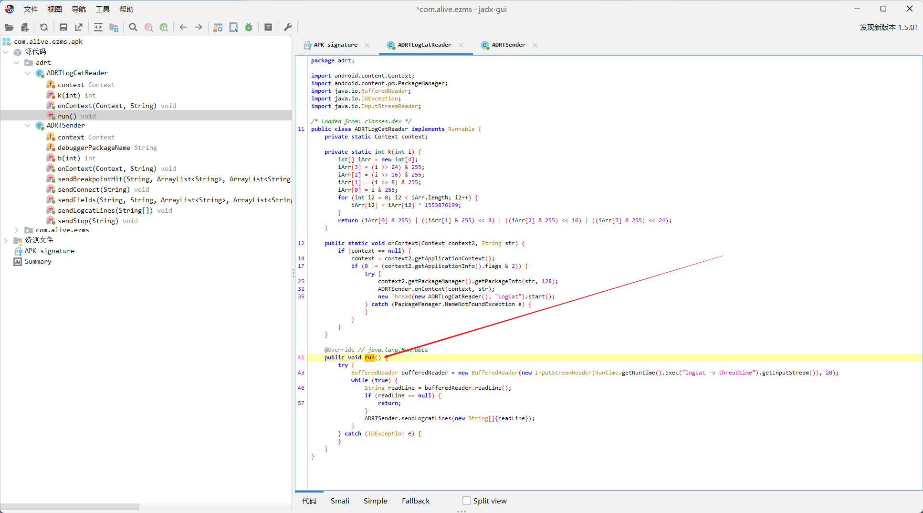
加密的过程：异或/换位/base64换表
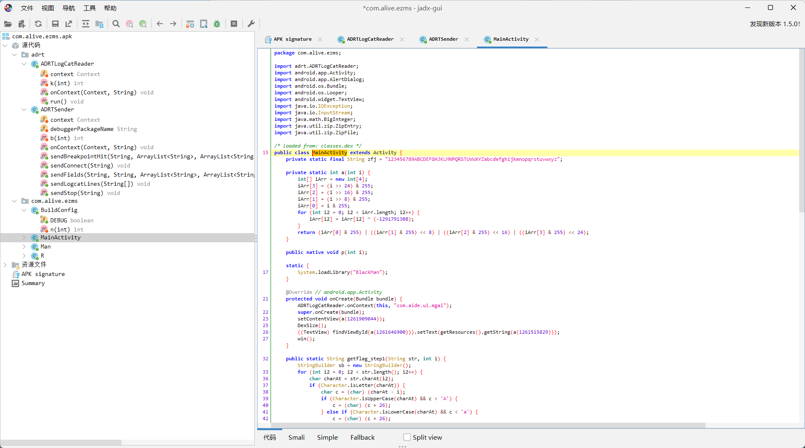
让gpt写个逐位爆破输出解密字符串的脚本即可

Exp
#include <stdio.h>
#include <stdlib.h>
#include <string.h>
#include <ctype.h>

char* table = "123456789ABCDEFGHJKLMNPQRSTUVWXYZabcdefghijkmnopqrstuvwxyz";
char* message = "3SRNH1pdcta4283rFzAHxvZOLjIizbJ64UFx";

unsigned long long base58_to_decimal(char* s) {
int digits[] = "123456789ABCDEFGHJKLMNPQRSTUVWXYZabcdefghijkmnopqrstuvwxyz";
int base = 58;
unsigned long long decimal = 0;
int power = 0;
for (int i = strlen(s) - 1; i >= 0; i--) {
int digit = strchr(digits, s[i]) - digits;
decimal += digit * (unsigned long long)pow(base, power);
power++;
}
return decimal;
}

int main() {
char enc[strlen(message) + 1];
for (int k = 0; k < 26; k++) {
memset(enc, 0, sizeof(enc));
for (int i = 0; i < strlen(message); i++) {
if (isdigit(message[i])) {
enc[i] = message[i];
} else if (islower(message[i])) {
enc[i] = (char)((message[i] - 'a' + k) % 26 + 'a');
} else if (isupper(message[i])) {
enc[i] = (char)((message[i] - 'A' + k) % 26 + 'A');
}
}
unsigned long long decimal = base58_to_decimal(enc);
printf("%d, %s\n", k, (char*)&decimal);
}
return 0;
}

