ISCC2024 WriteUp 提交模板
Py74on+习翼+1962389612@qq.com

Reverse-Ezobf

解题思路
这是一个一个Obfuscation！（flag无需包裹ISCC{}）
老样子丢尽ida看看情况
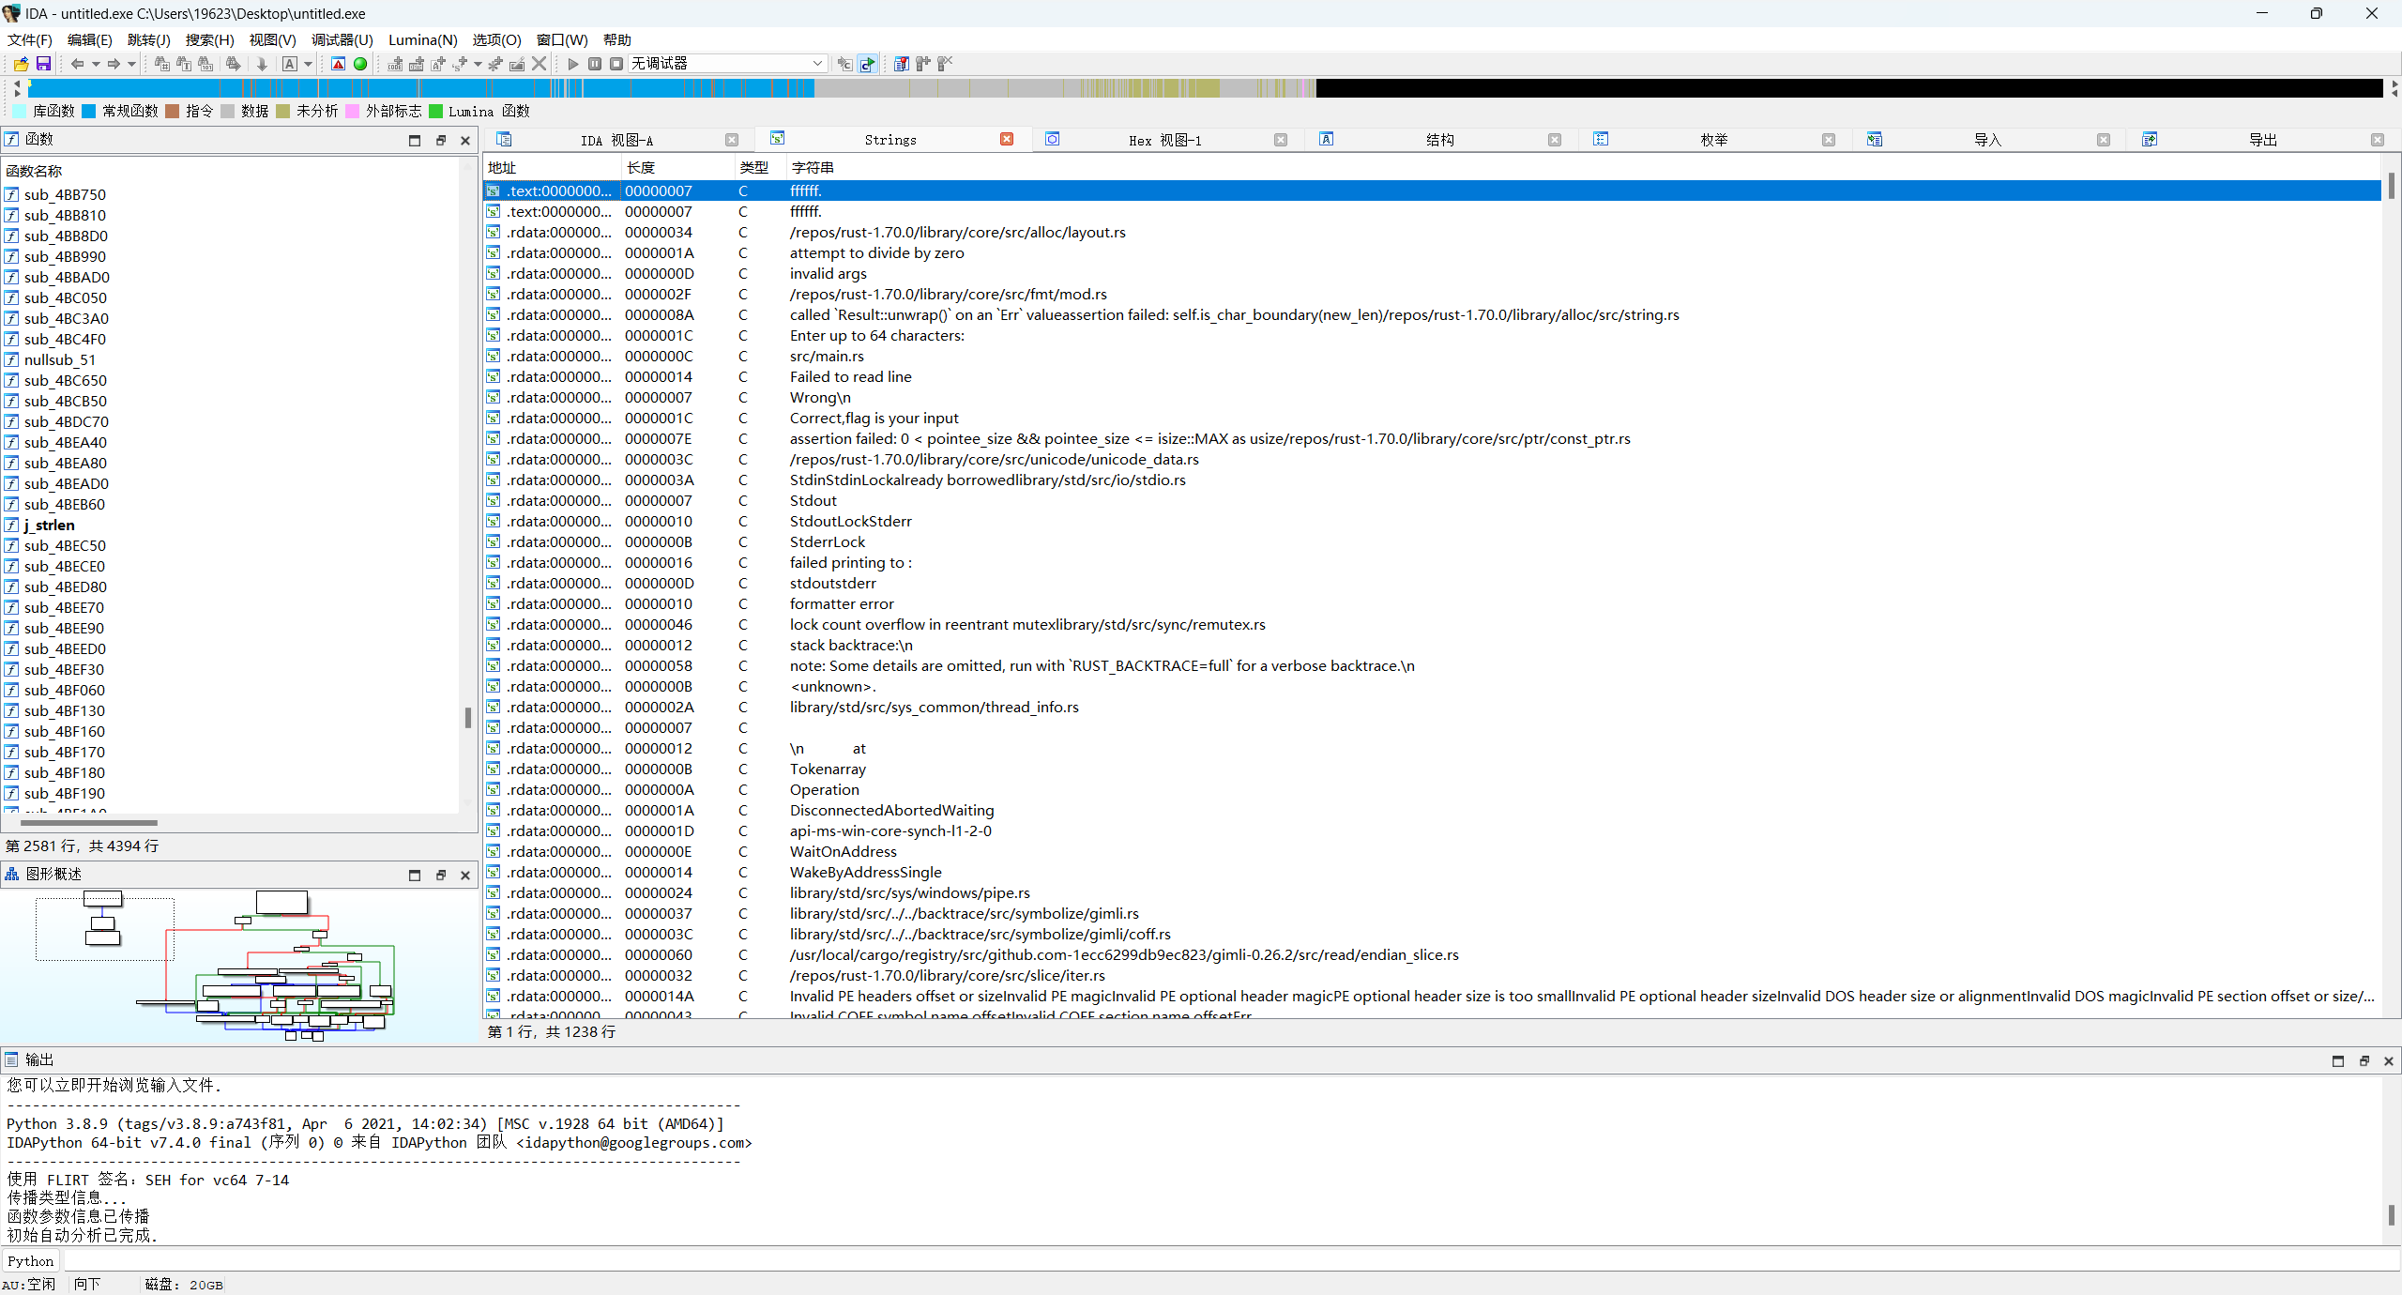
尝试调试
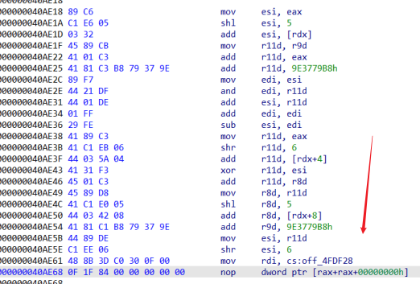
看来这就是密钥和密文了
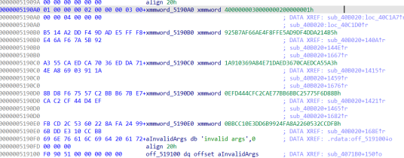
让gpt受搓一个代码出来

Exp
#include <stdio.h>
#include <stdint.h>

#define TIMES 16
#define DELTA 0x9E3779B8

uint32_t a1[] = {
0xDDA214B5, 0xE5AD9DF4, 0x6AE4F8FF, 0x925B7AF6,
0xEDCA55A3, 0xED3670CA, 0xA84E71DA, 0x1A910369,
0x75F6D88B, 0xB6BBC257, 0xC2CAE77B, 0xEFD444CF,
0x532CCDFB, 0xFA8A2260, 0xDD6B9924, 0xBBCC10E3
};
uint32_t decode[16];

char* n2s(uint32_t num) {
static char str[5];
str[0] = (num >> 24) & 0xFF;
str[1] = (num >> 16) & 0xFF;
str[2] = (num >> 8) & 0xFF;
str[3] = num & 0xFF;
str[4] = '\0';
return str;
}

void reverse_str(char* str) {
int len = 0;
while (str[len] != '\0') len++;
for (int i = 0; i < len / 2; i++) {
char temp = str[i];
str[i] = str[len - 1 - i];
str[len - 1 - i] = temp;
}
}

int main() {
uint32_t v5 = 0;
uint32_t a2[4];
uint32_t v1, v2;

for (int j = 0; j < 16; j += 2) {
v5 = DELTA * TIMES;
v1 = a1[j];
v2 = a1[j + 1];
for (int k = 0; k < 4; k++) {
a2[k] = (k + 1) * ((j / 2) + 1);
}

for (int i = 0; i < TIMES; i++) {
uint32_t r8d = (v1 << 5) + a2[2];
r8d ^= (v1 + v5);
uint32_t esi = (v1 >> 6) + a2[3];
uint32_t edi = esi & r8d;
edi *= 2;
v2 -= r8d - edi + esi;

esi = (v2 << 5) + a2[0];
uint32_t r11d = v2 + v5;
edi = esi & r11d;
esi += r11d;
edi *= 2;
esi -= edi;

r11d = (v2 >> 6) + a2[1];
r11d ^= esi;
v1 -= r11d;

v5 -= DELTA;
}

decode[j] = v1;
decode[j + 1] = v2;
}

for (int i = 0; i < 16; i++) {
char *decoded_str = n2s(decode[i]);
reverse_str(decoded_str);
printf("%s", decoded_str);
}

return 0;
}

