ISCC2024 WriteUp 提交模板
Py74on+习翼+1962389612@qq.com

题目类型+题目名称

解题思路

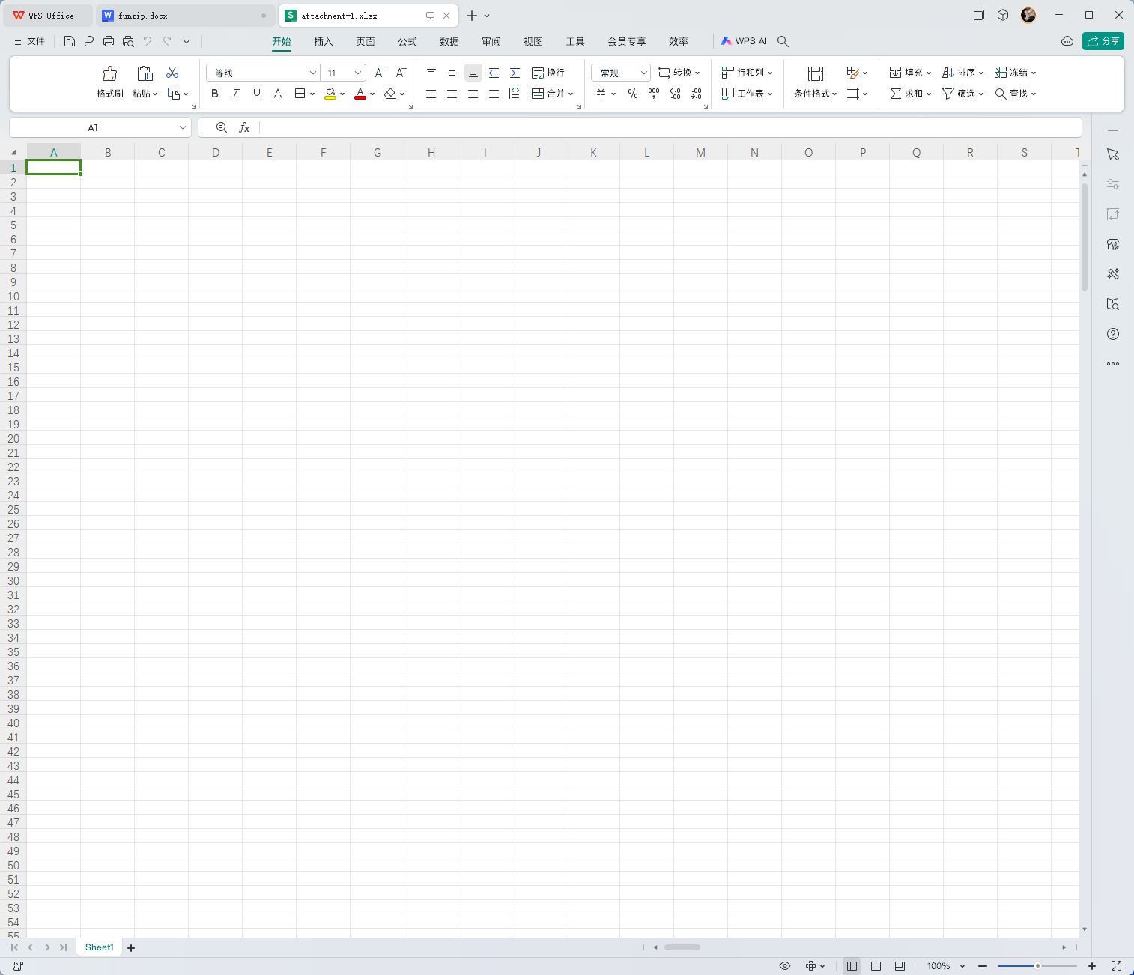
用excel打开后发现啥玩意都看不见，但是缩小一点发现有空白的高亮部分，用gpt写个脚本去提亮换个颜色

from openpyxl import load_workbook
from openpyxl.styles import PatternFill
workbook = load_workbook('1.xlsx')
worksheet = workbook.active
bold_cells_coordinates = [
cell.coordinate
for row in worksheet.iter_rows()
for cell in row if cell.font.bold
]
highlight_style = PatternFill(start_color="000000", end_color="000000", fill_type="solid")
for coordinate in bold_cells_coordinates:
worksheet[coordinate].fill = highlight_style
workbook.save('666.xlsx')
print('加粗的单元格已设置为黑色高亮并保存到 666.xlsx 文件中。')
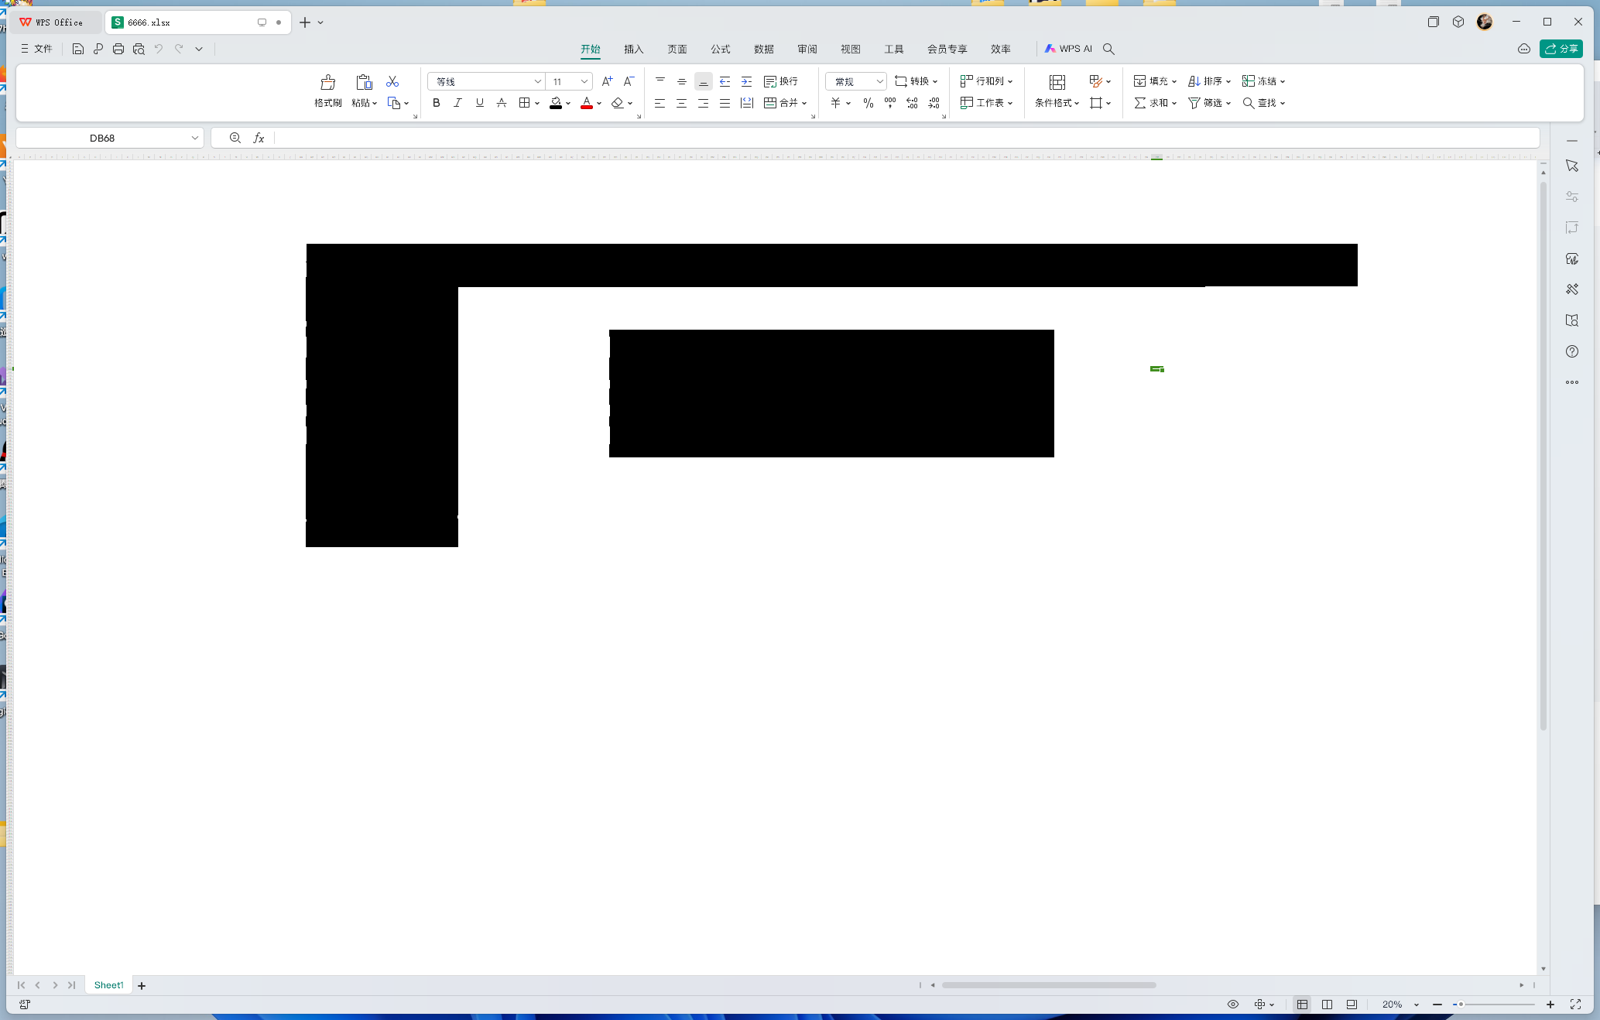
后期就是一个个的把加粗显示的格子涂成黑的，修改列宽和行高，就会有一个二维码直接扫就是flag

Exp
from openpyxl import load_workbook
from openpyxl.styles import PatternFill
workbook = load_workbook('1.xlsx')
worksheet = workbook.active
bold_cells_coordinates = [
cell.coordinate
for row in worksheet.iter_rows()
for cell in row if cell.font.bold
]
highlight_style = PatternFill(start_color="000000", end_color="000000", fill_type="solid")
for coordinate in bold_cells_coordinates:
worksheet[coordinate].fill = highlight_style
workbook.save('666.xlsx')
print('加粗的单元格已设置为黑色高亮并保存到 666.xlsx 文件中。')

