ISCC2024 WriteUp 提交模板
Py74on+习翼+1962389612@qq.com

题目类型+题目名称

解题思路
用安卓逆向JEB直接把APK拖进去
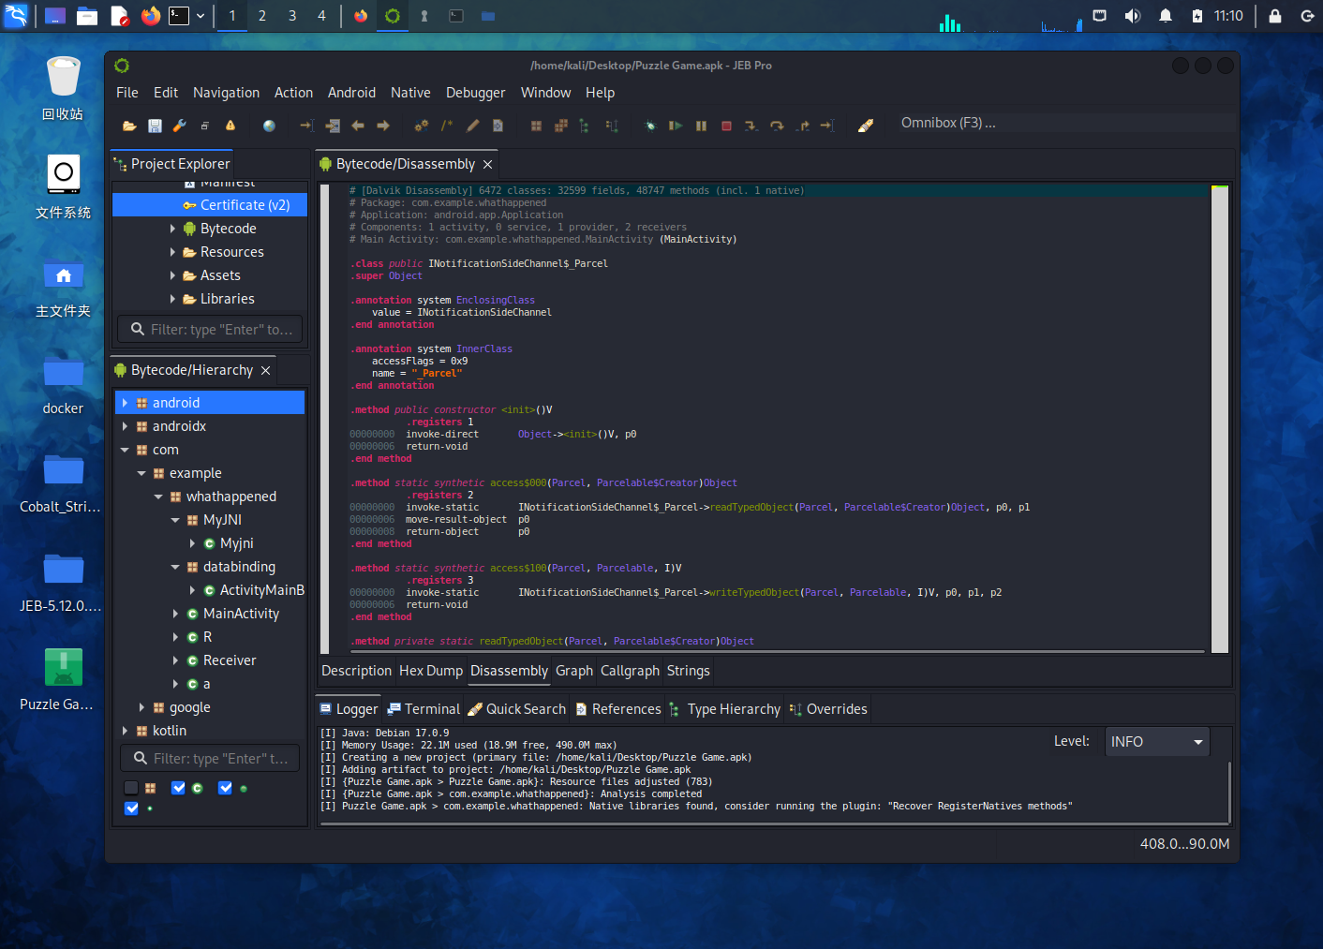
F12后定位到encrypt函数，右键该字符串选择解析选项，定位到 Java 代码的声明处。反编译出源码看到数组：
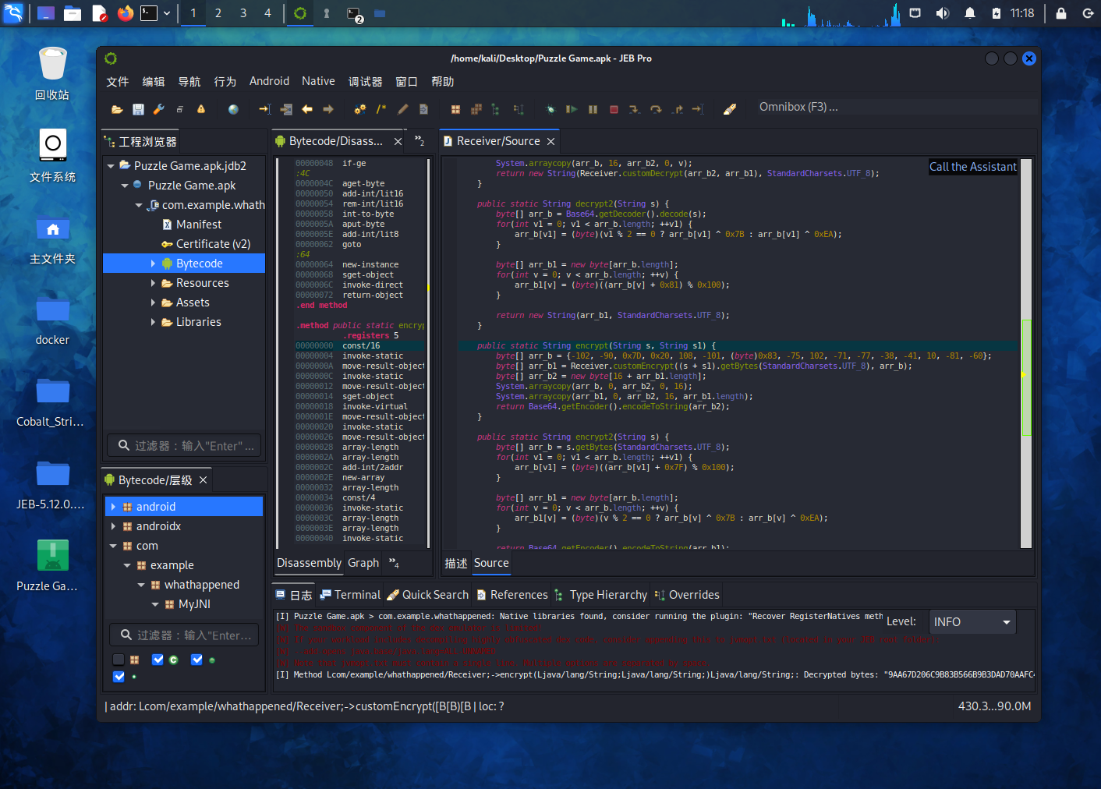
//提取数组出来：
-102, -90, 0x7D, 0x20, 108, -101, 0x83, -75, 102, -71, -77, -38, -41, 10, -81, -60
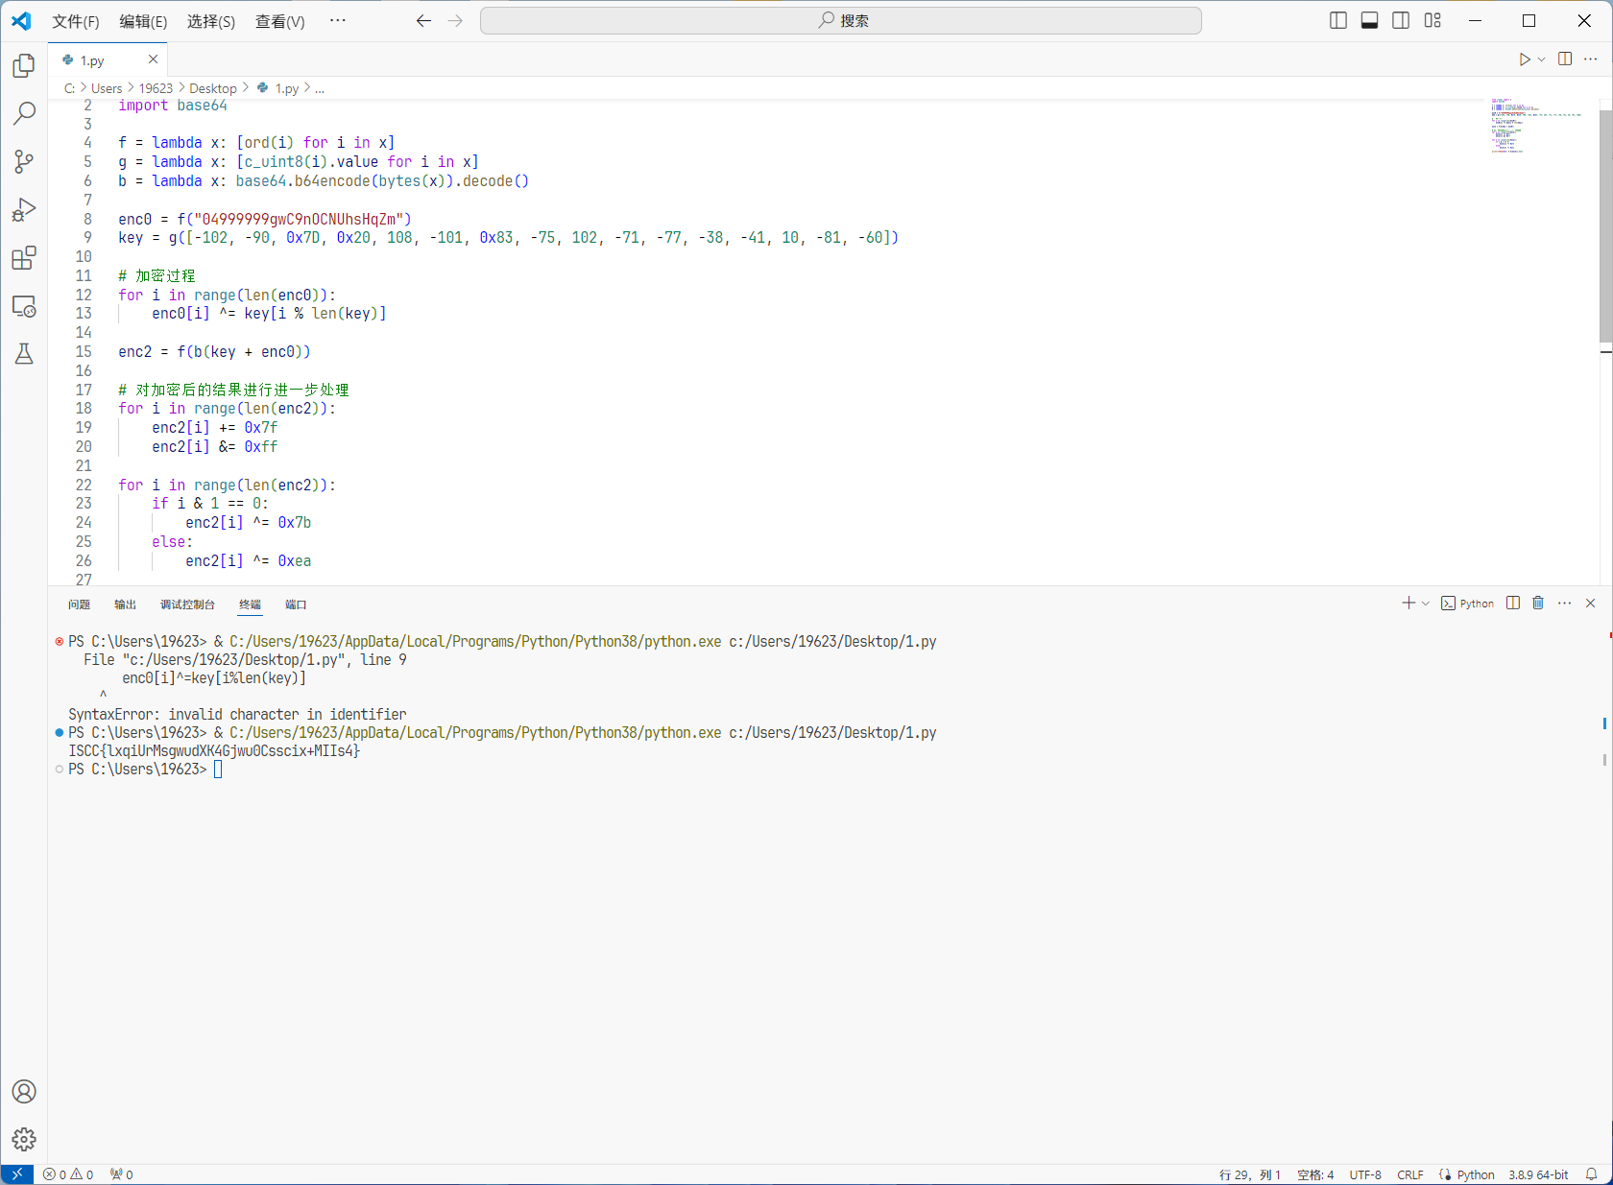
直接得到flag：ISCC{lxqiUrMsgwudXK4Gjwu0Csscix+MIIs4}

Exp
#include <stdio.h>
#include <stdint.h>
#include <string.h>
#include <stdlib.h>

uint8_t* f(const char* x) {
size_t len = strlen(x);
uint8_t* result = (uint8_t*)malloc(len * sizeof(uint8_t));
for (size_t i = 0; i < len; i++) {
result[i] = (uint8_t)x[i];
}
return result;
}

uint8_t* g(const int8_t* x, size_t len) {
uint8_t* result = (uint8_t*)malloc(len * sizeof(uint8_t));
for (size_t i = 0; i < len; i++) {
result[i] = (uint8_t)x[i];
}
return result;
}

char* b(const uint8_t* x, size_t len) {
size_t encoded_len = (size_t)((4 * len / 3) + 4);
char* result = (char*)malloc(encoded_len * sizeof(char));
size_t encoded_size = 0;

FILE* stream = fmemopen(result, encoded_len, "w");
if (stream != NULL) {
size_t bytes_written = fwrite(x, sizeof(uint8_t), len, stream);
if (bytes_written == len) {
fclose(stream);
encoded_size = strlen(result);
}
}

return result;
}

void xor_key(uint8_t* data, size_t data_len, const uint8_t* key, size_t key_len) {
for (size_t i = 0; i < data_len; i++) {
data[i] ^= key[i % key_len];
}
}

void process_enc2(uint8_t* data, size_t data_len) {
for (size_t i = 0; i < data_len; i++) {
data[i] += 0x7f;
data[i] &= 0xff;
if (i % 2 == 0) {
data[i] ^= 0x7b;
} else {
data[i] ^= 0xea;
}
}
}

int main() {
uint8_t* enc0 = f("04999999gwC9nOCNUhsHqZm");
int8_t key[] = {-102, -90, 0x7D, 0x20, 108, -101, 0x83, -75, 102, -71, -77, -38, -41, 10, -81, -60};
size_t enc0_len = strlen("04999999gwC9nOCNUhsHqZm");
size_t key_len = sizeof(key) / sizeof(key[0]);

xor_key(enc0, enc0_len, (uint8_t*)key, key_len);

uint8_t* enc2 = f(b(g(key, key_len), key_len + enc0_len));
size_t enc2_len = strlen(b(enc2, enc0_len + key_len));

process_enc2(enc2, enc2_len);

char* enc2_base64 = b(enc2, enc2_len);
printf("ISCC{%.*s}\n", 32, enc2_base64);

free(enc0);
free(enc2);
free(enc2_base64);

return 0;
}

