ISCC2024 WriteUp 提交模板
Py74on+习翼+1962389612@qq.com

Reverse+Which_is_the_flag

解题思路
So many flags, which one is true?
丢尽ida里面进去
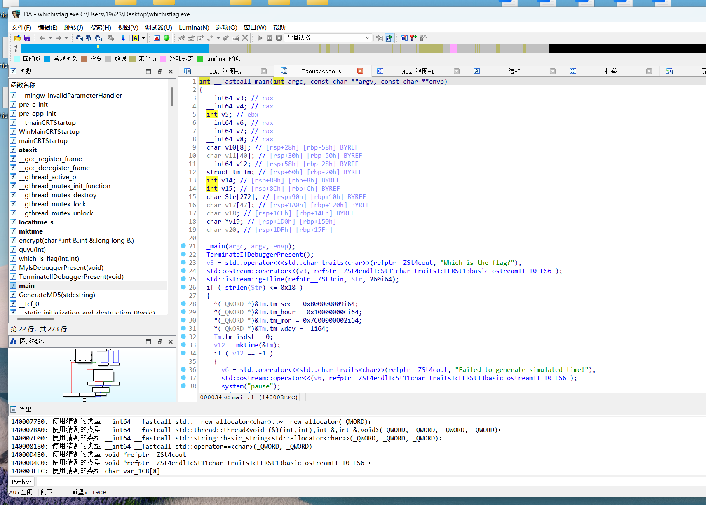
HYPERLINK
https://github.com/ggerganov/kbd-audio/tree/master/.github/workflows
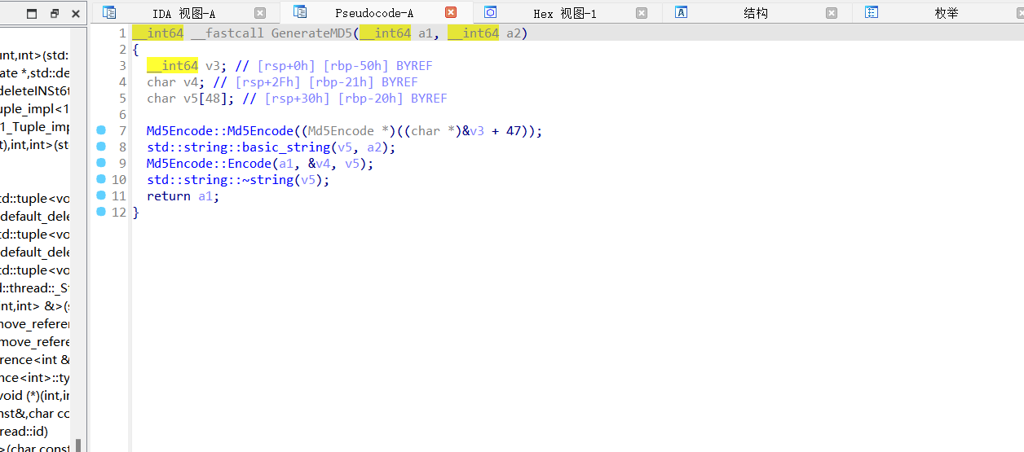
循环和异或 写个idapython直接运行

Exp
print("ISCC{" + base64.b64decode(bytes.fromhex("".join([chr(get_wide_byte(0x14000BF40+i) ^ 0xc) for i in range(48)])).decode('utf-8')).decode() + "}")

