ISCC2024 WriteUp 提交模板
Py74on+习翼+1962389612@qq.com

题目类型+题目名称

解题思路
- 解压后发现文件exe丢进ida分析
My frozen pen, reluctant to write a new poem,
Warms old wine beside the cold stove from time to time.
Drunk, I gaze at the ink blots in the moonlight,
And fancy a village, deeply covered in snow.
提示是诗歌吗
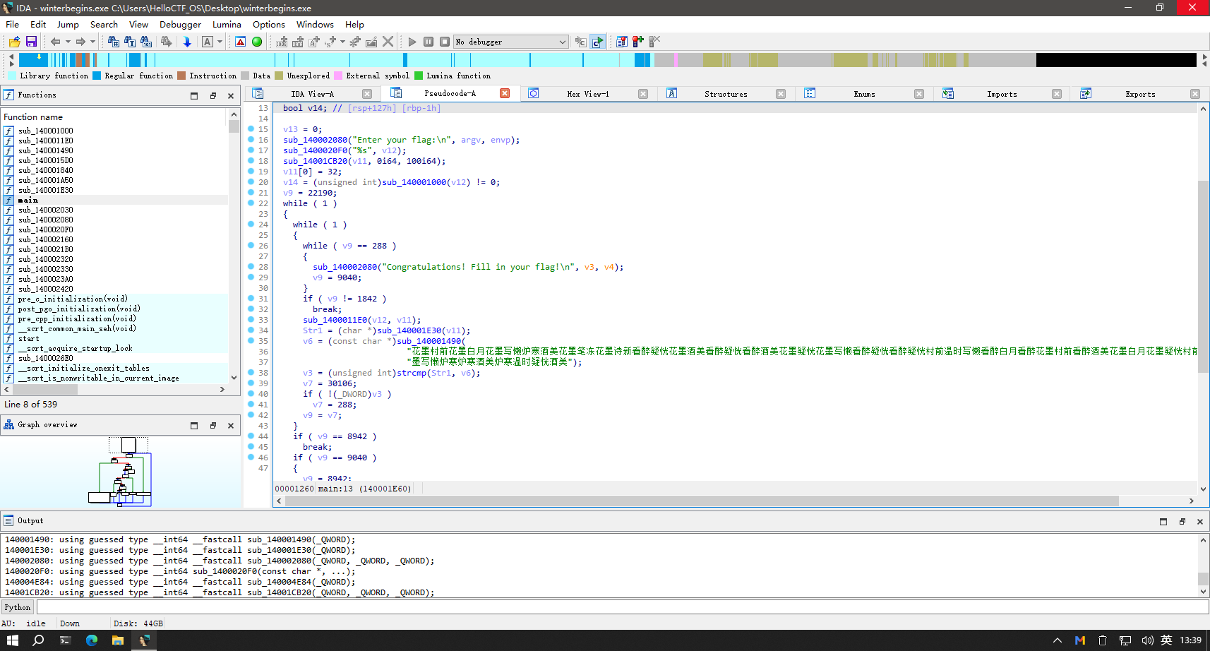
一进去就有的两段：
花墨村前花墨白月花墨写懒炉寒酒美花墨笔冻花墨诗新看醉疑恍花墨酒美看醉疑恍看醉酒美花墨疑恍花墨写懒看醉疑恍看醉疑恍村前温时写懒看醉白月看醉花墨村前看醉酒美花墨白月花墨疑恍村前温时温时村前花"
"墨写懒炉寒炉寒酒美炉寒温时疑恍酒美
最后一段是在shift+f12
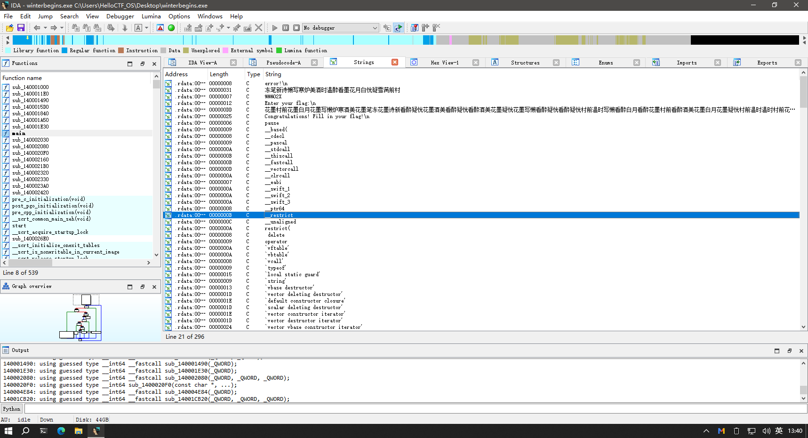

Exp
en2 = "时村前花墨写懒炉寒炉寒酒美炉寒温时疑恍酒美"
en = en2[::-1]
en3 = "花墨村前花墨温时村前看醉疑恍村前看醉写懒花墨酒美花墨温时村前看醉酒美花墨炉寒花墨温时看醉看醉看醉温时村前看醉白月看醉花墨看醉炉寒花墨温时花墨炉寒看醉酒美花墨温时看醉写懒看醉疑恍村前温时温"
en1 = en3[::-1]
table = "冻笔新诗懒写寒炉美酒时温醉看墨花月白恍疑雪满前村"
enc = en + en1
index = 0
idx_list = []
while index < len(enc):
temp = enc[index:index + 2]
idx = table.find(temp) // 2
idx_list.append(idx)
index += 2

char_list = []
index = 0
while index < len(idx_list):
if idx_list[index] == 11:
char_list.append(chr(61 + idx_list[index + 1]))
index += 2
else:
char_list.append(chr(idx_list[index] + ord('0')))
index += 1
result = ''.join(char_list[:-1])
# 删除非十六进制字符 'B' 和 'F'
result = result.replace('B', '').replace('F', '')
# 检查 result 的长度是否为偶数
if len(result) % 2 != 0:
result += '0' # 如果长度为奇数，则补充一个额外的零
# 输出修正后的 result
print("修正后的 result:", result)
ascii_str = bytes.fromhex(result).decode('utf-8')
print(ascii_str)
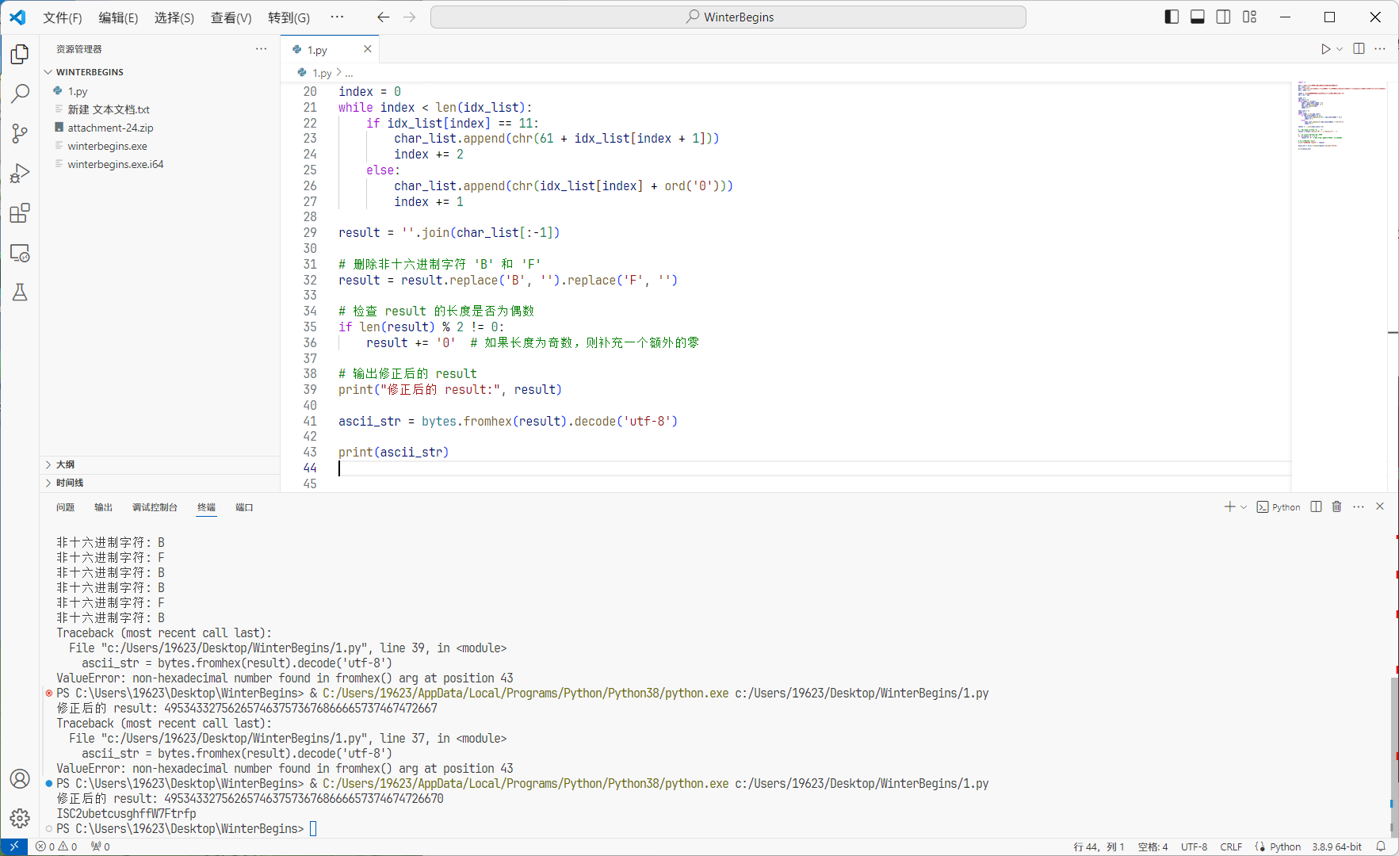
ISC2ubetcusghffW7Ftrfp
2换成c c2==cc直接的直接提交

