ISCC2024 WriteUp 提交模板
Py74on+习翼+1962389612@qq.com

Mobile+ohHELP

解题思路
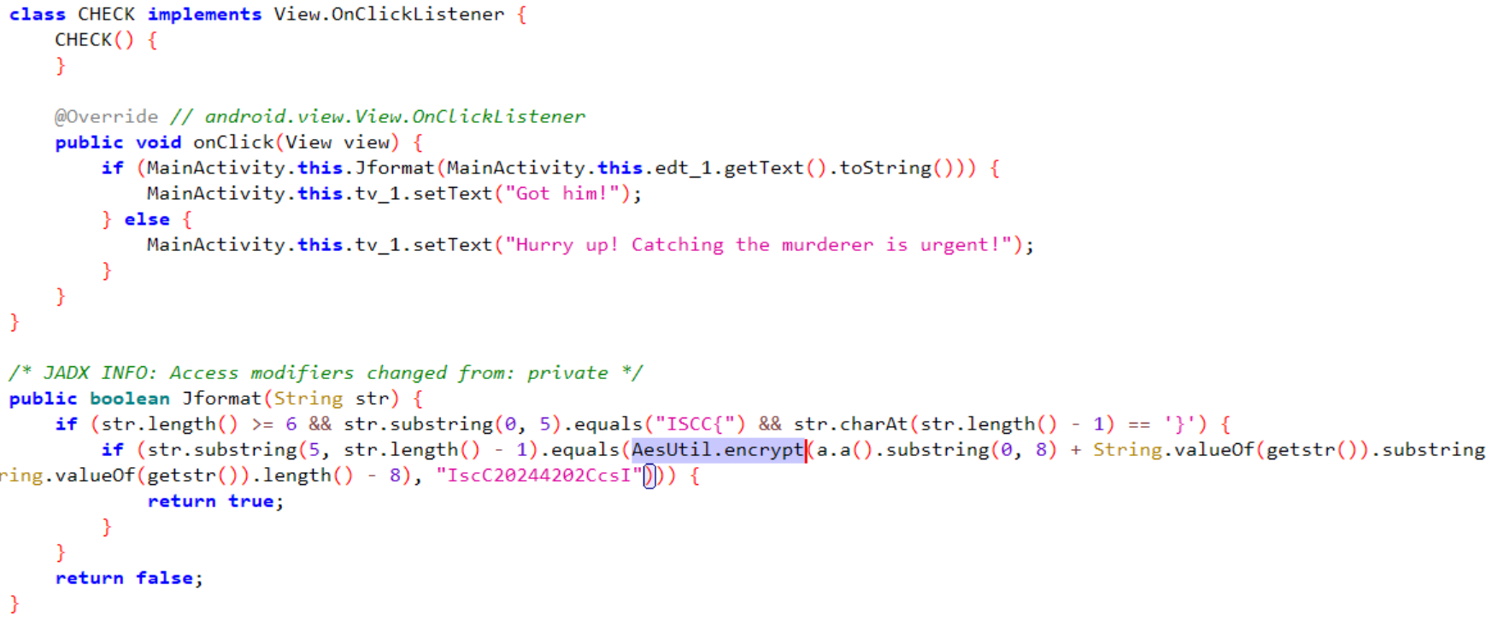

check发现a.a() 异常GetKey返回了null
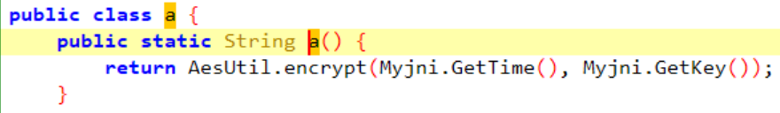
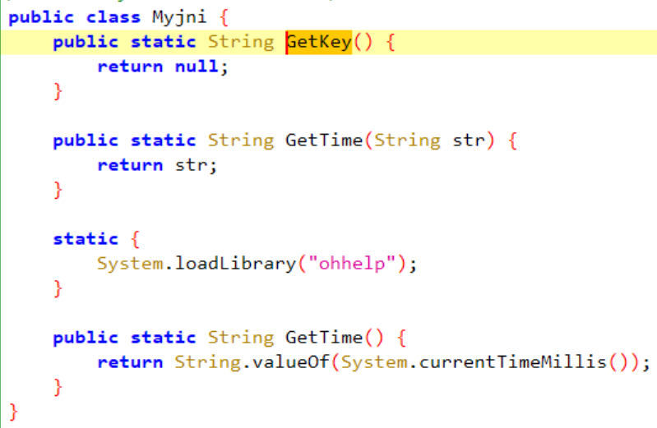
在assets->ssh翻到一个word，镜像后得到”PUDzbflthjqxlJVW”，应该就是GetKey的返回值frida设置GetKey返回值
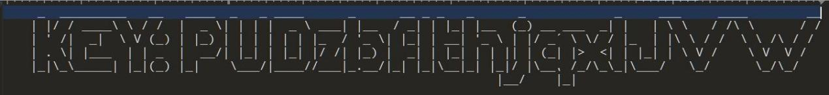
let Myjni = Java.use("com.example.ohhelp.MyJNI.Myjni");
Myjni["GetKey"].implementation = function () {
console.log('GetKey is called');
let ret = this.GetKey();
console.log('GetKey ret value is ' + ret);
return "PUDzbflthjqxlJVW";
};
getstr反射调用com.example.ohhelp.getstr.generateRandomString发现校验property时会退出frida设置System.getProperty返回值
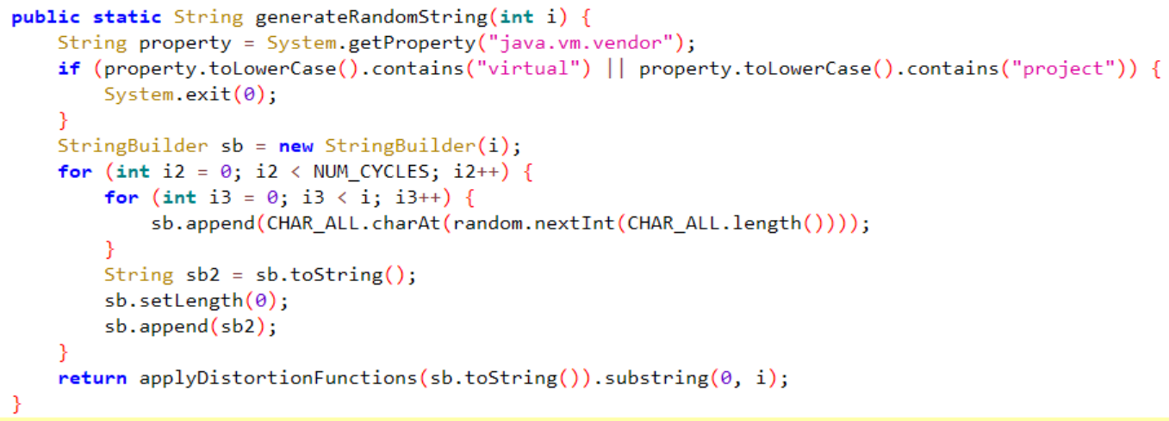
let System = Java.use('java.lang.System');
System.getProperty.overload('java.lang.String').implementation = function (propertyName) {
var returnValue = this.getProperty(propertyName);
console.log("System.getProperty called with propertyName: " + propertyName + ", returned: " + returnValue);
if (propertyName === "java.vm.vendor") {
return "";
}
return returnValue;
};
之后hook AesUtil.encrypt就不会退出了
GetTime返回的是当前时间戳，肯定不对，根据题目描述拿到正确时间戳
frida设置GetTime返回值
let Myjni = Java.use("com.example.ohhelp.MyJNI.Myjni");
Myjni["GetTime"].overload().implementation = function () {
console.log('GetTime is called');
let ret = this.GetTime();
console.log('GetTime ret value is ' + ret);
return "1055853128000";
};
之后hook AesUtil.encrypt拿到的返回值即为flag
整体脚本
function hook() {
Java.perform(function () {
let Myjni = Java.use("com.example.ohhelp.MyJNI.Myjni");
Myjni["GetTime"].overload().implementation = function () {
console.log('GetTime is called');
let ret = this.GetTime();
console.log('GetTime ret value is ' + ret);
return "1055853128000";
};
Myjni["GetKey"].implementation = function () {
console.log('GetKey is called');
let ret = this.GetKey();
console.log('GetKey ret value is ' + ret);
return "PUDzbflthjqxlJVW";
};
let AesUtil = Java.use("com.example.ohhelp.AesUtil");
AesUtil["encrypt"].overload('java.lang.String', 'java.lang.String').implementation = function (str, str2) {
console.log('encrypt is called' + ', ' + 'str: ' + str + ', ' + 'str2: ' + str2);
let ret = this.encrypt(str, str2);
console.log('encrypt ret value is ' + ret);
return ret;
};
let System = Java.use('java.lang.System');
System.getProperty.overload('java.lang.String').implementation = function (propertyName) {
var returnValue = this.getProperty(propertyName);
console.log("System.getProperty called with propertyName: " + propertyName + ", returned: " + returnValue);
if (propertyName === "java.vm.vendor") {
return "";
}
return returnValue;
};
})
}
hook()
hook结果：ISCC{VJS6yUGcQNC3K3lZ5BeYng==}

Exp

