ISCC2024 WriteUp 提交模板
Py74on+习翼+1962389612@qq.com

Web+回来吧永远滴神

解题思路
凯凯是乌兹的铁粉（绝对的白子，非串子），你能实现他的愿望，帮助永远滴神再次回归赛场，并拿下世界冠军吗？
http://101.200.138.180:16356
先F12看看把，这我那知道填啥
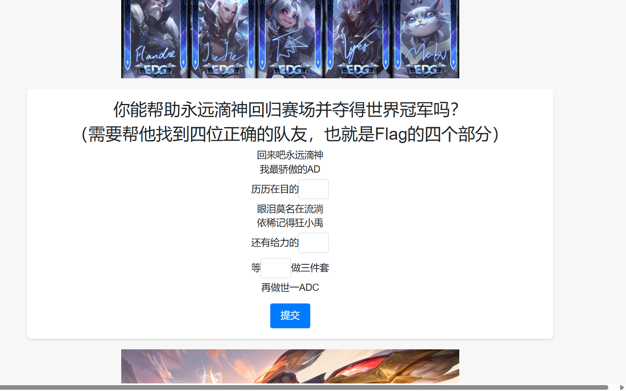
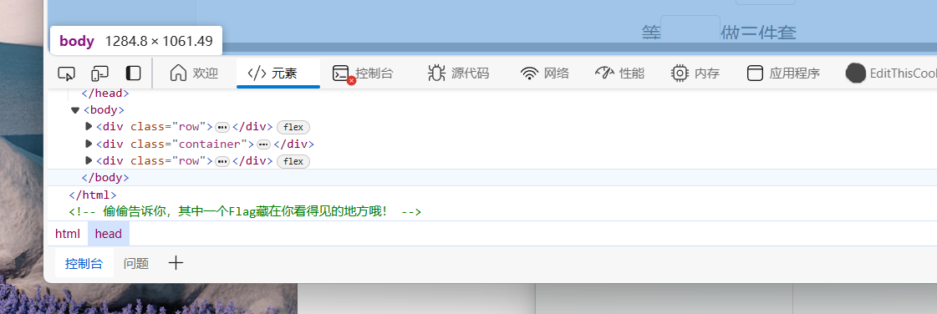
VN 卡莎 小狗 只能搜答案去了
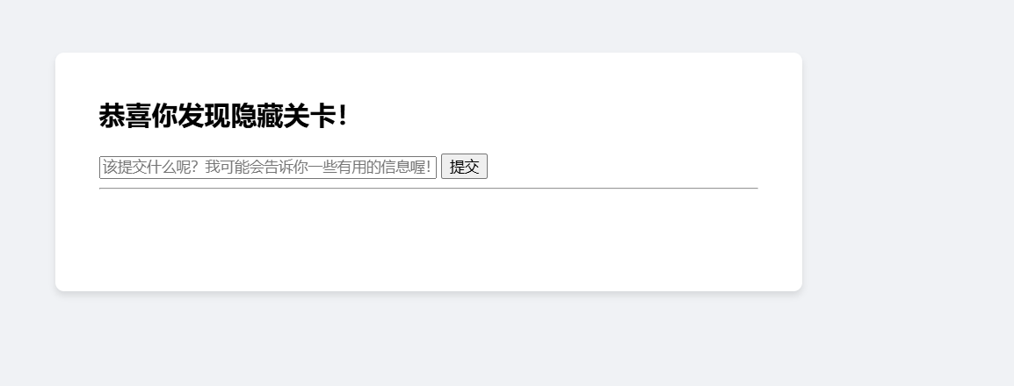
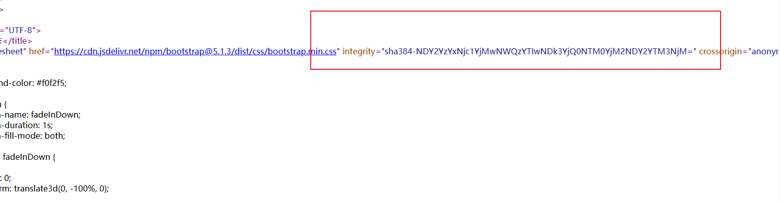
F12发现了这玩意base64解一下 复制下来解码得到Flag[0]: I{R_ifcs@j
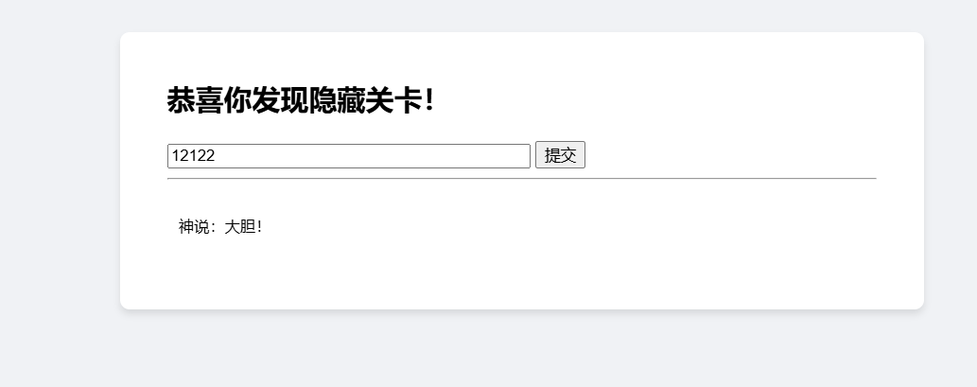
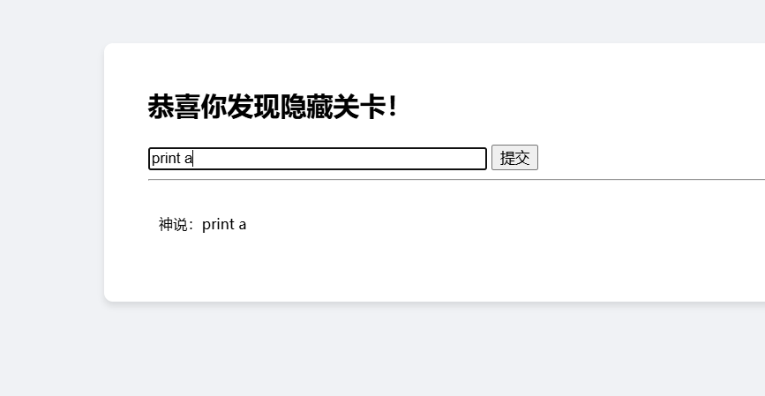
感觉像是SSTI啊
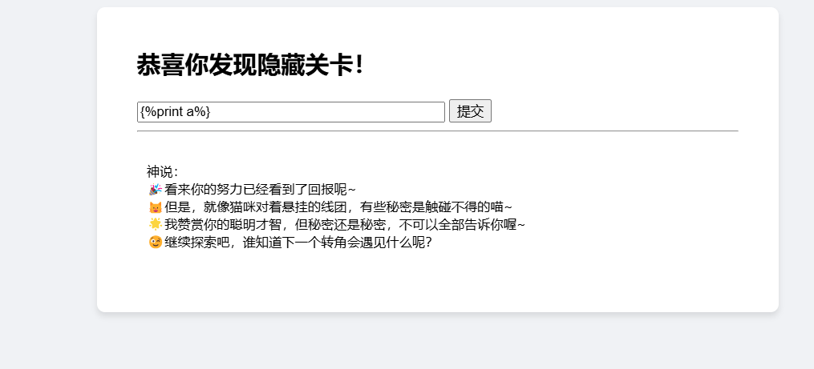
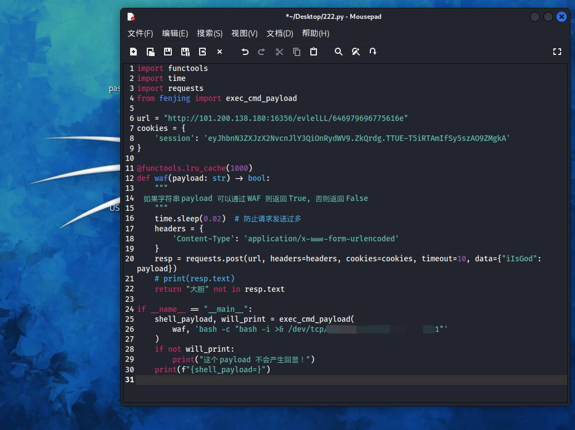
直接一把反弹shell到vps上然后读到Flag[2]和Flag[1]
接着发现还得把源码dump下来进行审计，根据源码去找到Flag[3]加密逻辑
写一个脚本把Flag[3]跑出来然后把几个部分全部拼起来
把这玩意直接栅栏解密一下子（枚举）
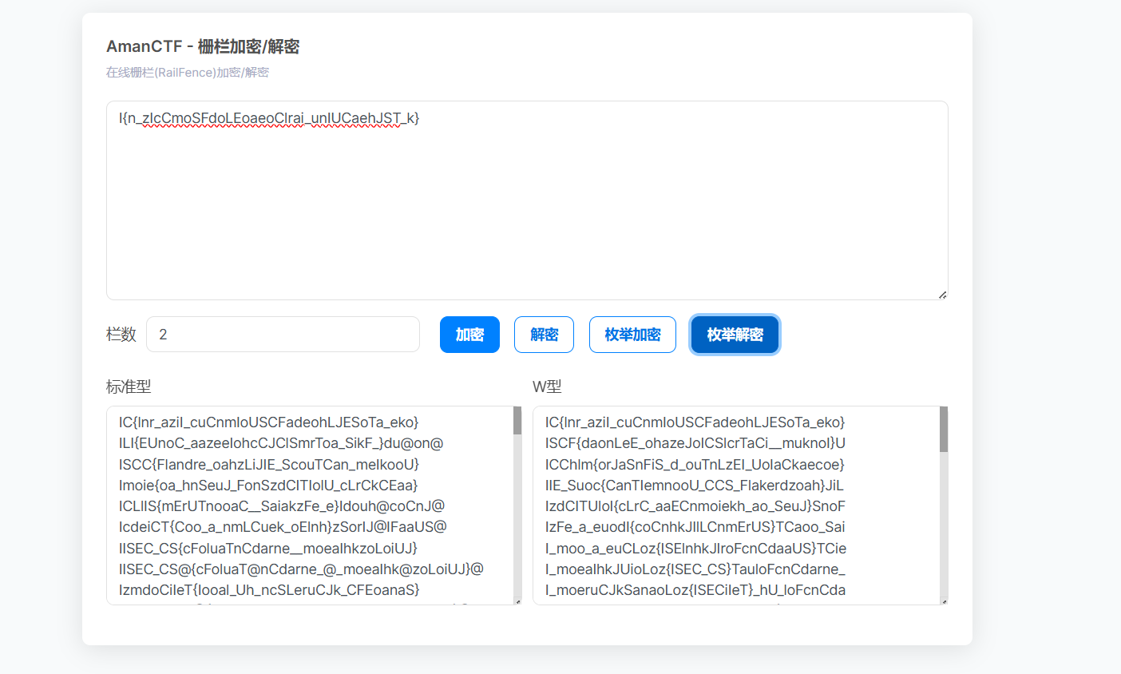
ISCC{Flandre_oahzLiJIE_ScouTCan_meIkooU}

Exp
from Crypto.Util.Padding import pad, unpad
from Crypto.Util.number import bytes_to_long as b2l, long_to_bytes as l2b
from Crypto.Random import get_random_bytes
from enum import Enum

class Mode(Enum):
ECB = 0x01
CBC = 0x02
CFB = 0x03

class Cipher:
def __init__(self, key, iv=None):
self.BLOCK_SIZE = 64
self.KEY = [
b2l(key[i: i + self.BLOCK_SIZE // 16])
for i in range(0, len(key), self.BLOCK_SIZE // 16)
]
self.DELTA = 0x9E3779B9
self.IV = iv
self.ROUNDS = 64
self.mode = Mode.CBC if iv else Mode.ECB
if iv and len(iv) * 8 != self.BLOCK_SIZE:
self.mode = Mode.CFB
print(f"Mode: {self.mode}")

def _xor(self, a, b):
return b"".join(bytes([_a ^ _b]) for _a, _b in zip(a, b))

def decrypt_block(self, ct):
m0 = b2l(ct[:4])
m1 = b2l(ct[4:])
msk = (1 << (self.BLOCK_SIZE // 2)) - 1
s = self.DELTA * self.ROUNDS
for i in range(self.ROUNDS):
m1 -= (
((m0 << 4) + self.KEY[(self.ROUNDS - 1 - i + 2) % len(self.KEY)])
^ (m0 + s)
^ ((m0 >> 5) + self.KEY[(self.ROUNDS - 1 - i + 3) % len(self.KEY)])
)
m1 &= msk
m0 -= (
((m1 << 4) + self.KEY[(self.ROUNDS - 1 - i) % len(self.KEY)])
^ (m1 + s)
^ ((m1 >> 5) + self.KEY[(self.ROUNDS - 1 - i + 1) % len(self.KEY)])
)
m0 &= msk
s -= self.DELTA
return l2b((m0 << (self.BLOCK_SIZE // 2)) | m1)

def decrypt(self, ct):
blocks = [ct[i: i + self.BLOCK_SIZE // 8] for i in range(0, len(ct), self.BLOCK_SIZE // 8)]
msg = b""
if self.mode == Mode.ECB:
for ct_block in blocks:
msg += self.decrypt_block(ct_block)
elif self.mode == Mode.CBC:
X = self.IV
for ct_block in blocks:
decrypted_block = self._xor(X, self.decrypt_block(ct_block))
msg += decrypted_block
X = ct_block
elif self.mode == Mode.CFB:
X = self.IV
for ct_block in blocks:
output = self.encrypt_block(X) # Note: encrypt_block method is not defined in the original code
decrypted_block = self._xor(output, ct_block)
msg += decrypted_block
X = ct_block
return unpad(msg, self.BLOCK_SIZE // 8)

if __name__ == "__main__":
KEY = bytes.fromhex("3362623866656338306539313238353733373566366338383563666264386133")
IV = bytes.fromhex("64343537373337663034346462393931")
cipher = Cipher(KEY, IV)
ct = bytes.fromhex("1cb8db8cabe8edbbddb211f3da4869cdee3bcfb850bce808")
print(f"FLAG: {cipher.decrypt(ct)}")

# 栅栏解密部分
# FLAG = b'xxxxxxxxxxxxxxxxxxx'
# ct = cipher.encrypt(FLAG)
# print(f'KEY: {KEY.hex()}')
# print(f'IV: {IV.hex()}')
# print(f'Ciphertext: {ct.hex()}')

