ISCC2024 WriteUp 提交模板
Py74on+习翼+1962389612@qq.com

题目类型+题目名称

解题思路
拖到IDA先看先分析main函数，可以得到flag长度为27
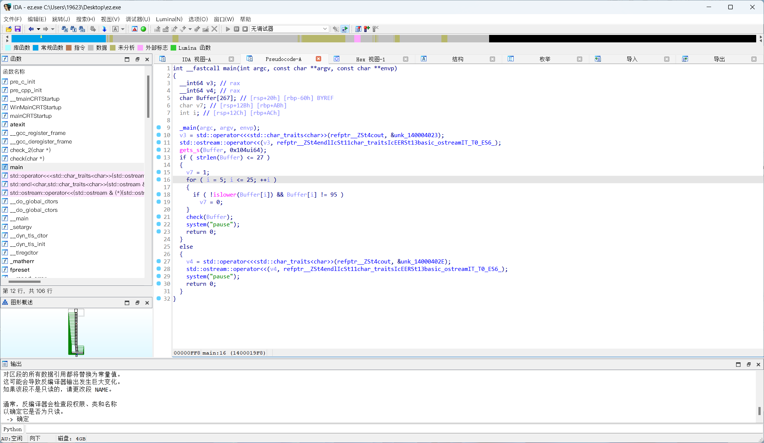
然后先看一下check函数
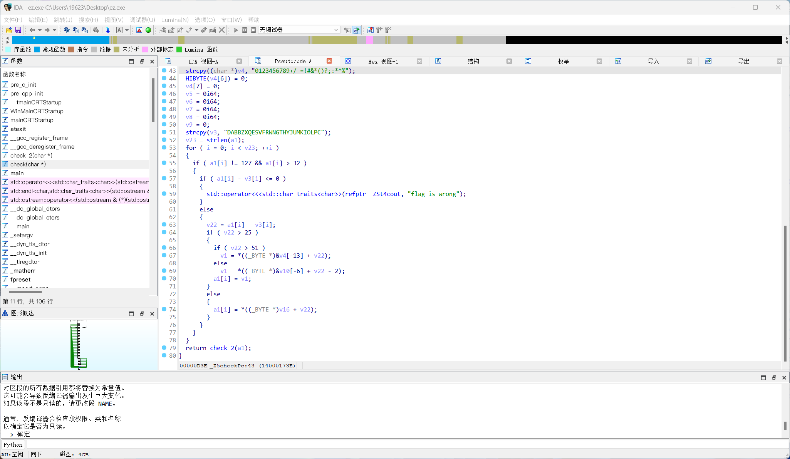
输入a1数组的每一位减去一个特定值后他就会去进行了一个范围的判断，然后直接进入check_2函数判断，然后看一下check2函数
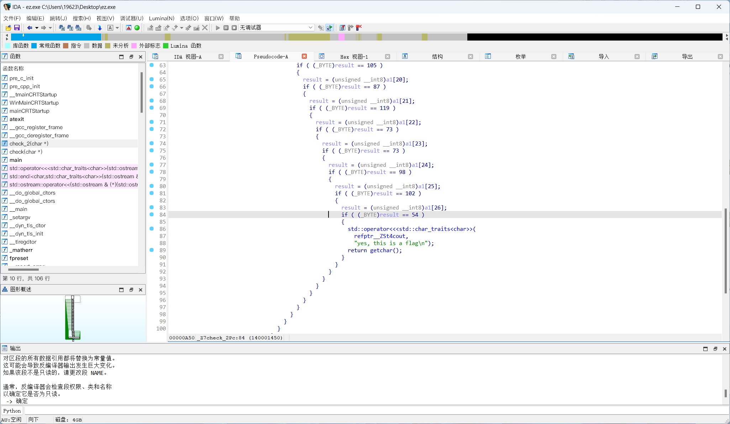
check_2函数看得出来是：逐位比较，用此逻辑让GPT写个脚本试一试即可
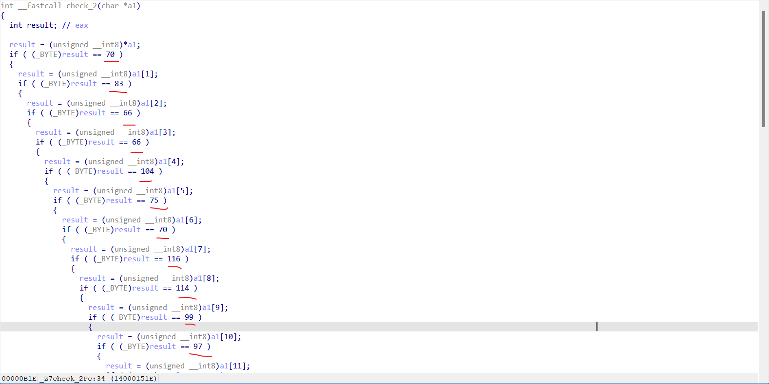
依次把比较的字符串提取出来
import re
# 原始代码字符串
code = '''
int __fastcall check_2(char *a1)
{
int result; // eax
result = (unsigned __int8)*a1;
if ( (_BYTE)result == 70 )
{
result = (unsigned __int8)a1[1];
if ( (_BYTE)result == 83 )
{
result = (unsigned __int8)a1[2];
if ( (_BYTE)result == 66 )
{
result = (unsigned __int8)a1[3];
if ( (_BYTE)result == 66 )
{
result = (unsigned __int8)a1[4];
if ( (_BYTE)result == 104 )
{
result = (unsigned __int8)a1[5];
if ( (_BYTE)result == 75 )
{
result = (unsigned __int8)a1[6];
if ( (_BYTE)result == 70 )
{
result = (unsigned __int8)a1[7];
if ( (_BYTE)result == 116 )
{
result = (unsigned __int8)a1[8];
if ( (_BYTE)result == 114 )
{
result = (unsigned __int8)a1[9];
if ( (_BYTE)result == 99 )
{
result = (unsigned __int8)a1[10];
if ( (_BYTE)result == 97 )
{
result = (unsigned __int8)a1[11];
if ( (_BYTE)result == 112 )
{
result = (unsigned __int8)a1[12];
if ( (_BYTE)result == 76 )
{
result = (unsigned __int8)a1[13];
if ( (_BYTE)result == 86 )
{
result = (unsigned __int8)a1[14];
if ( (_BYTE)result == 85 )
{
result = (unsigned __int8)a1[15];
if ( (_BYTE)result == 101 )
{
result = (unsigned __int8)a1[16];
if ( (_BYTE)result == 119 )
{
result = (unsigned __int8)a1[17];
if ( (_BYTE)result == 77 )
{
result = (unsigned __int8)a1[18];
if ( (_BYTE)result == 86 )
{
result = (unsigned __int8)a1[19];
if ( (_BYTE)result == 105 )
{
result = (unsigned __int8)a1[20];
if ( (_BYTE)result == 87 )
{
result = (unsigned __int8)a1[21];
if ( (_BYTE)result == 119 )
{
result = (unsigned __int8)a1[22];
if ( (_BYTE)result == 73 )
{
result = (unsigned __int8)a1[23];
if ( (_BYTE)result == 73 )
{
result = (unsigned __int8)a1[24];
if ( (_BYTE)result == 98 )
{
result = (unsigned __int8)a1[25];
if ( (_BYTE)result == 102 )
{
result = (unsigned __int8)a1[26];
if ( (_BYTE)result == 54 )
{
std::operator<<<std::char_traits<char>>(
refptr__ZSt4cout,
"yes, this is a flag\n");
return getchar();
}
}
}
}
}
}
}
}
}
}
}
}
}
}
}
}
}
}
}
}
}
}
}
}
}
}
}
return result;
}
'''
# 使用正则表达式提取result == 后面的数字
result_numbers = re.findall(r'result\s*==\s*(\d+)', code)
# 打印提取的数字
print(result_numbers)
result_numbers = ['70', '83', '66', '66', '104', '75', '70', '116', '114', '99', '97', '112', '76', '86', '85', '101', '119', '77', '86', '105', '87', '119', '73', '73', '98', '102', '54']
# 将数字转换为 ASCII 字符
ascii_characters = [chr(int(num)) for num in result_numbers]
# 打印转换后的 ASCII 字符列表
print(ascii_characters)
转换为ASCII字符，然后用此check2的逻辑让GPT写个脚本试一试即可
cmp = 'FSBBhKFtrcapLVUewMViWwIIbf6'
v16 = 'ABCDEFGHIJKLMNOPQRSTUVWXYZ'
v10 = 'abcdefghijklmnopqrstuvwxyz'
v4 = '0123456789+/-=!#&*()?;:*^%'
v3 = 'DABBZXQESVFRWNGTHYJUMKIOLPC'
for i, c in enumerate(cmp):
if c in v16:
index = (v16.index(c) + ord(v3[i]) - ord('A')) % 26
print(v16[index], end='')
elif c in v10:
index = (v10.index(c) + ord(v3[i]) - ord('A')) % 26
print(v10[index], end='')
elif c in v4:
index = (v4.index(c) + ord(v3[i]) - ord('A')) % len(v4)
print(v4[index], end='')

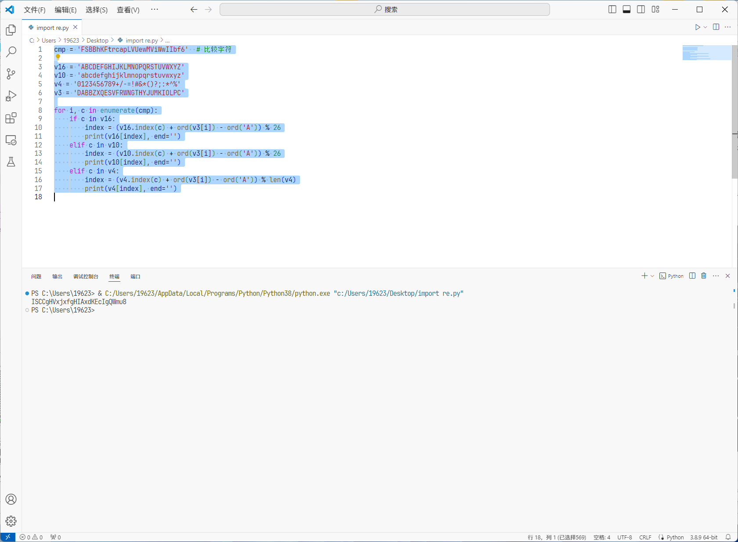Exp
cmp = 'FSBBhKFtrcapLVUewMViWwIIbf6'

v16 = 'ABCDEFGHIJKLMNOPQRSTUVWXYZ'
v10 = 'abcdefghijklmnopqrstuvwxyz'
v4 = '0123456789+/-=!#&*()?;:*^%'
v3 = 'DABBZXQESVFRWNGTHYJUMKIOLPC'

for i, c in enumerate(cmp):
if c in v16:
index = (v16.index(c) + ord(v3[i]) - ord('A')) % 26
print(v16[index], end='')
elif c in v10:
index = (v10.index(c) + ord(v3[i]) - ord('A')) % 26
print(v10[index], end='')
elif c in v4:
index = (v4.index(c) + ord(v3[i]) - ord('A')) % len(v4)
print(v4[index], end='')

