ISCC2025 WriteUp 提交模板
吊椅宝宝赚钱养小猫+习翼+1962389612@qq.com

MOBILE+Detective

解题思路
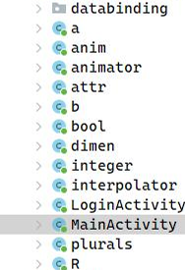
使用jadx进行反编译：

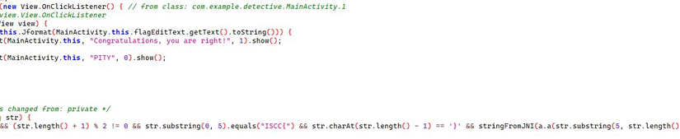
存在比较字符串，依照逻辑写出脚本跑出flag：

def _hex_from_cipher(cipher: str) -> str:
"""A.c的逆操作：字符➜4位十六进制，去掉前导'00'"""
hex_str = ''.join(f'{ord(ch):04x}' for ch in cipher)
return hex_str[2:] if hex_str.startswith('00') else hex_str

def _undo_padding(hex_str: str) -> str:
"""
逆操作：去掉每2位后强插的'00'（若剩余长度%4 ==2说明末尾少一个'00'），
得到插针/交换前的串replaced
"""
if len(hex_str) % 4 == 2:
hex_str += '00' # 还原被截掉的最后两个0
return ''.join(hex_str[i:i+2] for i in range(0, len(hex_str), 4))

def _undo_pair_shuffle(replaced: str) -> str:
"""
逆操作：解析2-字节或4-字节(…'21')片段，复原sb2+sb的顺序
"""
out, i = [], 0
while i < len(replaced):
# 4字节模式：c2 c1 21
if i + 3 < len(replaced) and replaced[i+2:i+4] == '21':
c2, c1 = replaced[i], replaced[i+1]
out.extend([c1, c2])
i += 4
else: # 2字节保持原序
out.extend(replaced[i:i+2])
i += 2
return ''.join(out)

def _split_and_fix_zero(concat: str) -> str:
"""
按sb2 | sb切分，再把被替换成'3'的零位改回'0'。
sb负责偶数索引（0,2,4…），替换条件idx==0或idx%3==0
sb2负责奇数索引（1,3,5…），替换条件idx==1或(idx-1)%3==0
"""
half = len(concat) // 2
sb2, sb = concat[:half], concat[half:]

# sb复原0→3
sb = ''.join(
'0' if ch == '3' and (idx == 0 or idx % 3 == 0) else ch
for idx, ch in enumerate(sb)
)

# sb2复原0→3
sb2 = ''.join(
'0' if ch == '3' and (idx == 1 or (idx - 1) % 3 == 0) else ch
for idx, ch in enumerate(sb2)
)

# 交叉还原到原16进制序列
res = []
even = odd = 0
for idx in range(len(concat)):
if idx % 2 == 0: # 偶数位来自sb
res.append(sb[even])
even += 1
else: # 奇数位来自sb2
res.append(sb2[odd])
odd += 1
return ''.join(res)

def _hex_to_plain(hex_str: str) -> str:
"""
根据A.b的编码规则：
- 如果以'0'开头则为3位组(0xx)➜ASCII/单字节
- 否则为4位组➜Unicode (xxxx)
"""
out, i = [], 0
while i < len(hex_str):
if hex_str[i] == '0' and i + 2 < len(hex_str):
out.append(chr(int(hex_str[i+1:i+3], 16)))
i += 3
else:
out.append(chr(int(hex_str[i:i+4], 16))) # 修复括号缺失
i += 4
return ''.join(out)

def decrypt(cipher: str) -> str:
"""顶层接口：密文➜明文"""
step1 = _hex_from_cipher(cipher)
step2 = _undo_padding(step1)
step3 = _undo_pair_shuffle(step2)
step4 = _split_and_fix_zero(step3)
return _hex_to_plain(step4)

# ------------------------示例------------------------
if __name__ == "__main__":
xor_key = [0x53, 0x68, 0x65, 0x72, 0x6C, 0x6F, 0x63, 0x6B]
res = "1008444F0F2B5253600444475E4E534A" # 填
res_chr = []
for i in range(0, len(res), 2):
res_chr.append(int(res[i:i+2], 16))
print(res_chr)

flag = []
for i in range(len(res_chr)):
flag.append(res_chr[i] ^ xor_key[i % len(xor_key)])

sample = bytes(flag).decode()
print("Cipher :", sample)
print("Plain :", decrypt(sample))
print("ISCC{" + decrypt(sample) + "}")

Exp

