ISCC2025 WriteUp 提交模板
吊椅宝宝赚钱养小猫+习翼+1962389612@qq.com

REVERSE+greeting

解题思路
IDA直接打开主函数：

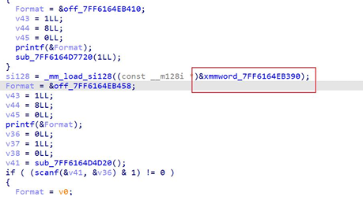
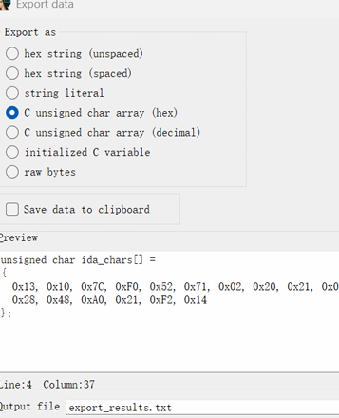
Edit-Export 导出数据

脚本解密：
s = [0x13, 0x10, 0x7C, 0xF0, 0x52, 0x71, 0x02, 0x20, 0x21, 0x04, 0x28, 0x48, 0xA0, 0x21, 0xF2, 0x14] for idx, val in enumerate(s): shifted = ((val >> (idx % 5)) | (val << (8 - idx % 5))) & 0xff ch = shifted ^ (90 + idx) print(chr(ch), end="")

Exp

