ISCC2025 WriteUp 提交模板
吊椅宝宝赚钱养小猫+习翼+1962389612@qq.com

REVERSE+有趣的小游戏解题思路

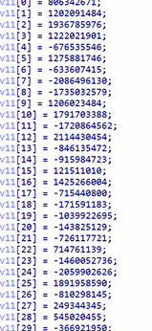
开ida看一下：
一 个while 循环，不断进行读取输入然后加密While 循环前主要是初始化v9，v9可以看作一个结构体，其成员包 括了p，c,e的坐标，分数，地图信息等 注意v11被写入v9+56的位置
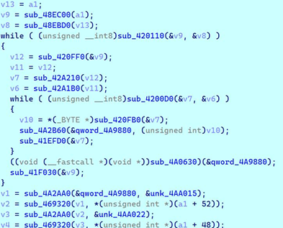

一个打印地图和分数
一个储存当前分数
一个储存总分数
循环内4a3a70读取输入，41D620进行处理
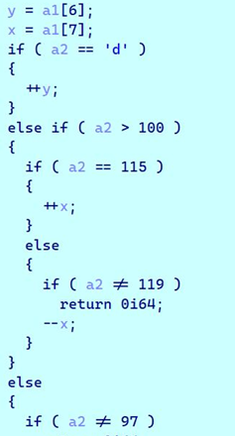

改变x,y坐标
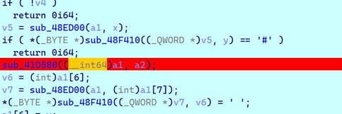

检测了是否撞墙
是否吃到金币进行操作，最后移动p的位置
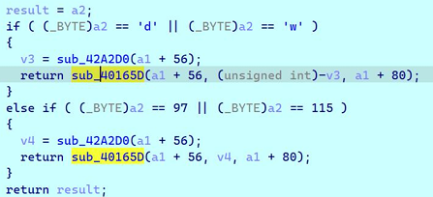

继续跟进发现是明显的xxtea解密特征，所以另一个文件就是加密了
明文就是 v9+56,密钥是v9+80多次解密， 知道出现特征ISCC{}

Exp
#include <stdio.h>
#include <stdint.h>
#include <string.h>
void xxtea_decrypt(uint32_t *v, int n, const uint32_t key[4]) {
uint32_t delta = 0x9e3779b9;
int r = 6 + 52 / n;
uint32_t total = delta * r;
uint32_t v0, v1;
int i, j;
for (i = 0; i < r; i++) {
uint32_t e = (total >> 2) & 3;
for (j = n- 1; j > 0; j--) {
v1 =v[j- 1];
uint32_t part1 = (v1 >> 5) ^ (v[j] << 2);
uint32_t part2 = (v[j] >> 3) ^ (v1 << 4);
uint32_t part3 = (total ^ v[j]) + (key[(j & 3) ^ e] ^ v1);
v[j]-= (part1 + part2) ^ part3;
}
v0 = v[n- 1];
uint32_t part1 = (v0 >> 5) ^ (v[0] << 2);
uint32_t part2 = (v[0] >> 3) ^ (v0 << 4);
uint32_t part3 = (total ^ v[0]) + (key[(0 & 3) ^ e] ^ v0);
v[0]-= (part1 + part2) ^ part3;
total-= delta;
}
}
int main() {
uint32_t v[] = {
0x3d0db055, 0x6aa21e1e, 0x5bc2f195, 0x372f36ac,
0xb3c606be,
0xce1077e2, 0x69fc40b1, 0x8f19d215, 0xf9a42897,
0x960fe985,
0xce0f9ef1, 0x6aaec9ef, 0x00d97f91, 0x4f43d749,
0x73ad8ec2,
0xd30e3dd4, 0xefa46ea4, 0x13b0ebe7, 0xcaef3614,
0xdb9dcaf7,
0x97731560, 0x05b9a135, 0xa60e32c6, 0x0818b8c4,
0xb6133c72,
0x92979bfc, 0xf23a75f1, 0x09c6b17c, 0x8191d18e,
0x80844b55
};
uint32_t key[] = {0x12345678, 0x9ABCDEF0, 0xFEDCBA98,
0x76543210};
int length = sizeof(v) / sizeof(v[0]);
int round;
for (round = 0; round < 20000; round++) {
xxtea_decrypt(v, length, key);
// Convert to little-endian bytes
unsigned char bytes[30 * 4];
for (int i = 0; i < 30; i++) {
bytes[i * 4 + 0] = (v[i] >> 0) & 0xFF;
bytes[i * 4 + 1] = (v[i] >> 8) & 0xFF;
bytes[i * 4 + 2] = (v[i] >> 16) & 0xFF;
bytes[i * 4 + 3] = (v[i] >> 24) & 0xFF;
}
// Check for printable characters
char buffer[30 * 4 + 1];
int pos = 0;
for (int i = 0; i < 30 * 4; i++) {
if (bytes[i] >= 0x20 && bytes[i] <= 0x7E) {
buffer[pos++] = bytes[i];
} else {
if (pos > 0 && buffer[pos- 1] != ' ') {
buffer[pos++] = ' ';
}
}
}
buffer[pos] = '\0';
// Search for flag pattern
char *start = strstr(buffer, "ISCC{");
if (start != NULL) {
char *end = strchr(start, '}');
if (end != NULL&& end > start) {
printf("Found at round %d: %.*s}\n", round + 1,
(int)(end- start + 1), start);
break; // Remove if multiple flags possible
}
}
}
return 0;
}

