ISCC2025 WriteUp 提交模板
吊椅宝宝赚钱养小猫+习翼+1962389612@qq.com

MISC+签个到吧

解题思路
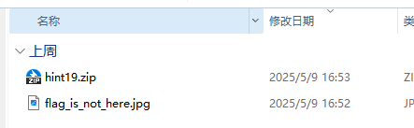
附件得到一个压缩包和图片

Binwalk对压缩包进行提取

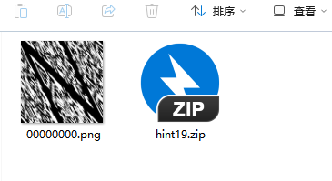

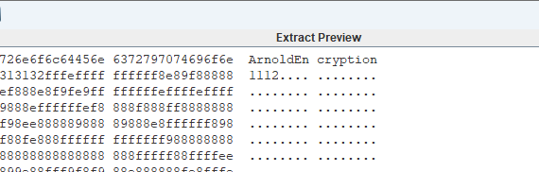
猫脸变换
逆向恢复脚本：
import cv2
import numpy as np
def arnold_encode(image, shuffle_times, a, b):
arnold_image = np.zeros(shape=image.shape, dtype=image.dtype)
h, w = image.shape[0], image.shape[1]
N = h # 或 N = w，需保证图片为方形
for _ in range(shuffle_times):
for ori_x in range(h):
for ori_y in range(w):
new_x = (ori_x + b * ori_y) % N
new_y = (a * ori_x + (a * b + 1) * ori_y) % N
arnold_image[new_x, new_y, :] = image[ori_x, ori_y, :]
image = np.copy(arnold_image)
cv2.imwrite('flag_arnold_encode.png', arnold_image, [int(cv2.IMWRITE_PNG_COMPRESSION),
0])
return arnold_image
def arnold_decode(image, shuffle_times, a, b):
decode_image = np.zeros(shape=image.shape, dtype=image.dtype)
h, w = image.shape[0], image.shape[1]
N = h # 或 N = w，需保证图片为方形
for _ in range(shuffle_times):
for ori_x in range(h):
for ori_y in range(w):
new_x = ((a * b + 1) * ori_x - b * ori_y) % N
new_y = (-a * ori_x + ori_y) % N
decode_image[new_x, new_y, :] = image[ori_x, ori_y, :]
image = np.copy(decode_image)
cv2.imwrite('flag.png', decode_image, [int(cv2.IMWRITE_PNG_COMPRESSION), 0])
return decode_image
if __name__ == "__main__":
img = cv2.imread('00000000.png')
# 编码示例
# arnold_encode(img, 1, 2, 3)
# 解码示例
arnold_decode(img, 1, 1, -2)

又得到一张二维码
⽤ stegsolve进行xor后逆时针旋转90度后与第一张二维码合并：

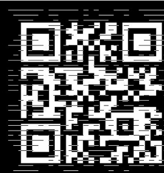

扫码得flag

Exp

