ISCC2025 WriteUp 提交模板
吊椅宝宝赚钱养小猫+习翼+1962389612@qq.com

MOBILE+邦布出击

解题思路
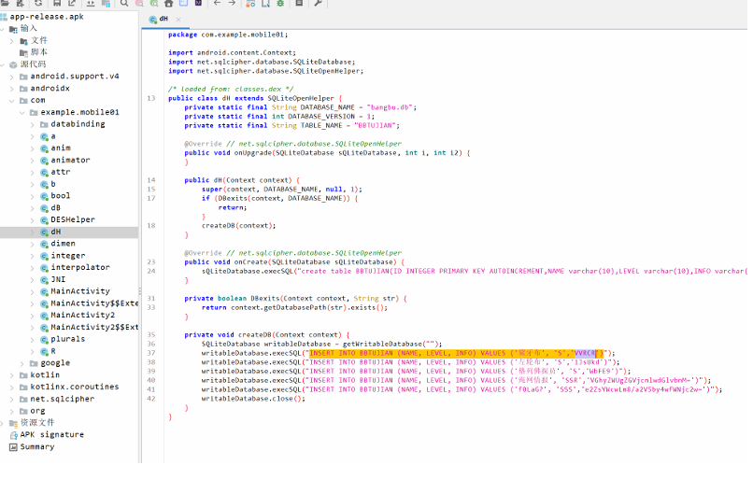
用jadx进行反编译：
在com.example.mobile01.dH找到关键信息
sqlcipher-shell32.exe encrypt.db PRAGMA key = '密钥'; ATTACH DATABASE 'plaintext9.db' AS plaintext KEY ''; SELECT sqlcipher_export('plaintext');

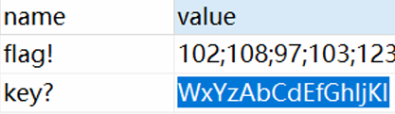
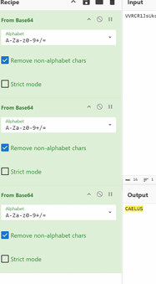
脚本：
function hook() {
Java.perform(function () {
//Dohapztlhuaiftpyhjsl
let b = Java.use("com.example.mobile01.b");
b["c"].implementation = function () {
return "WxYzAbCdEfGhIjKl";
};
let DESHelper = Java.use("com.example.mobile01.DESHelper");
DESHelper["encrypt"].implementation = function (str, str2, str3) {
console.log(`DESHelper.encrypt is called: str=${str}, str2=${str2},
str3=${str3}`);
let result = this["encrypt"](str, str2, str3);
console.log(`DESHelper.encrypt result=${result}`);
return result;
};
});
}
setImmediate(hook);
function hook() {
Java.perform(function () {
//Dohapztlhuaiftpyhjsl
let b = Java.use("com.example.mobile01.b");
b["c"].implementation = function () {
return "WxYzAbCdEfGhIjKl";
};
});
}
let DESHelper = Java.use("com.example.mobile01.DESHelper");
DESHelper["encrypt"].implementation = function (str, str2, str3) {
console.log(`DESHelper.encrypt is called: str=${str}, str2=${str2},
str3=${str3}`);
let result = this["encrypt"](str, str2, str3);
console.log(`DESHelper.encrypt result=${result}`);
return result;
};
setImmediate(hook);
使用模拟器输入入ISCC{191323223}
得到ISCC{pAK51YtjzLPtTlO2WF16SLnw63oJpCHn}

Exp

