Mobile1
用jadx打开下载的apk文件
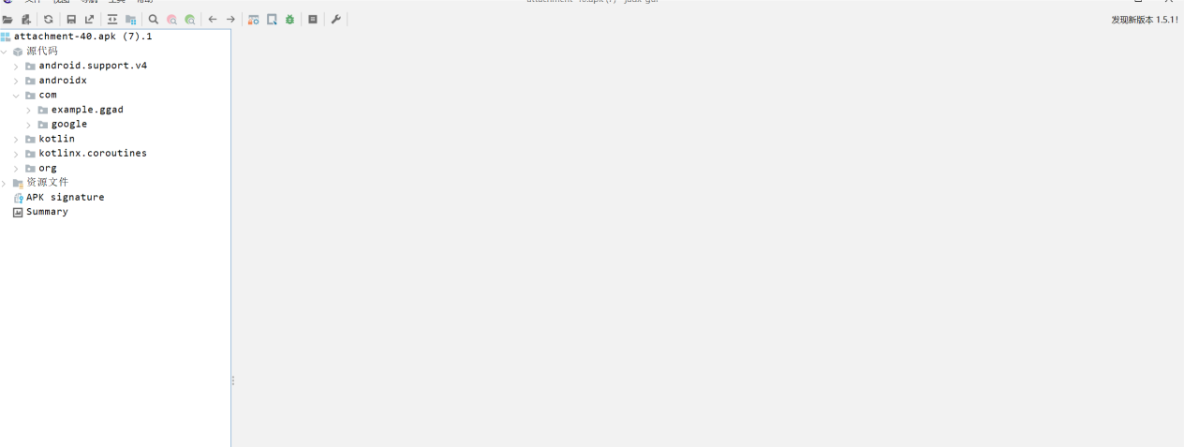
Com->example.ggad->b->preset_value找到以下数据
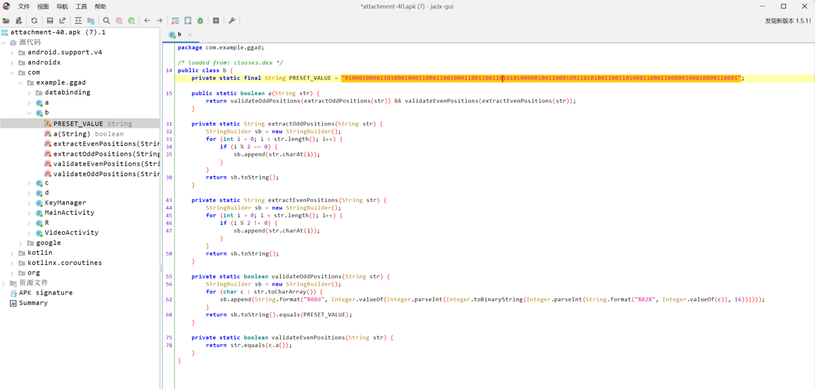
Com->example.ggad->c找到以下数据
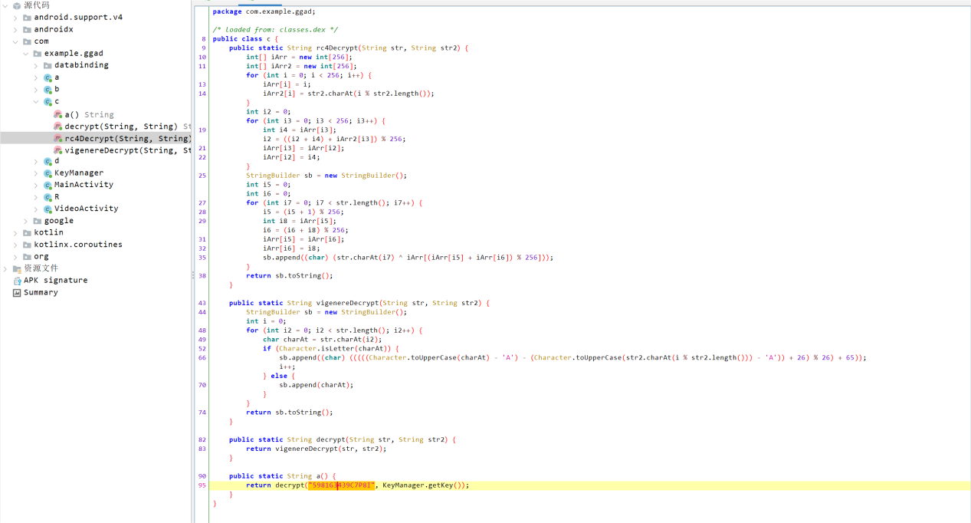
将这两串数据替换到脚本,跑出flag
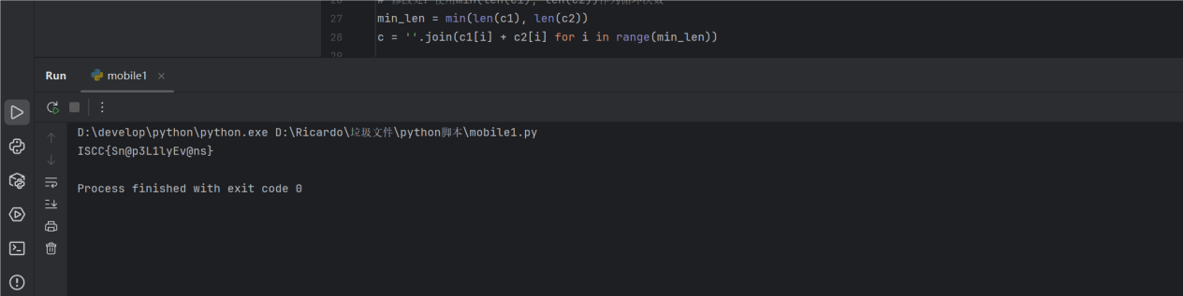
Exp:
ci = '0100010000110100010001100011001000110011001101010100000100110001001101010011001101000110001100000100010000110001'
c0 = '5981G3439C7P8I'

def vigenere_decrypt(text, key):
decrypted = []
key_shifts = [ord(k.upper()) - ord('A') for k in key]
key_len, key_idx = len(key_shifts), 0

for char in text:
if char.isalpha():
shift = key_shifts[key_idx % key_len]
upper_char = char.upper()
decrypted_code = (ord(upper_char) - ord('A') - shift) % 26 + ord('A')
decrypted_char = chr(decrypted_code)
decrypted.append(decrypted_char.lower() if char.islower() else decrypted_char)
key_idx += 1
else:
decrypted.append(char)
return ''.join(decrypted)

def a(cs):
return vigenere_decrypt(cs, 'ExpectoPatronum')

c2 = a(c0)
c1 = ''.join(chr(int(ci[i:i+8], 2)) for i in range(0, len(ci), 8))
# 修改处：使用min(len(c1), len(c2))作为循环次数
min_len = min(len(c1), len(c2))
c = ''.join(c1[i] + c2[i] for i in range(min_len))

byte_array = [int(c[i:i+2], 16) for i in range(0, len(c), 2)]
c3 = ''.join(f"{b:08b}" for b in byte_array)
str1 = c3.translate(str.maketrans('01', '10'))
c4 = bytes(int(str1[i:i+8], 2) for i in range(0, len(str1), 8))

def rc4_ksa(key):
key = key.encode() if isinstance(key, str) else key
S = list(range(256))
j = 0
for i in range(256):
j = (j + S[i] + key[i % len(key)]) % 256
S[i], S[j] = S[j], S[i]
return S

def rc4_prga(S, data):
data = data if isinstance(data, bytes) else data.encode()
i = j = 0
result = []
for byte in data:
i = (i + 1) % 256
j = (j + S[i]) % 256
S[i], S[j] = S[j], S[i]
result.append(byte ^ S[(S[i] + S[j]) % 256])
return bytes(result)

S = rc4_ksa('ExpectoPatronum')
res = rc4_prga(S, c4)
flag = f"ISCC{{{res.decode()}}}"
print(flag)

