#include<stdio.h>
#include<string.h>
#include<stdint.h>
#include<stdlib.h>

//标准RC4
void rc4(unsigned char* key, int key_Len, unsigned char* data, int data_Len) //加解密
{
int i = 0, j = 0, t = 0;
unsigned char s[256] = { 0 };
unsigned char tmp = 0;
for (i = 0; i < 256; i++) {
s[i] = i;
}
for (i = 0; i < 256; i++) {
j = (j + s[i] + key[i % key_Len]) % 256;
tmp = s[i];
s[i] = s[j]; //交换s[i]和s[j]
s[j] = tmp;
}
int q = 0;
i = j = 0;
for (q = 0; q < data_Len; q++) {
i = (i + 1) % 256;
j = (j + s[i]) % 256;

tmp = s[i];
s[i] = s[j]; //交换s[x]和s[y]
s[j] = tmp;
t = (s[i] + s[j]) % 256;
data[q] ^= s[t];
}
}
int main()
{
unsigned char flag[42] = {
//密文替换在这里
};

char* key = "SecretKey";
rc4(key, strlen(key), flag, 42);
for (int i = 0; i < 42; i++)
{
if (flag[i] >= 'a' && flag[i] <= 'z')
{
flag[i] = (flag[i] - 'a' + 26 - 3) % 26 + 'a';
}
else if (flag[i] >= 'A' && flag[i] <= 'Z')
{
flag[i] = (flag[i] - 'A' + 26 - 3) % 26 + 'A';
}
}
for (int i = 0; i < 42; i+=2)
{
printf("%c", flag[i] ^ 65);
}
return 0;
}

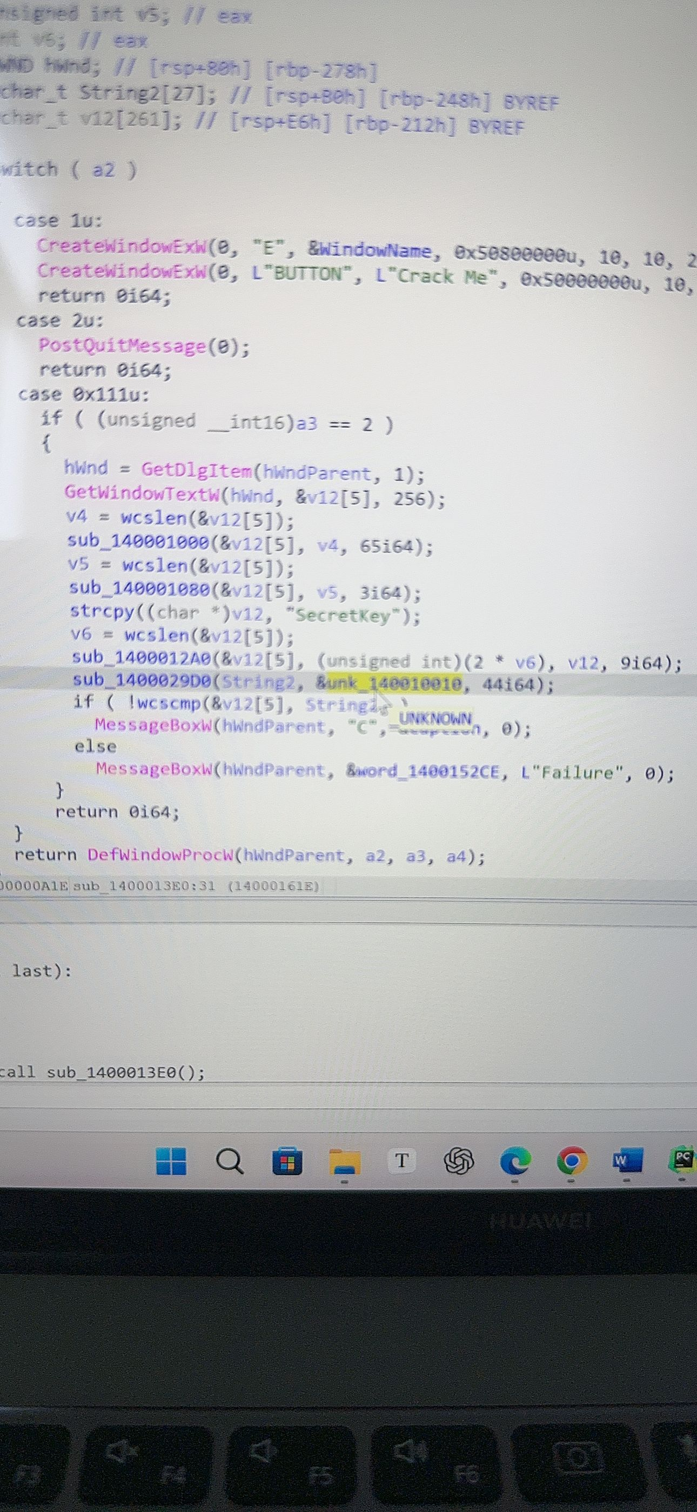

进去 sub1400013e0函数
42个0x
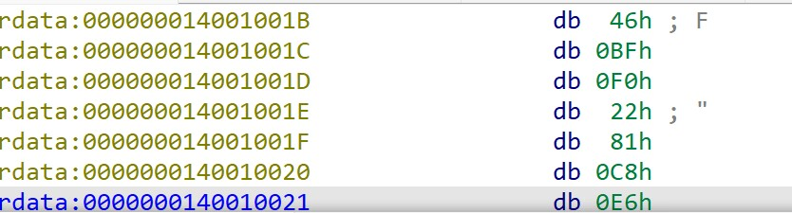
从1ch开始选到下面
shift e 导出就行

