找到该函数,F5反编译得到数据
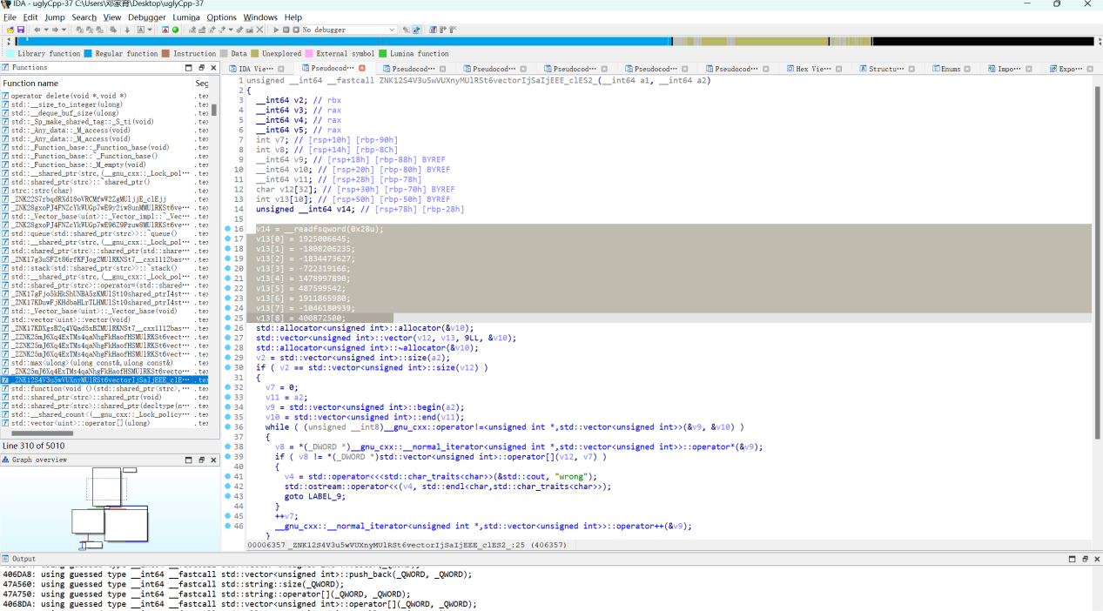
将这些数据代换到一下脚本
v = [1925006645, -1808206235, -1834473627, -722319166, 1478997890, 487599542, 1911865980, -1046180939, 400872500]
v = [i & 0xffffffff for i in v] # Convert to unsigned 32-bit integers

xor = [0x3ED6325B, 0xD709BF17, 0xE3F27E18, 0xA0870791, 0x0146D6F9, 0x7C6140FF, 0x10B69406, 0x94DDE0F6, 0x40B2BB6C]

for i in range(len(v)):
v[i] ^= xor[i]

flag = "".join([i.to_bytes(length=4, byteorder="little").decode() for i in v])
print(flag)

c_table = "5p6h7q8d9risbtjuevkwaxlyfzm0c1n2g3o4"
table = "abcdefghijklmnopqrstuvwxyz0123456789"
for i in table:
print(flag[c_table.index(i)], end="")

